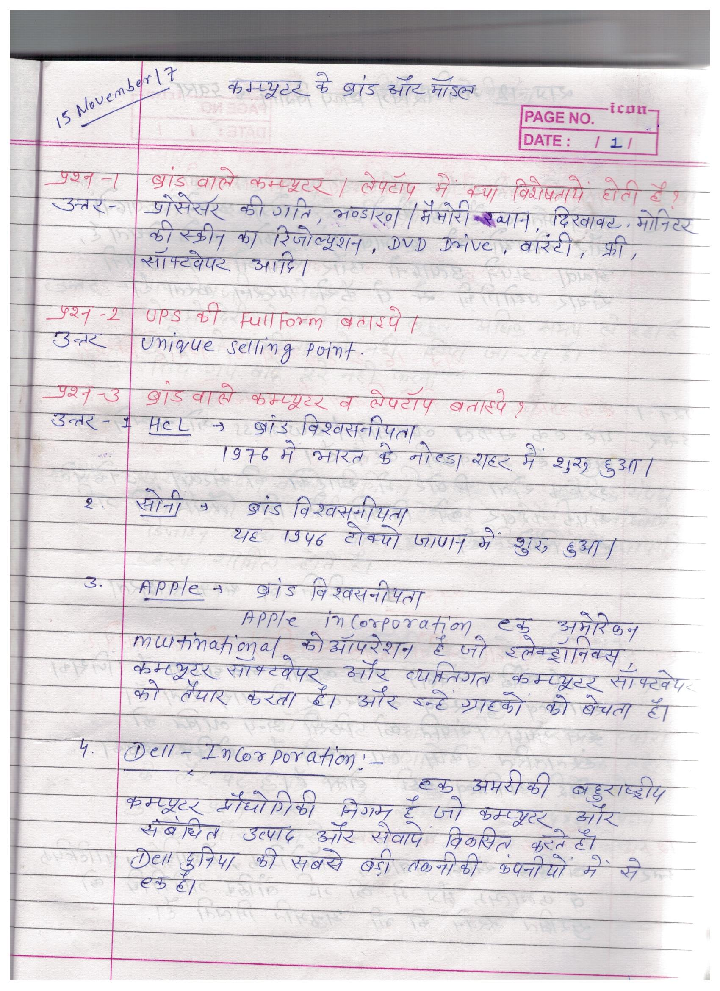

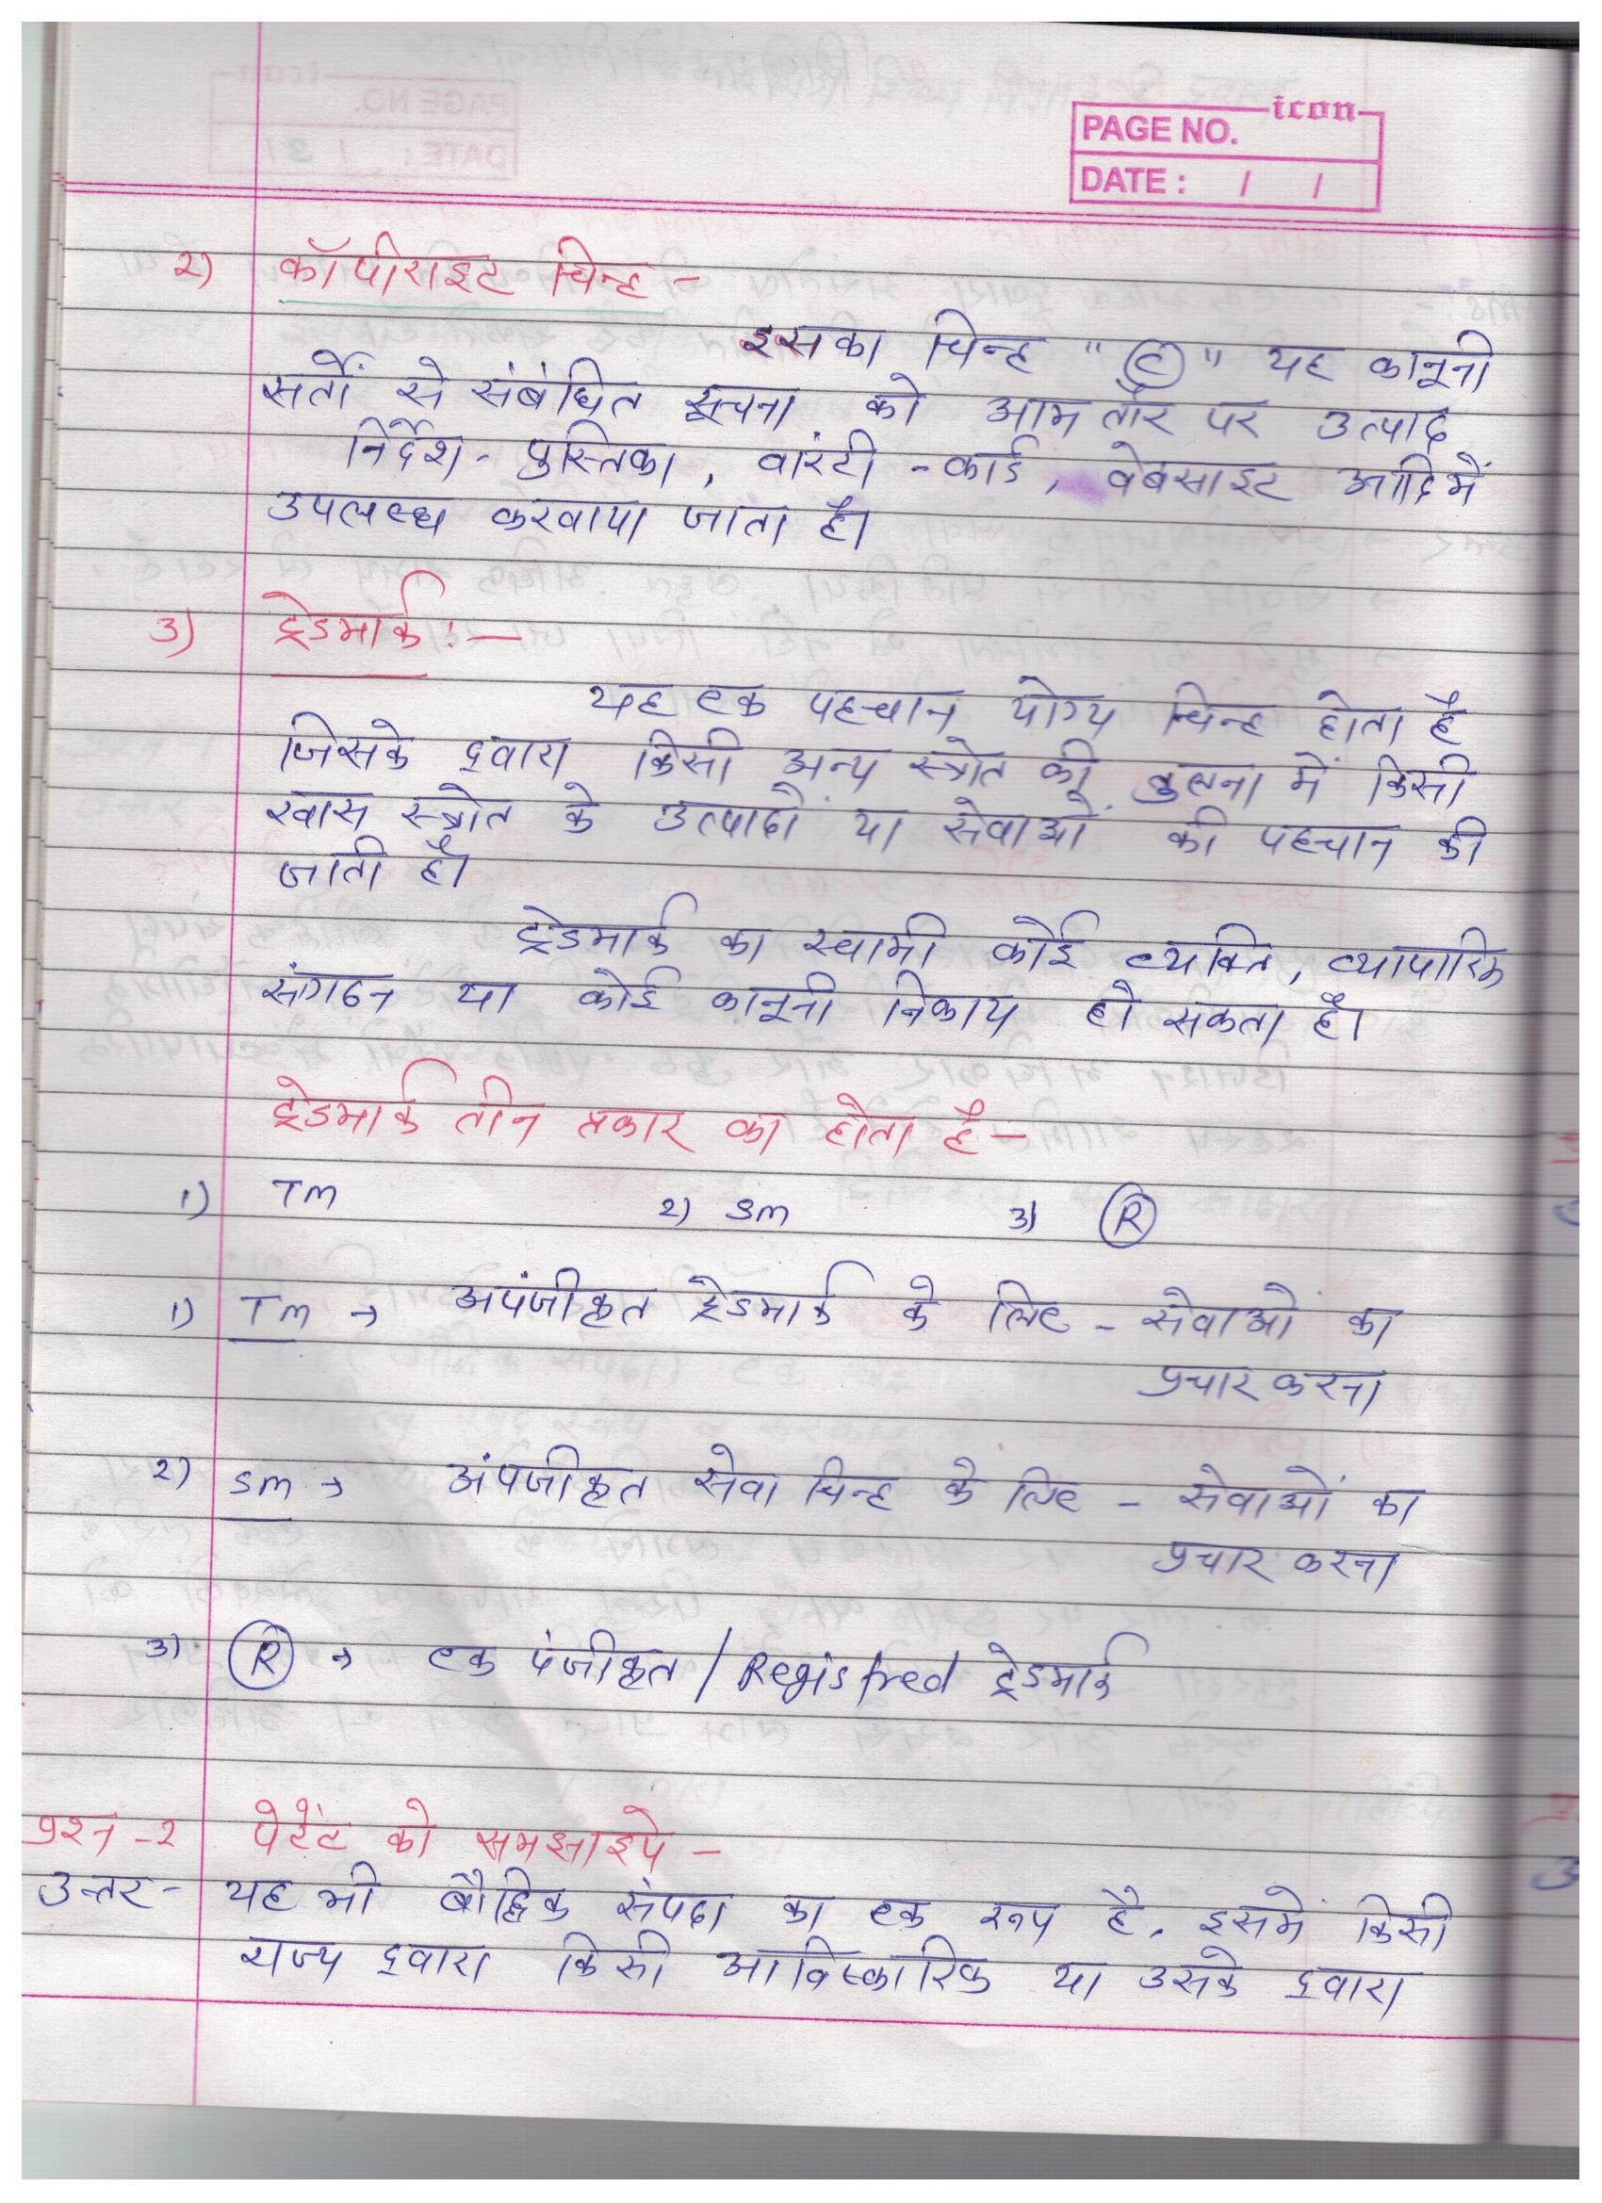
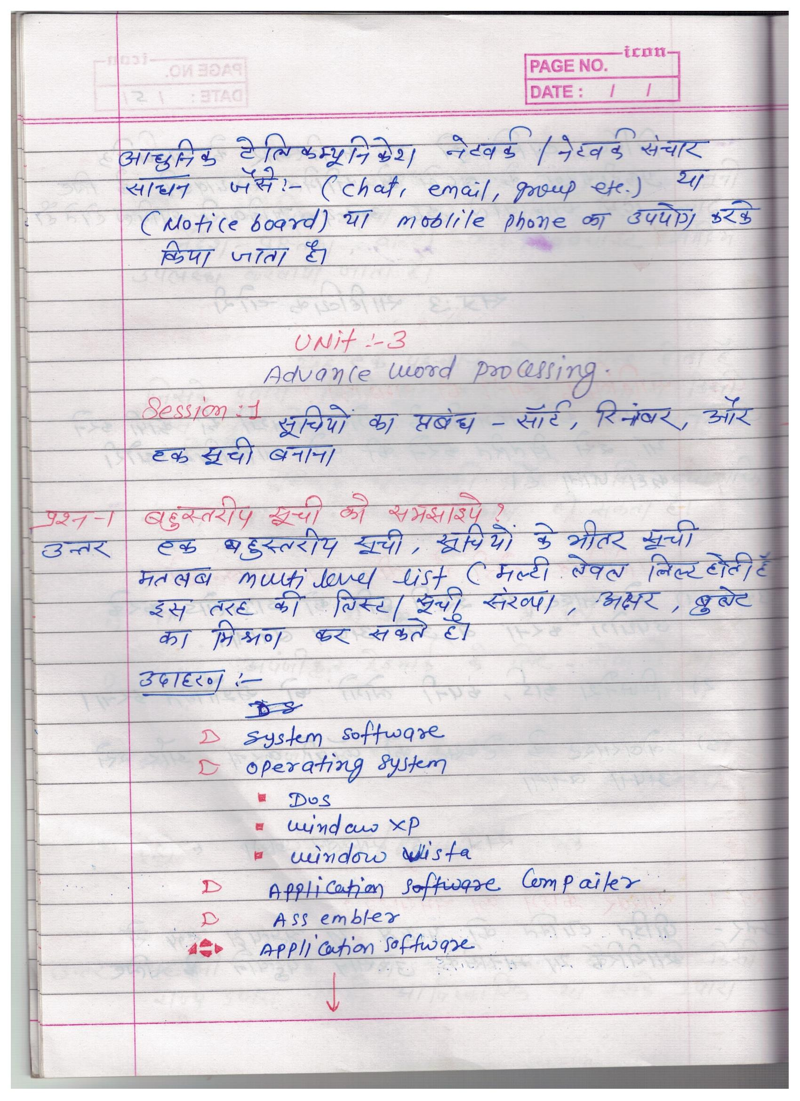
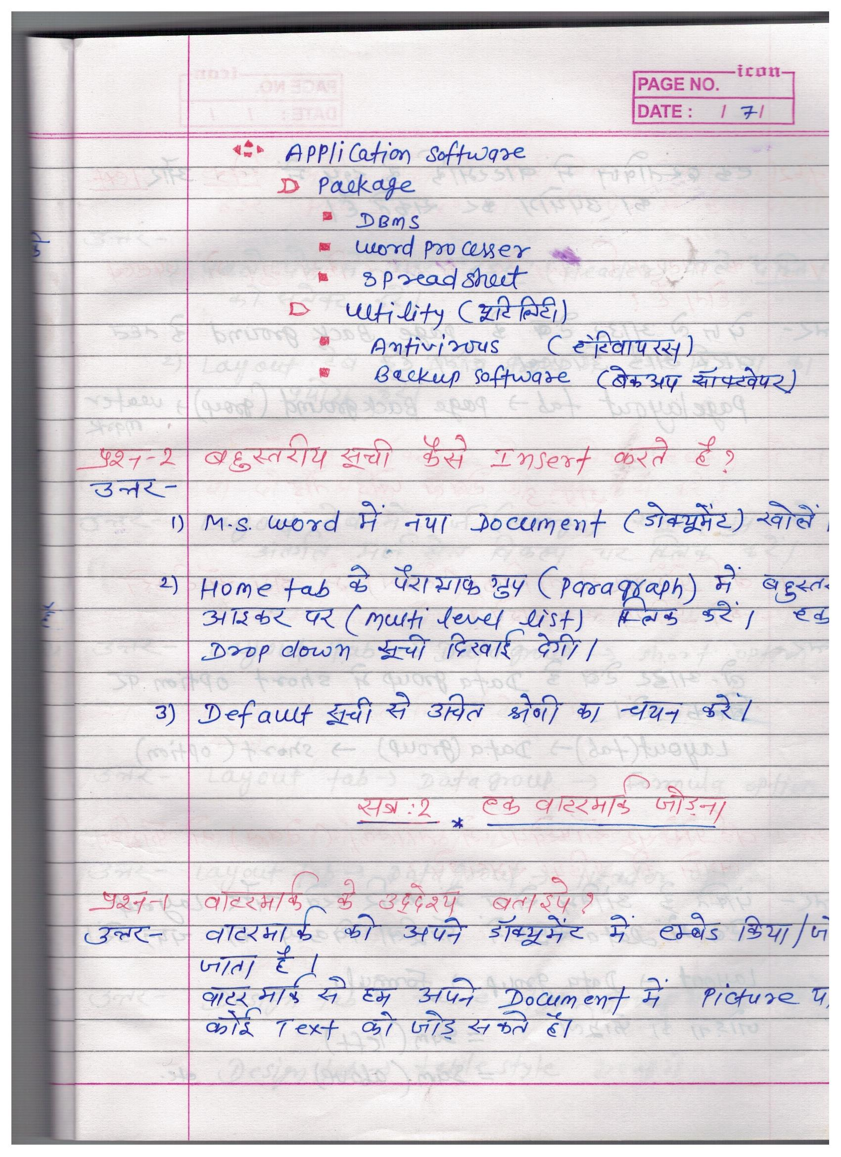
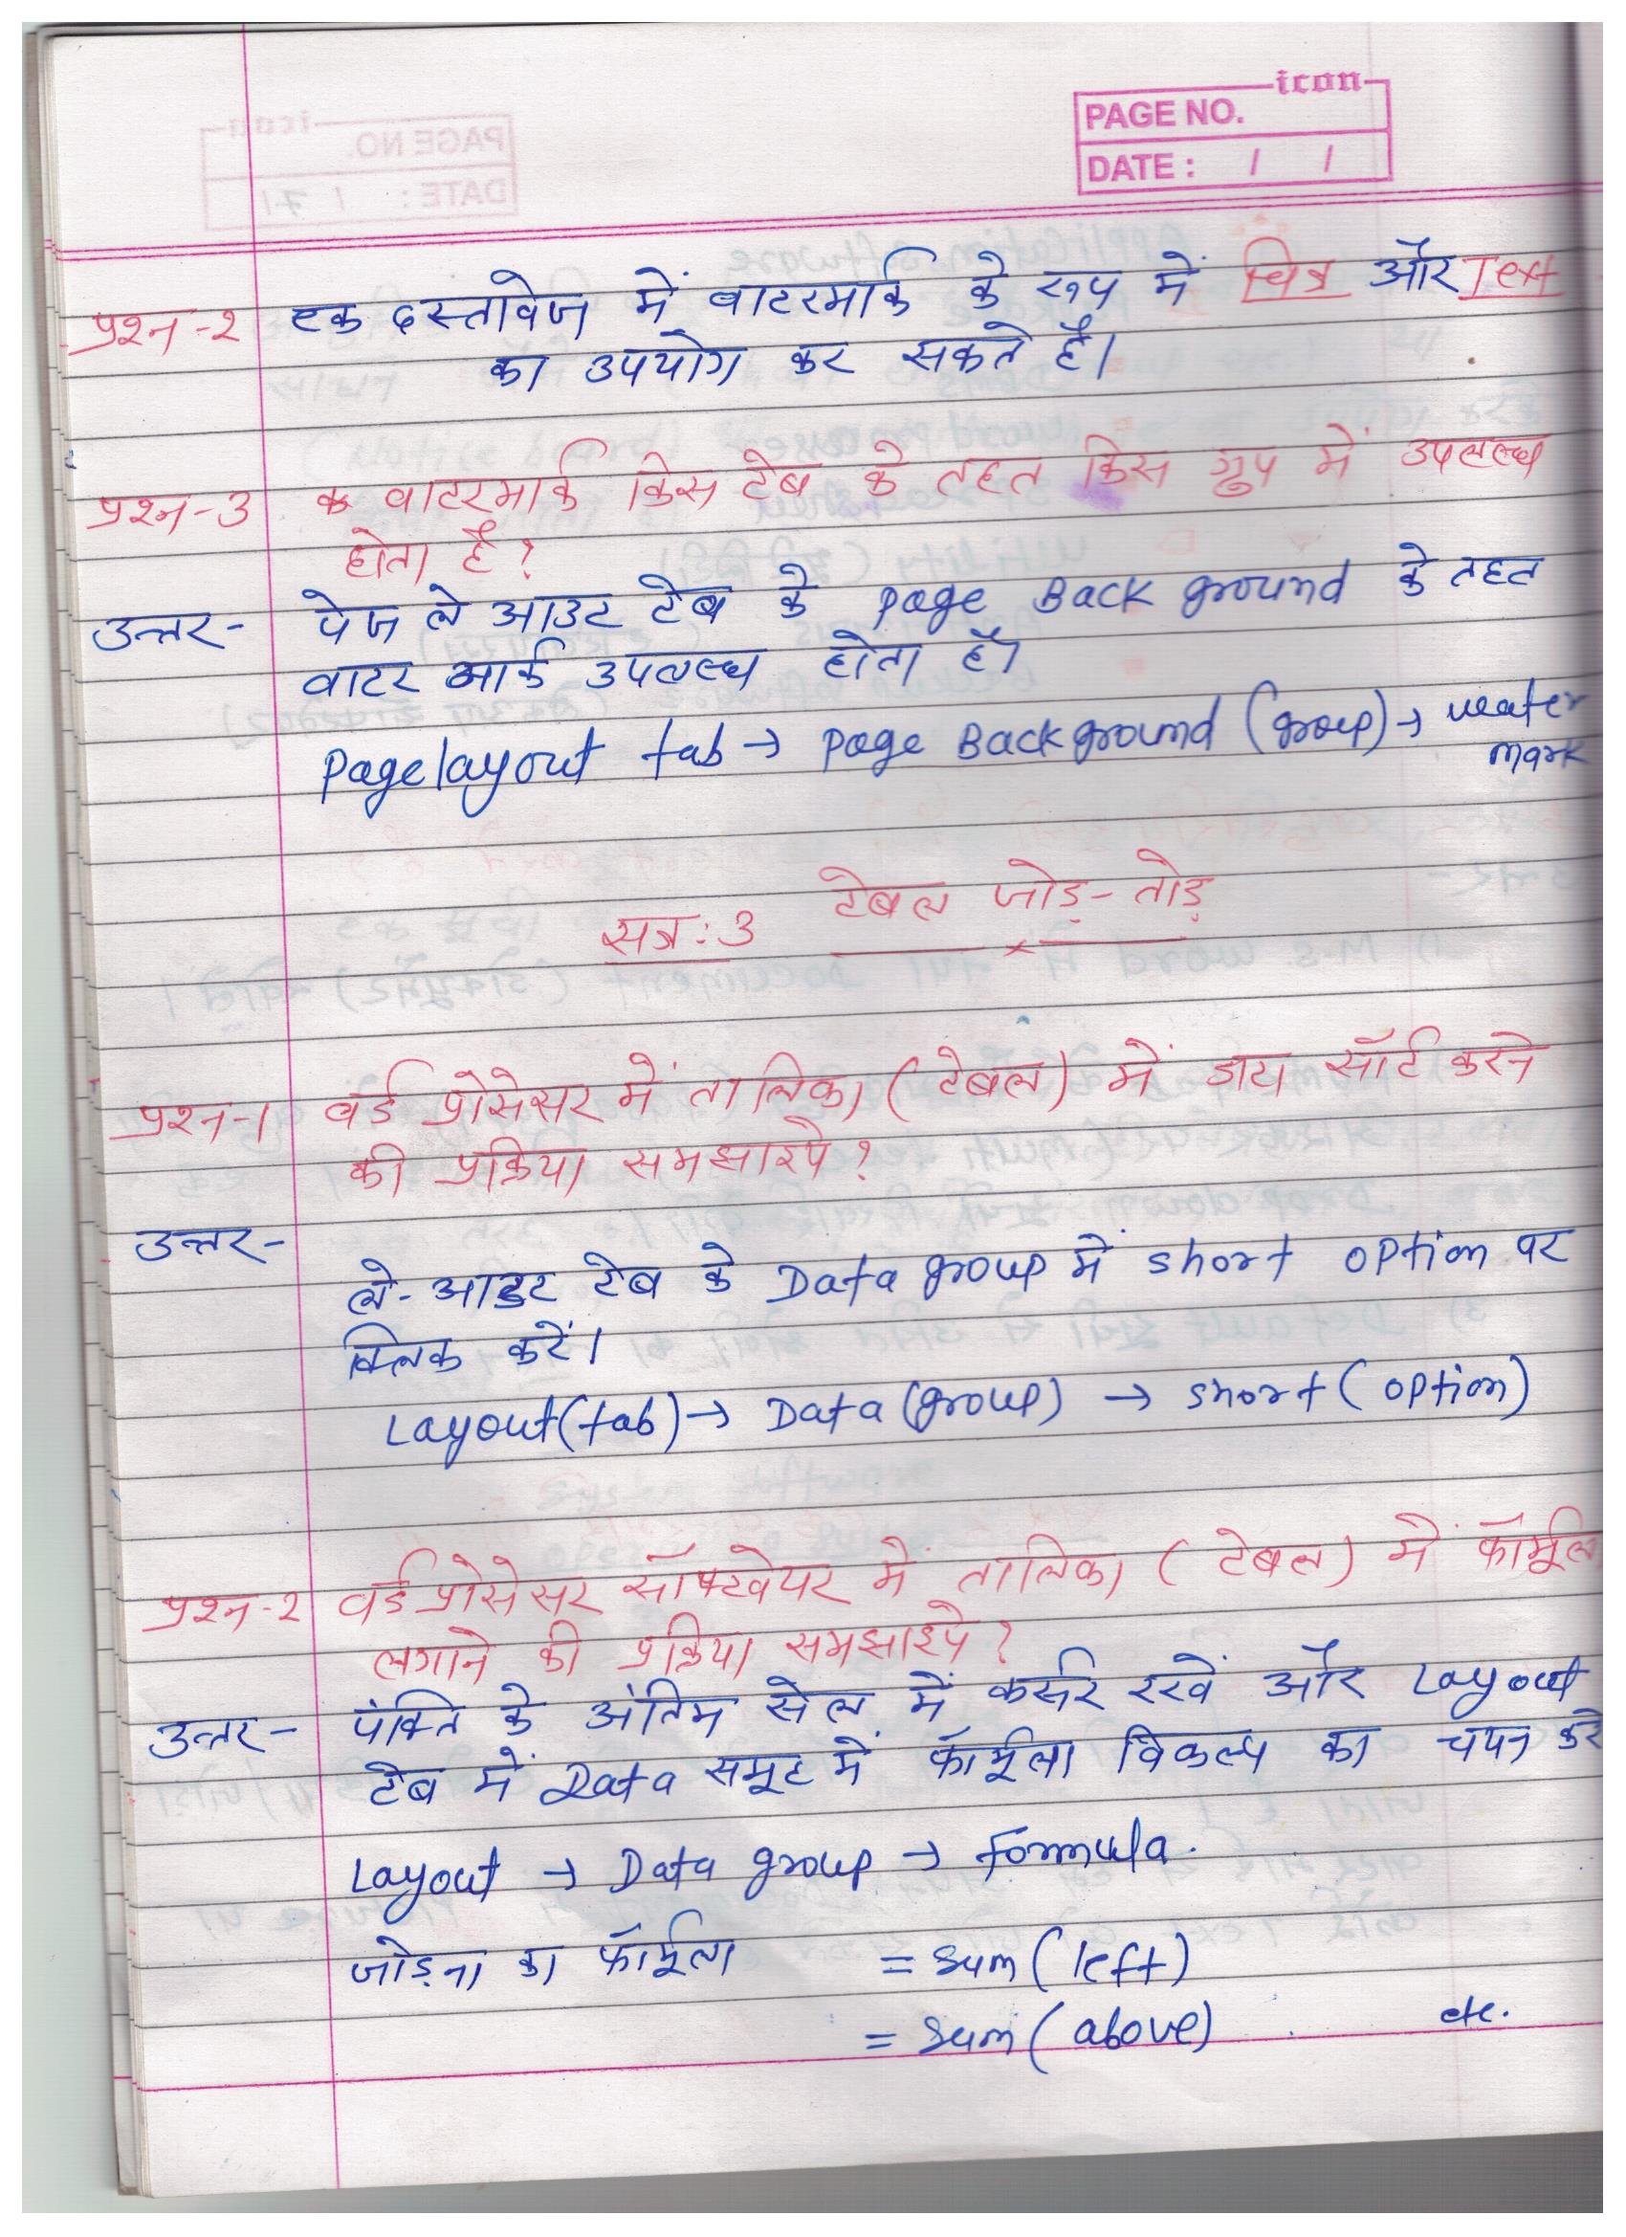
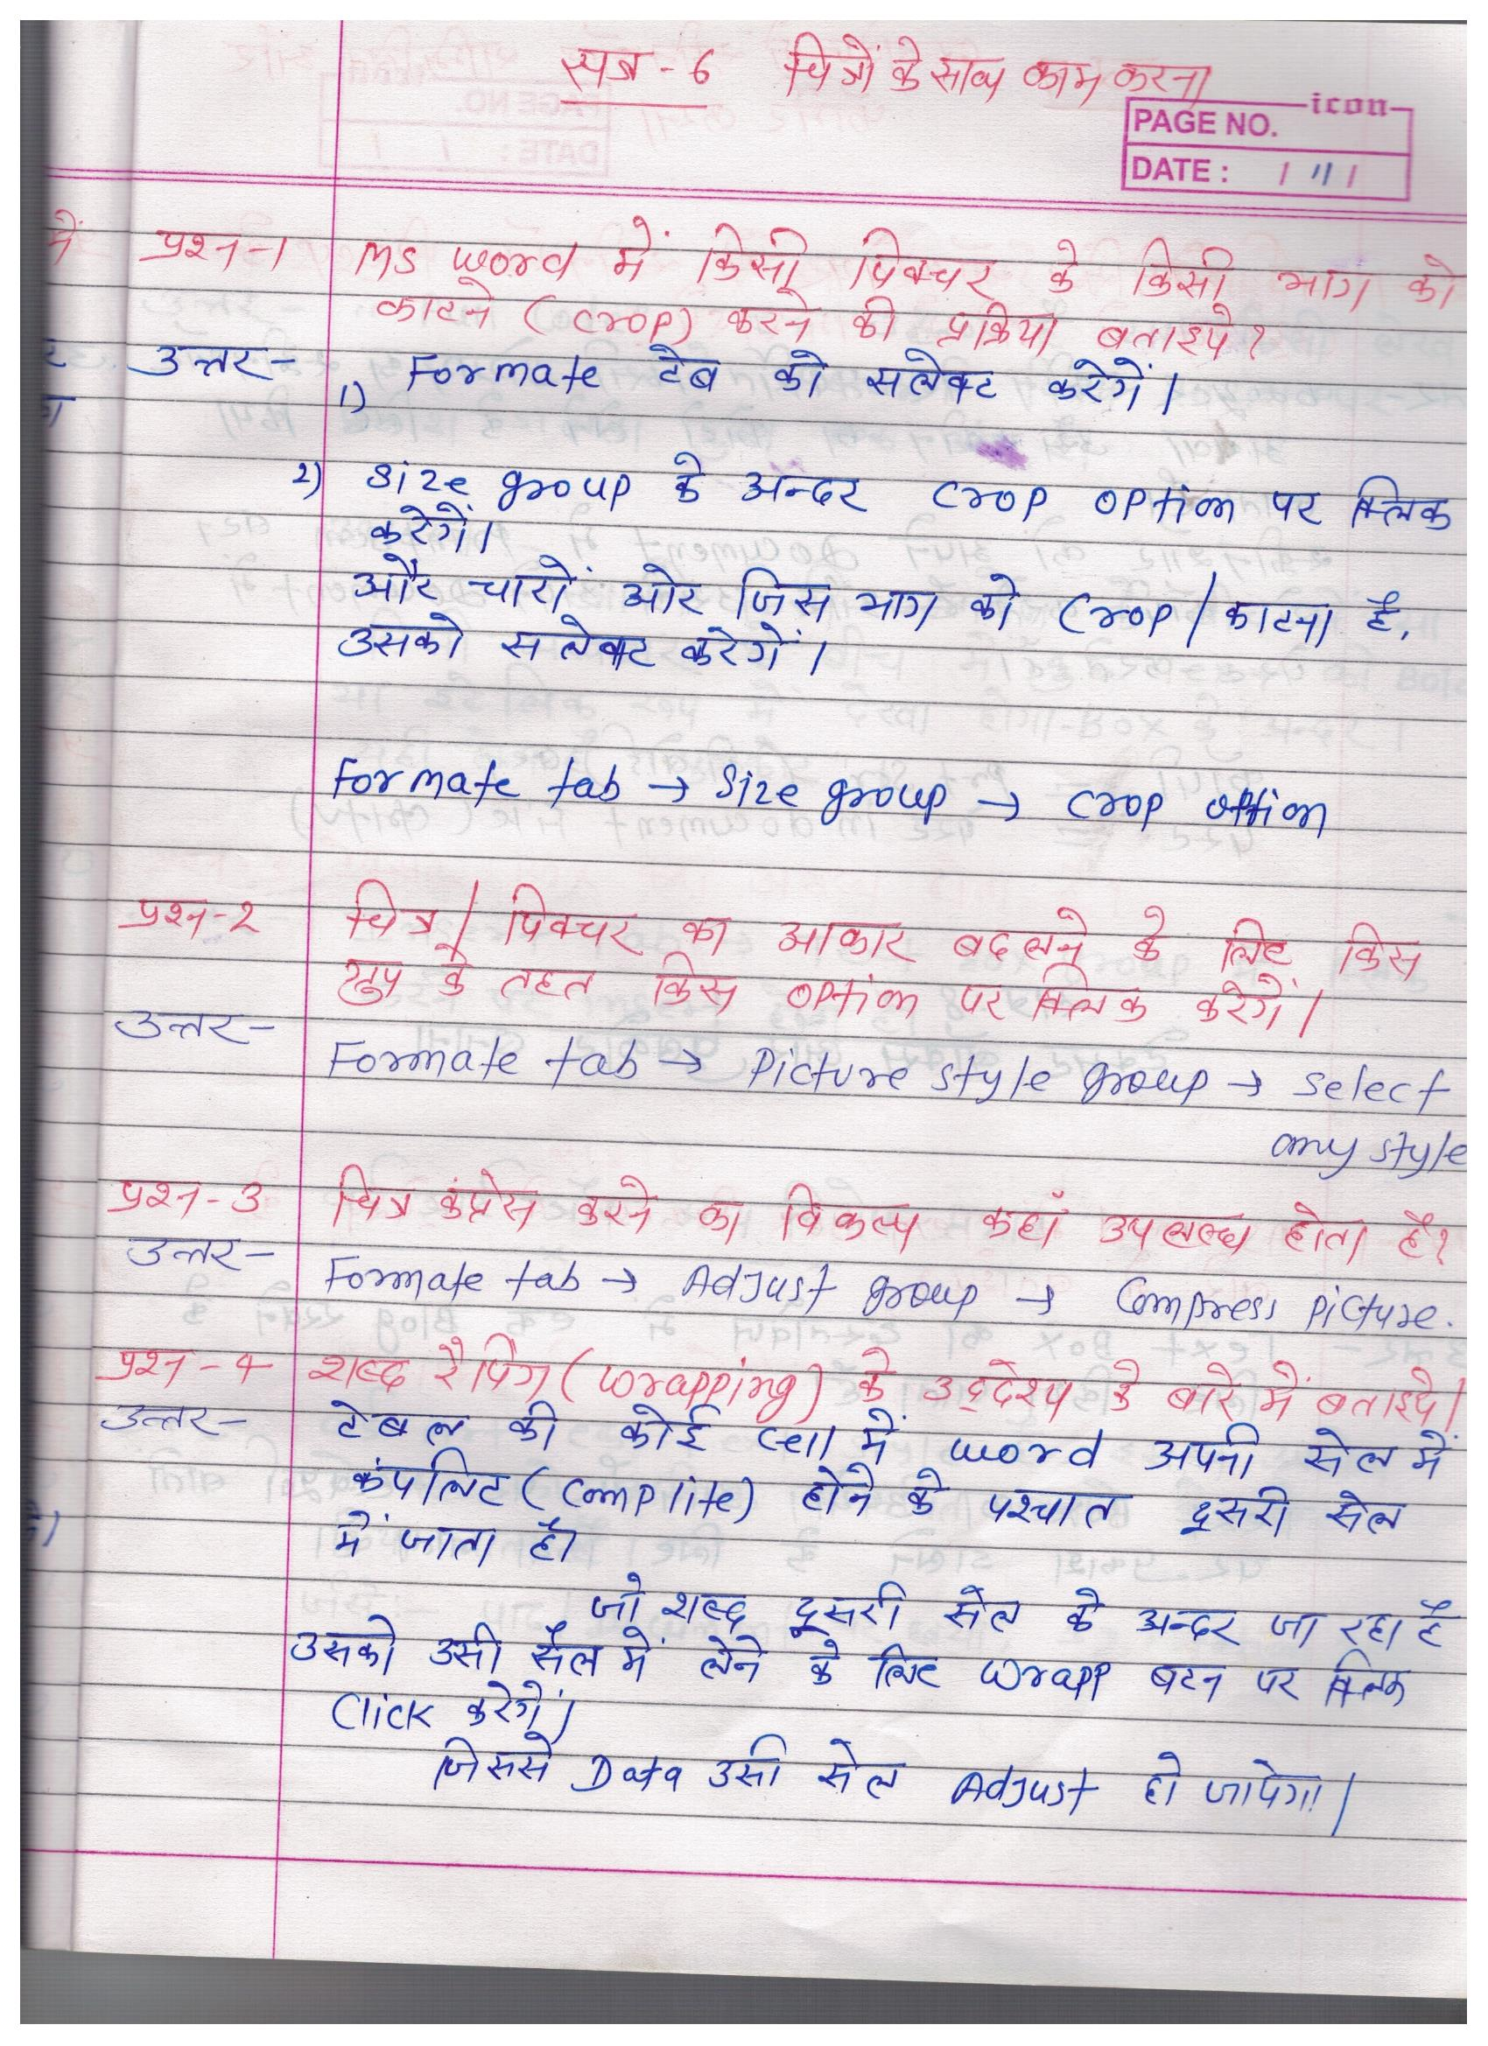
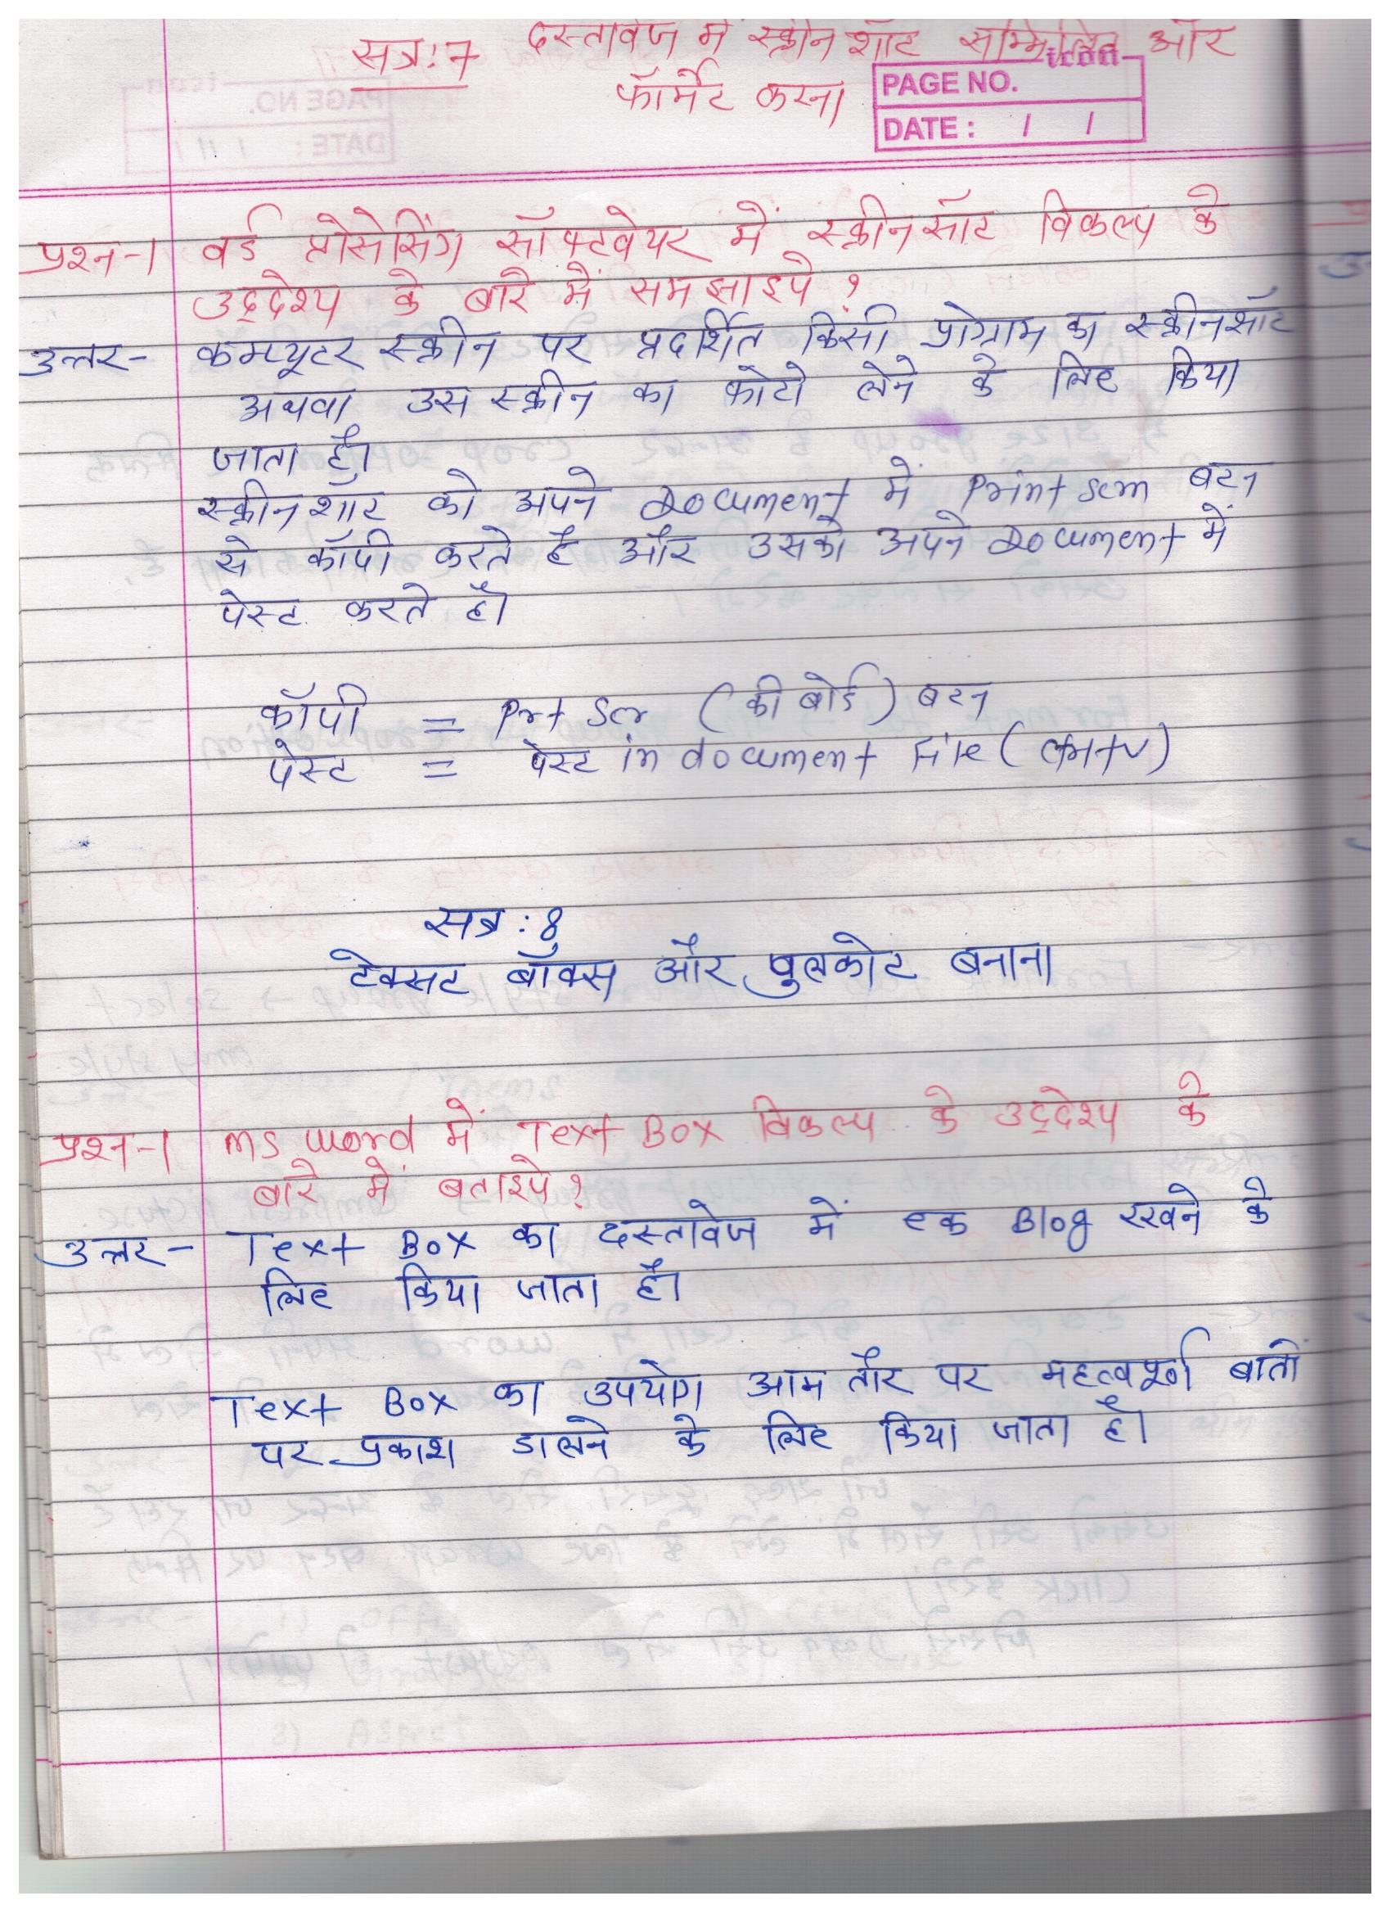
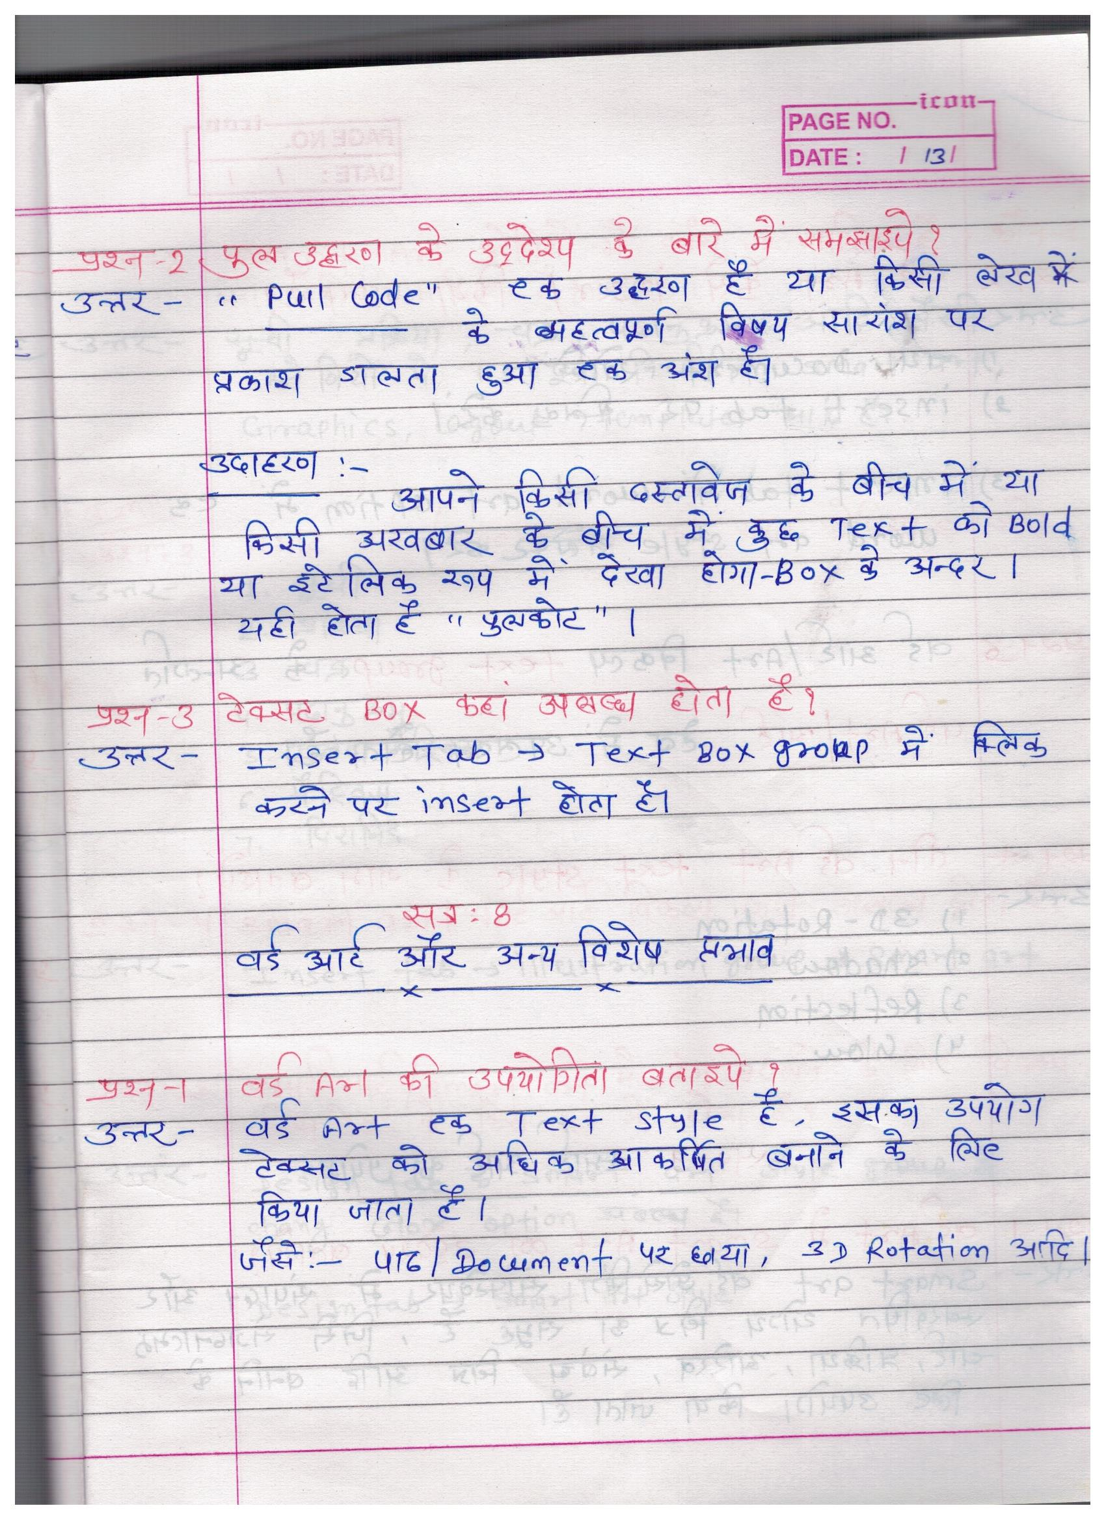
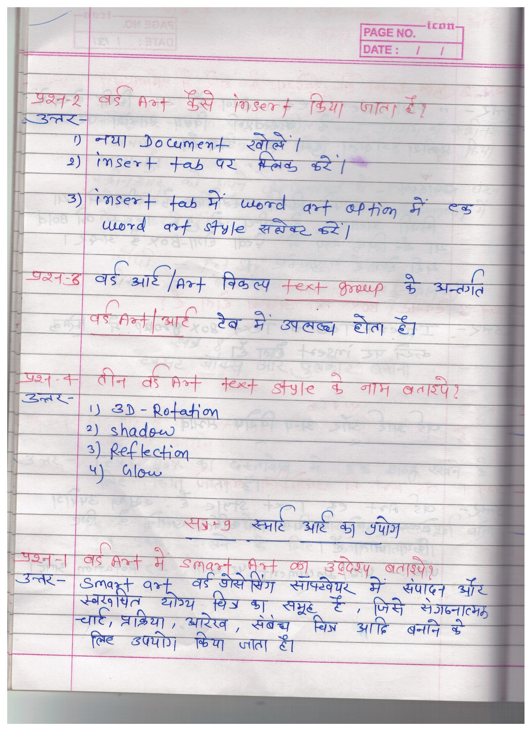
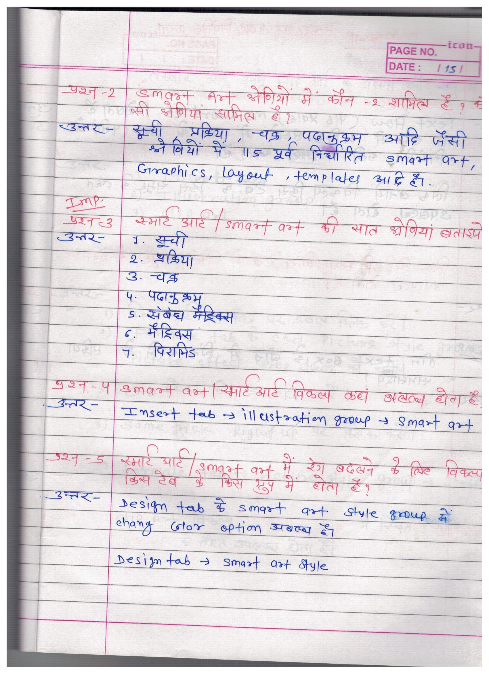
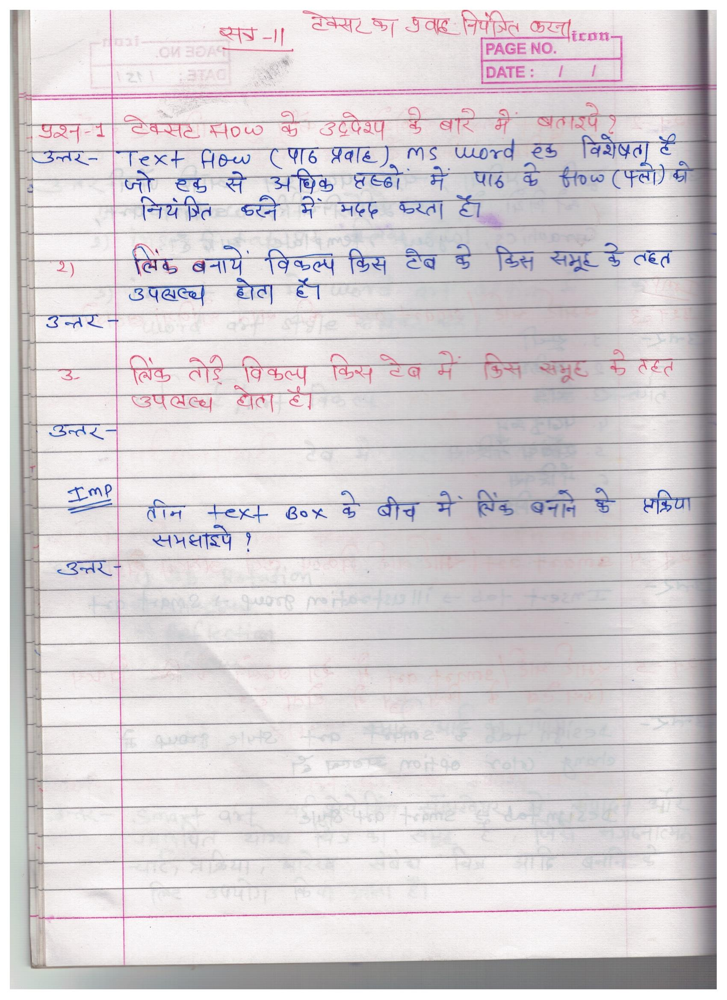
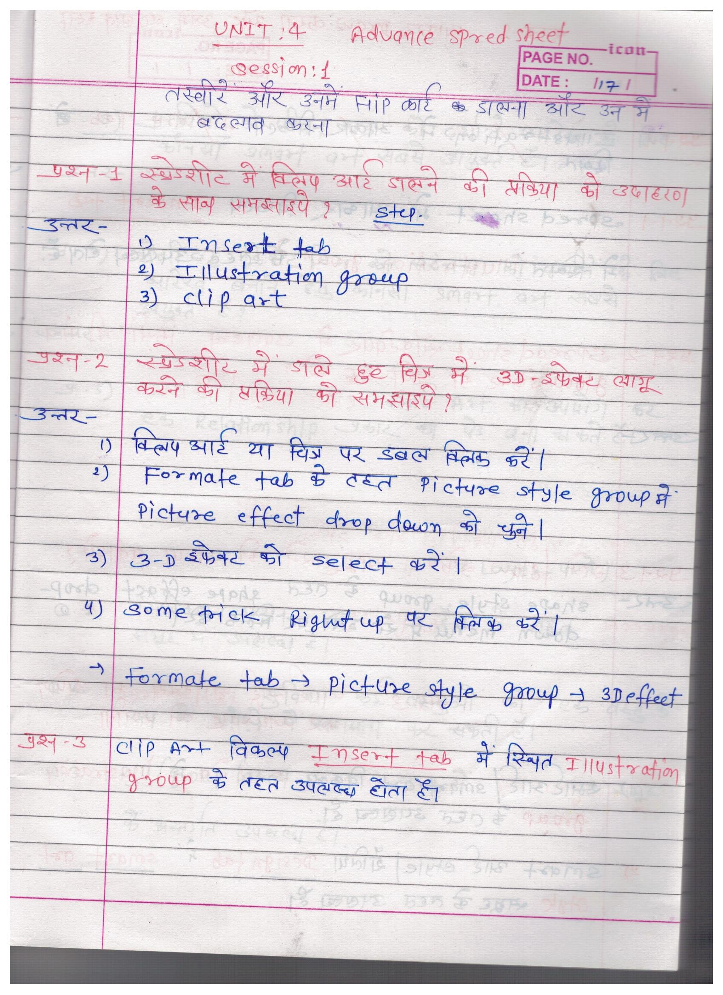
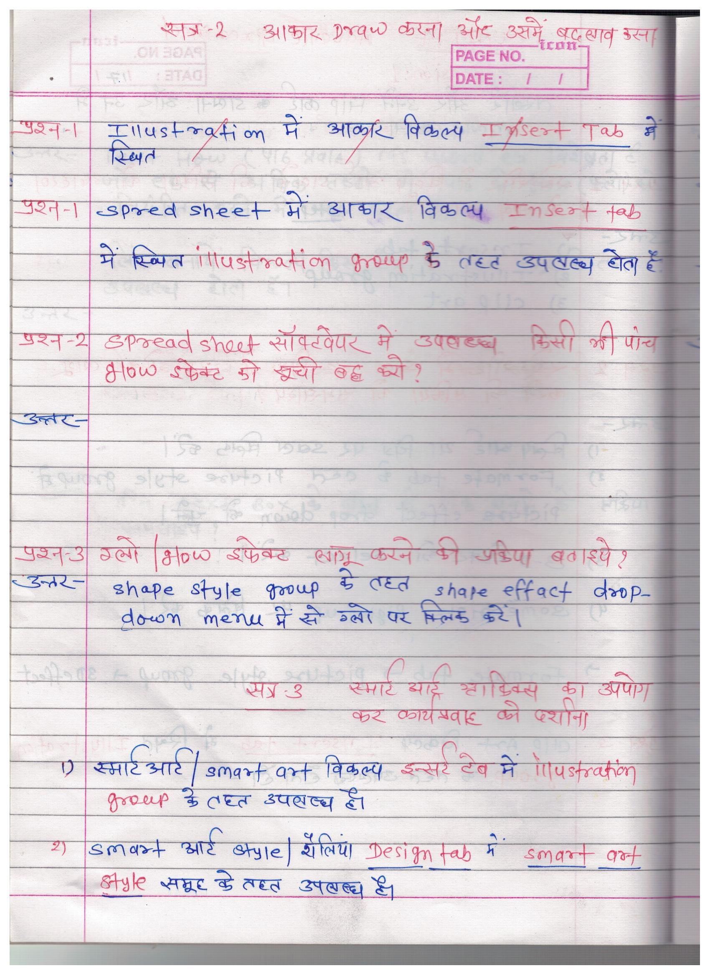
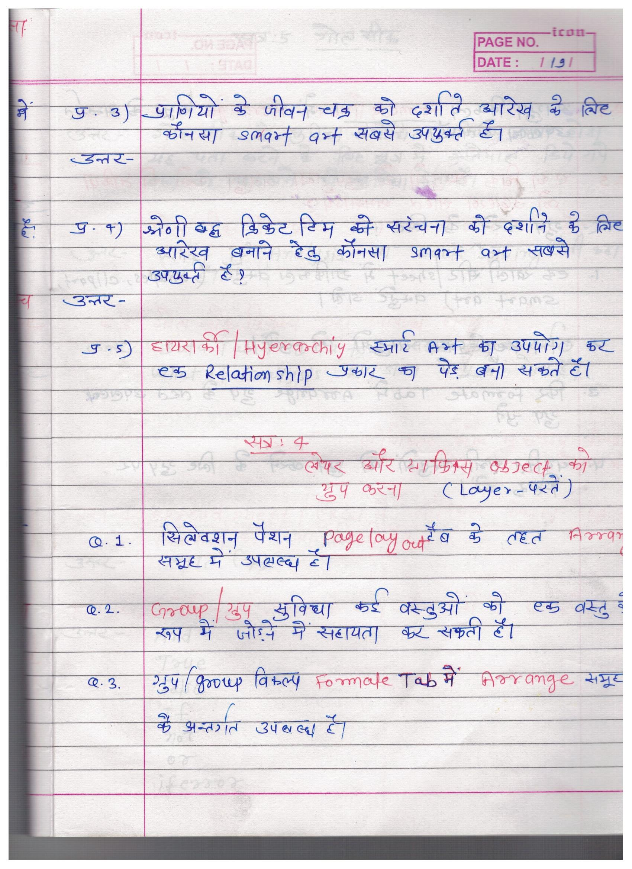
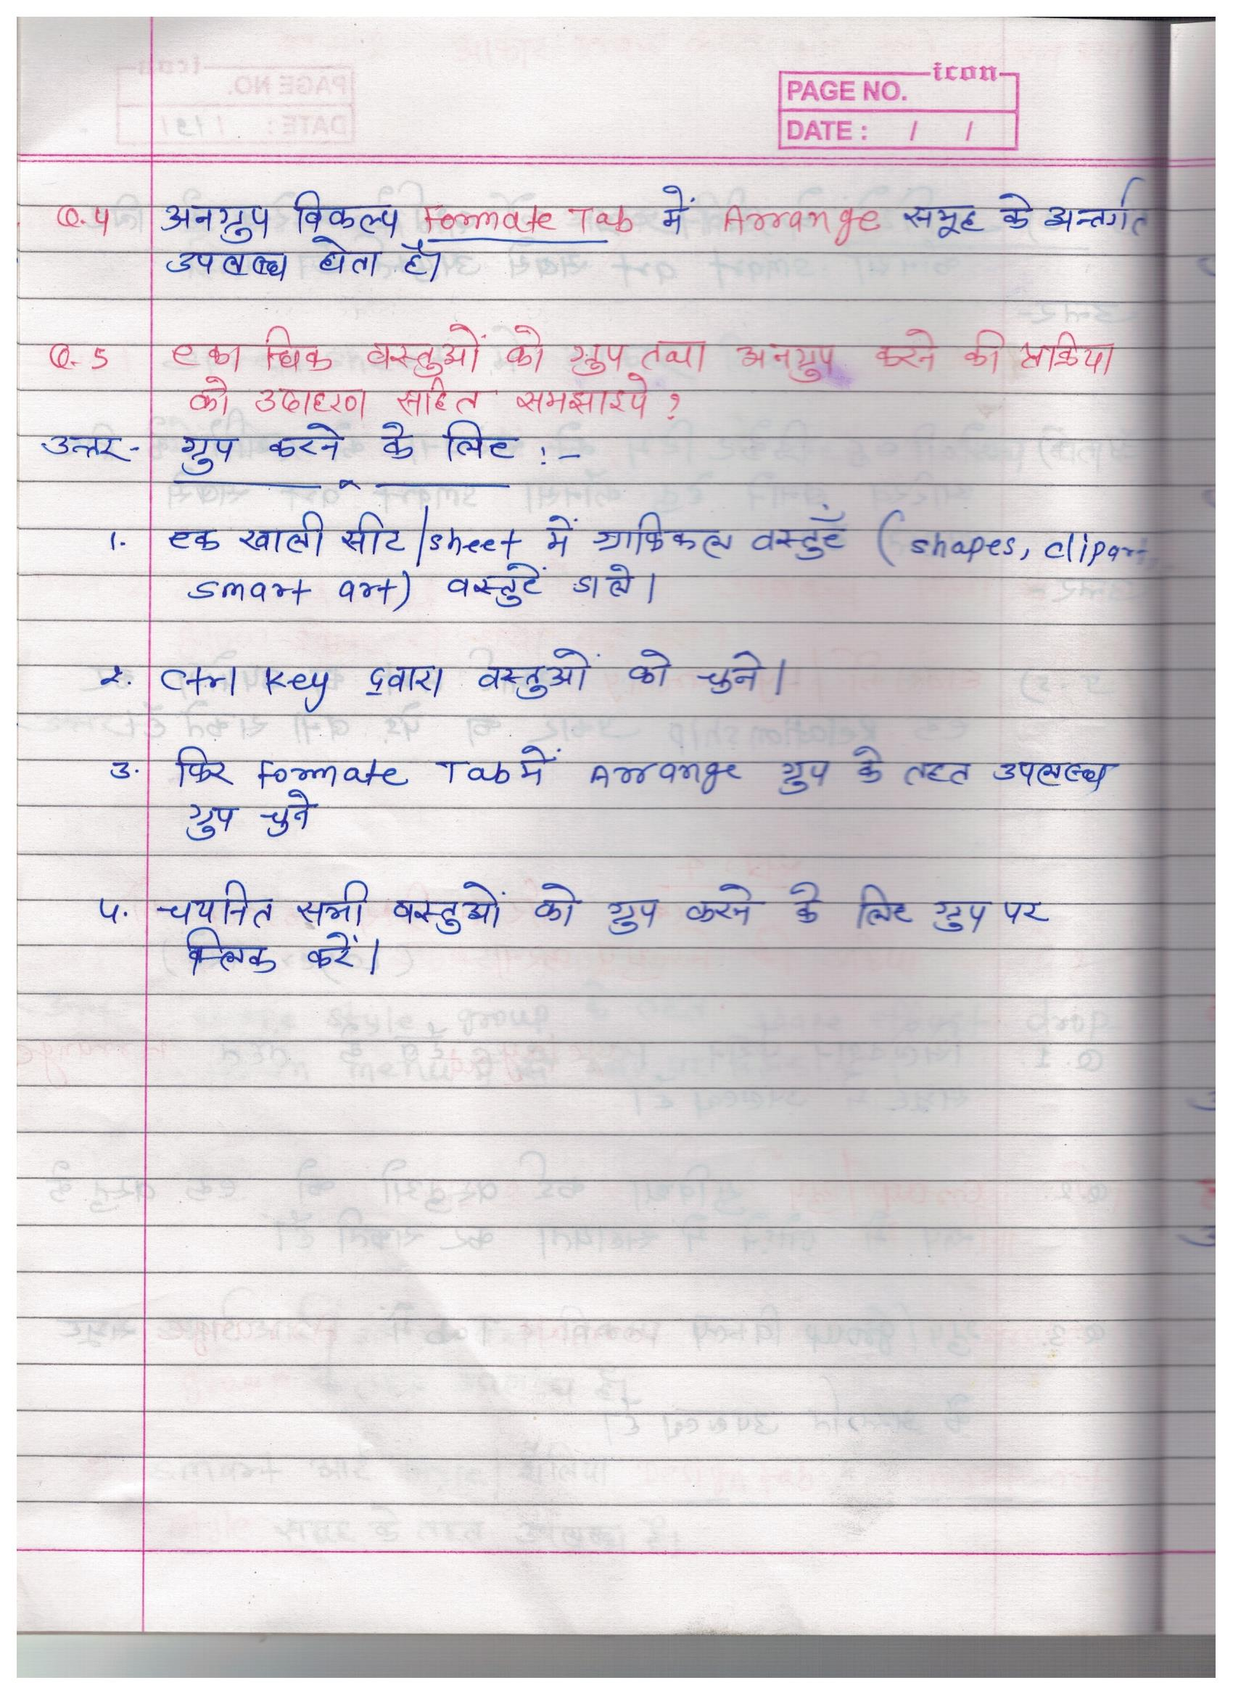
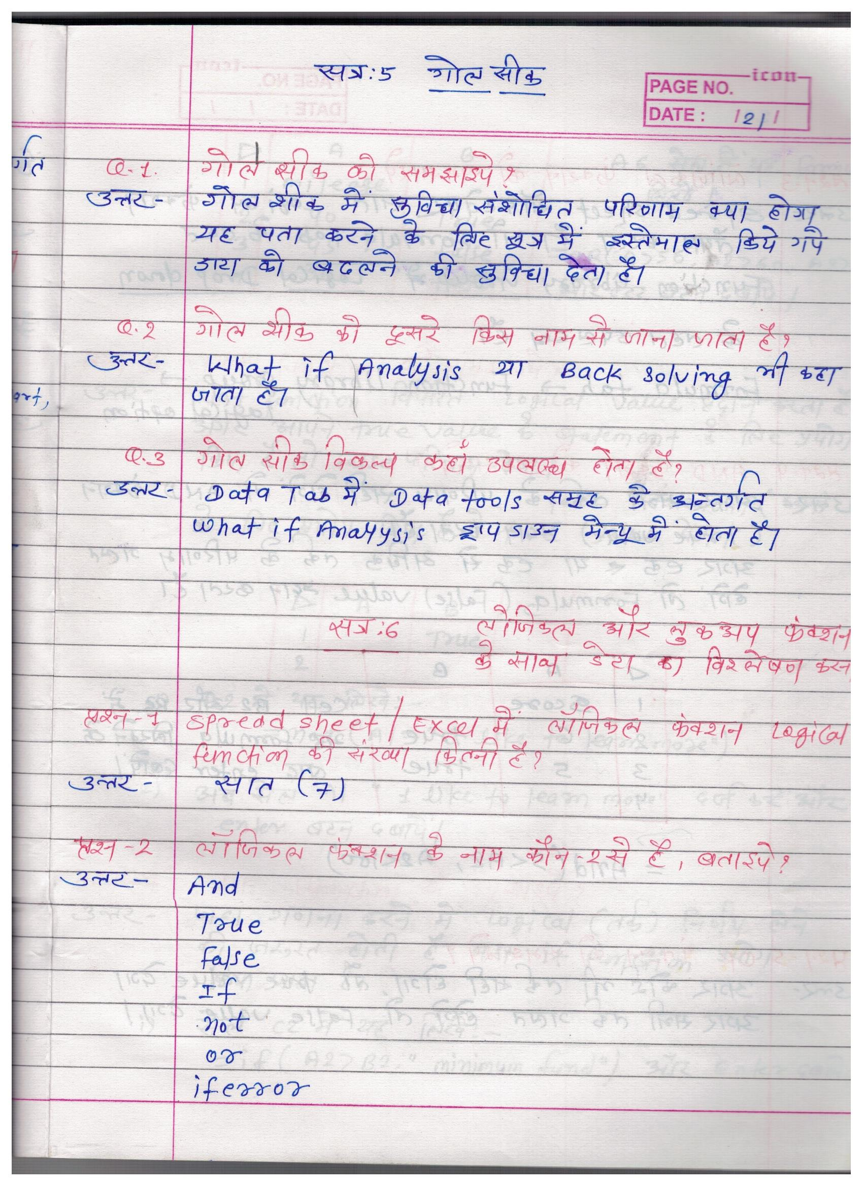
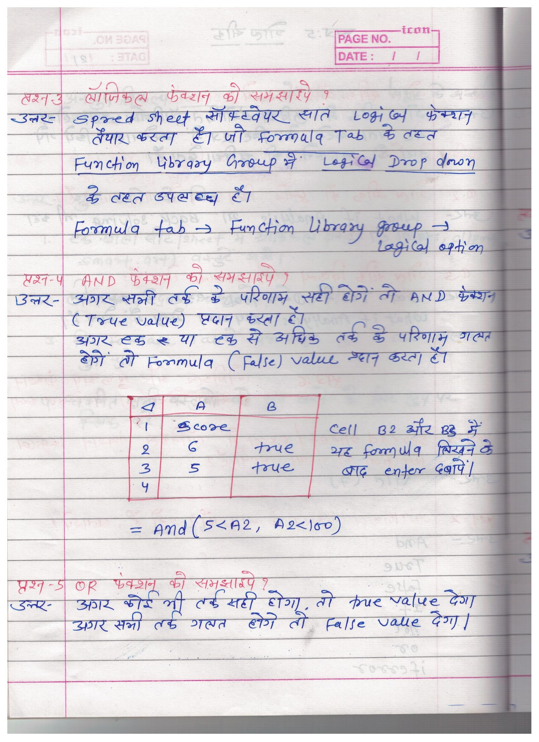
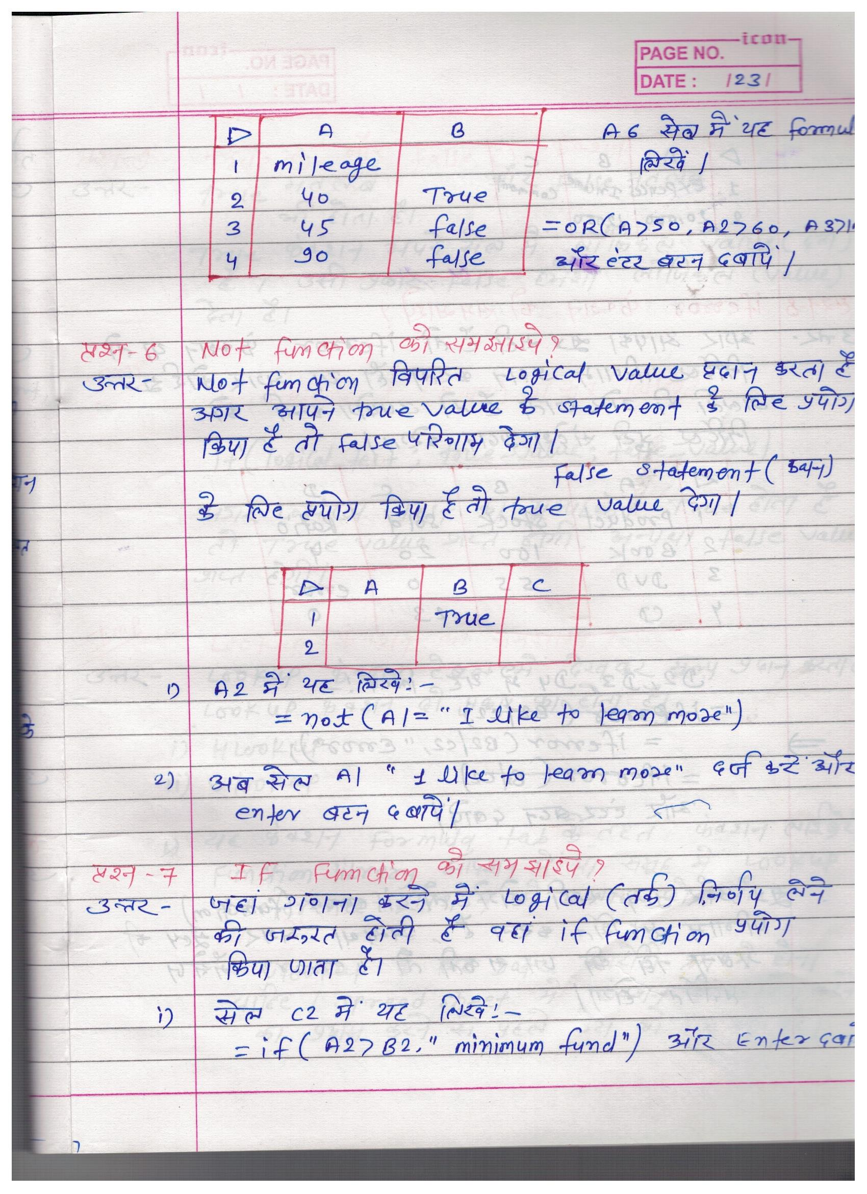
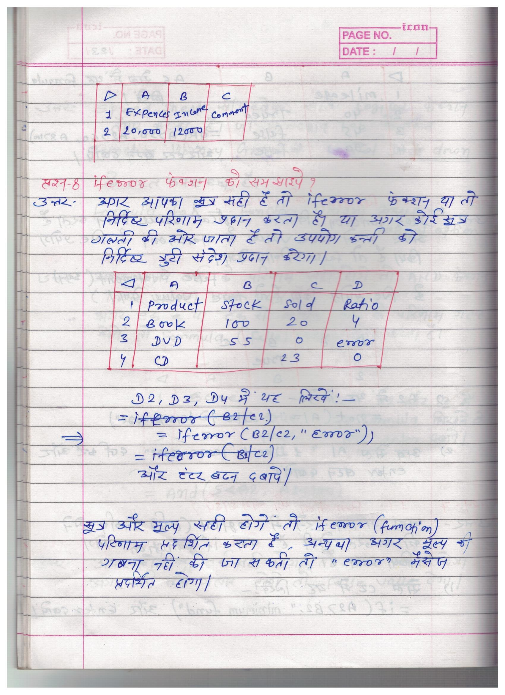
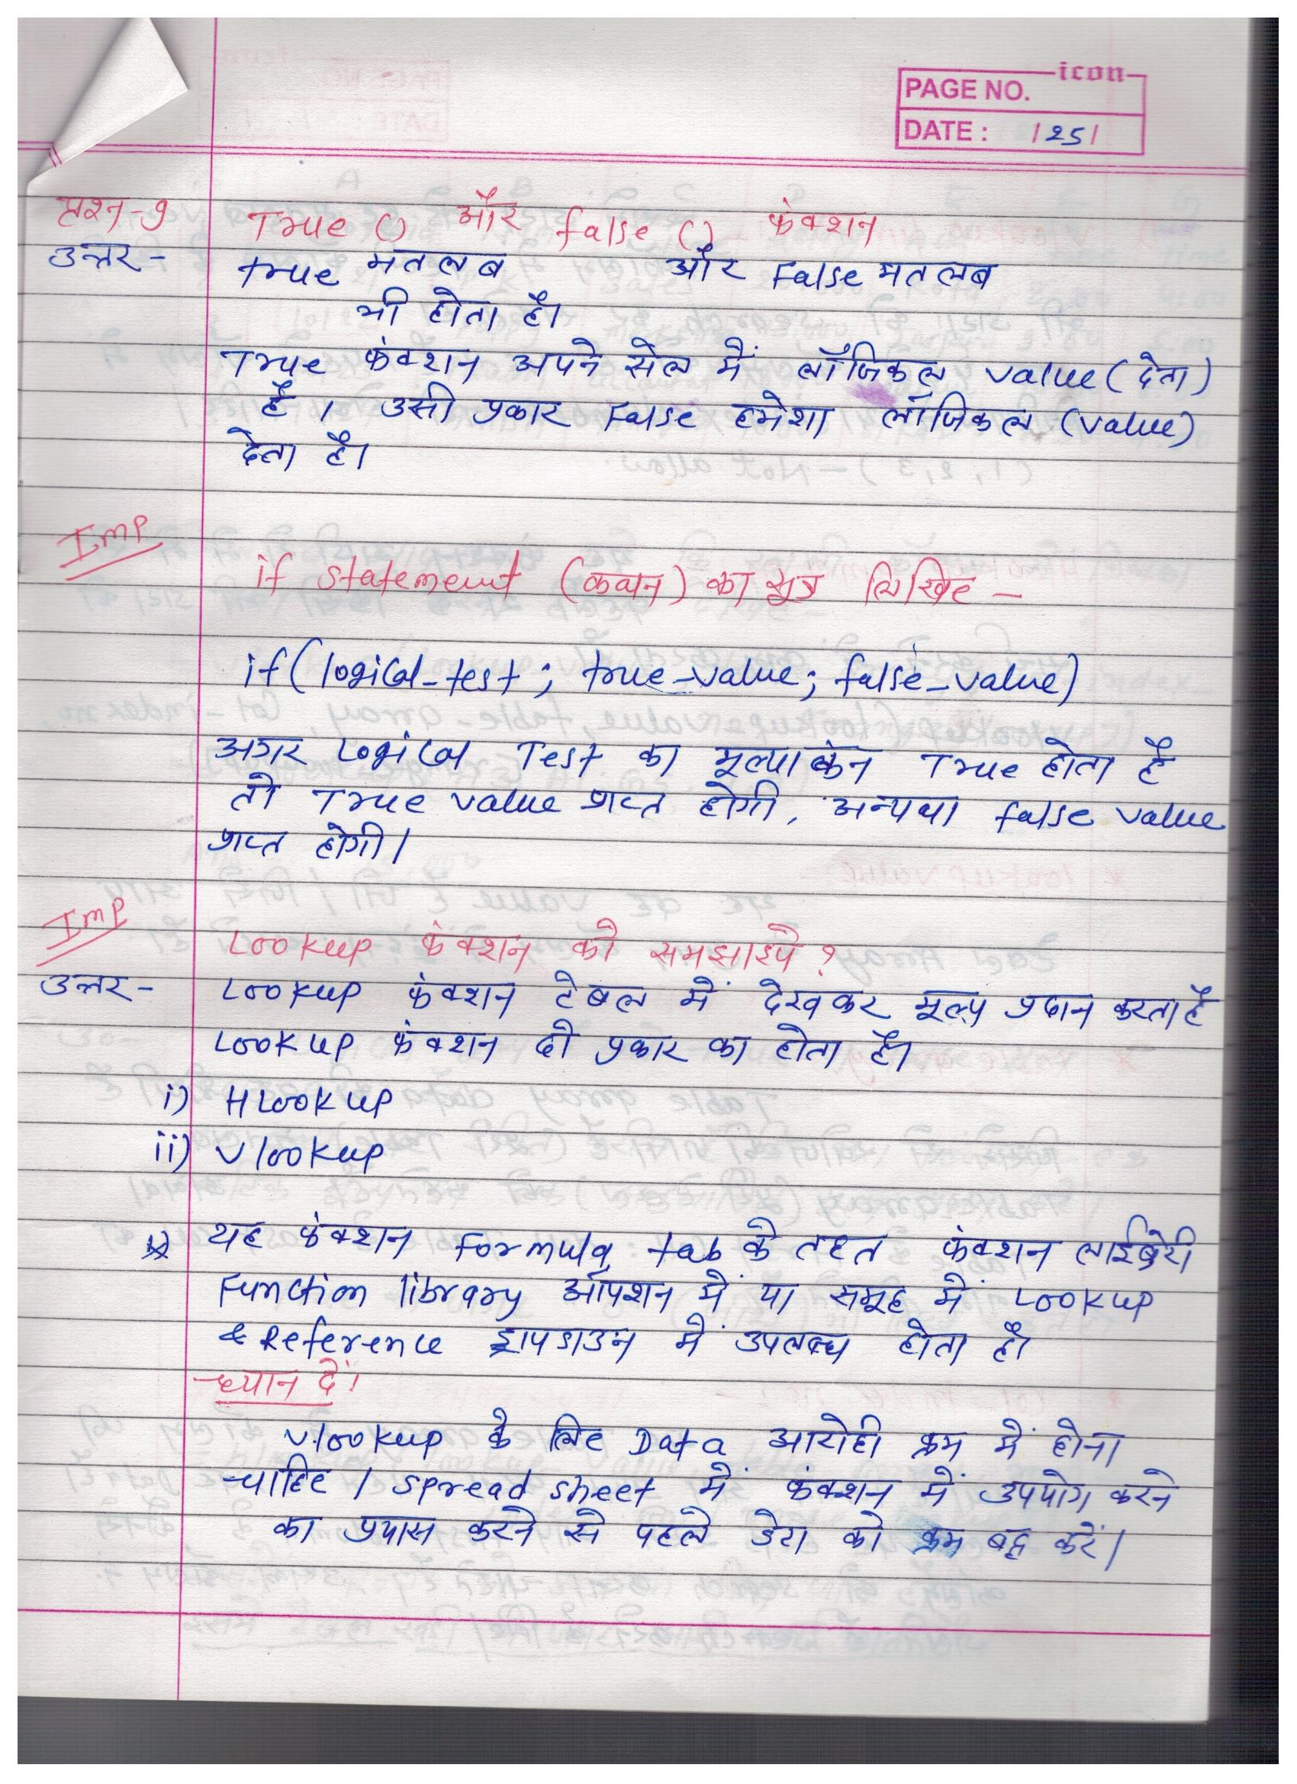
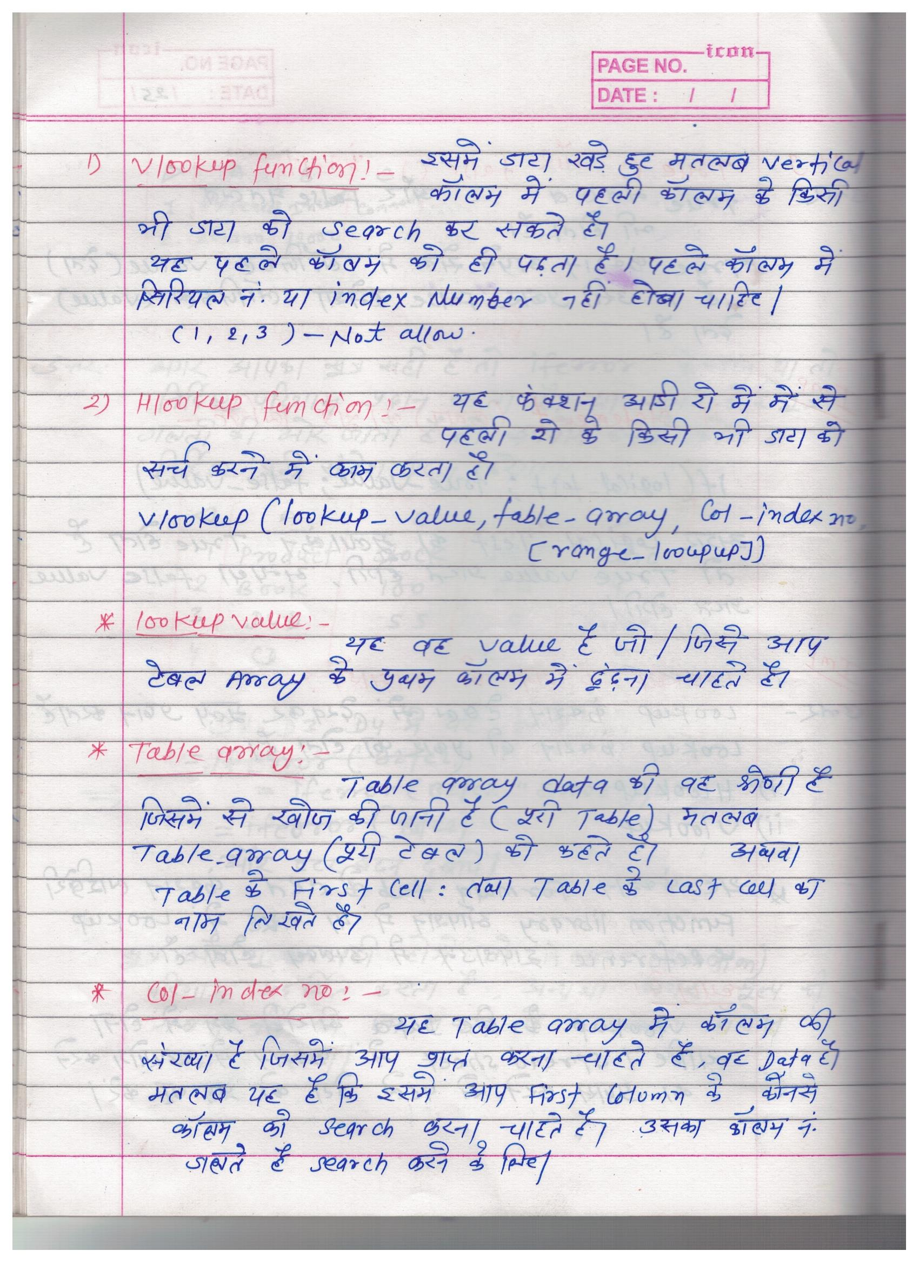
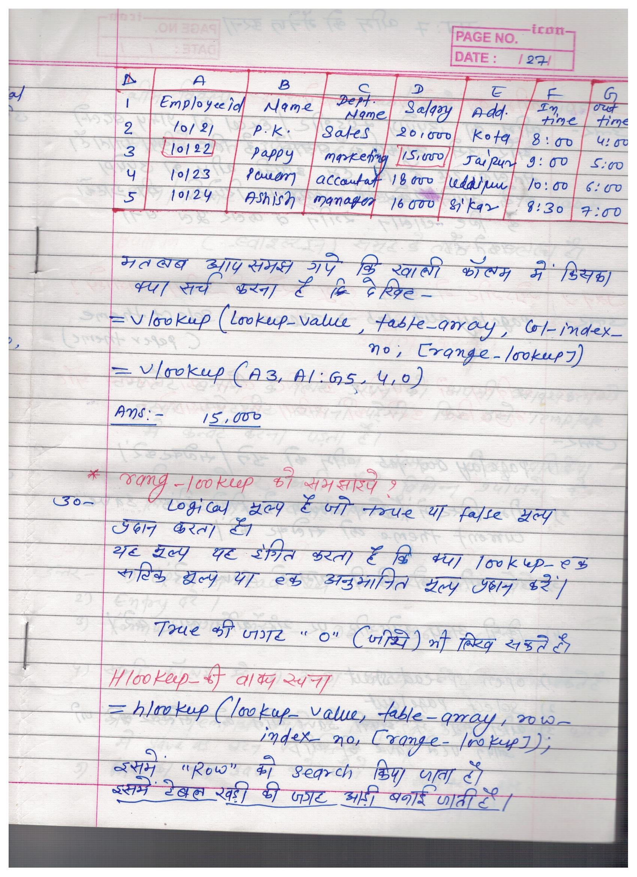
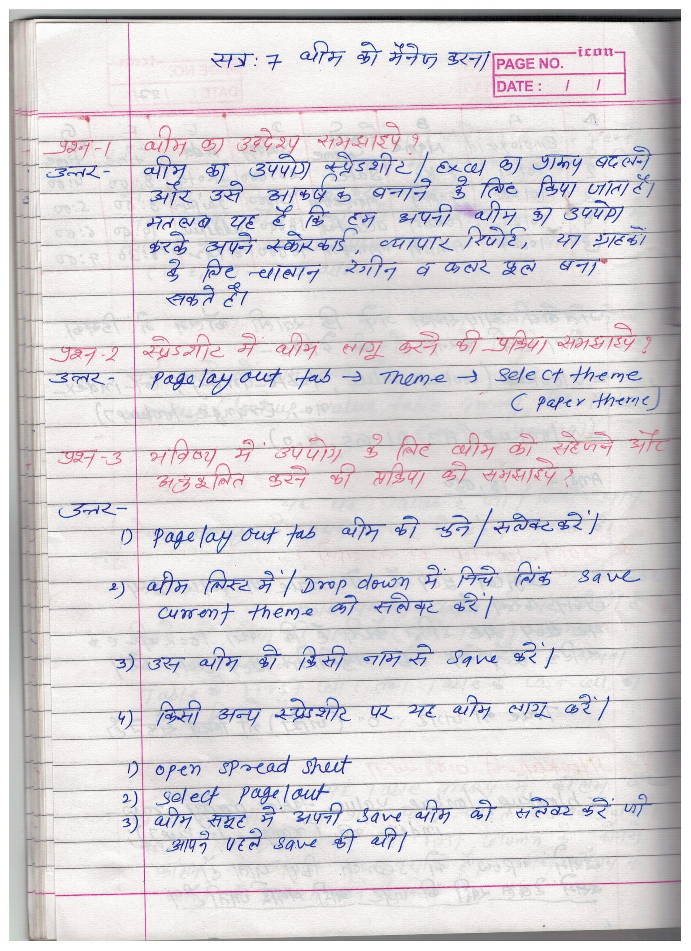
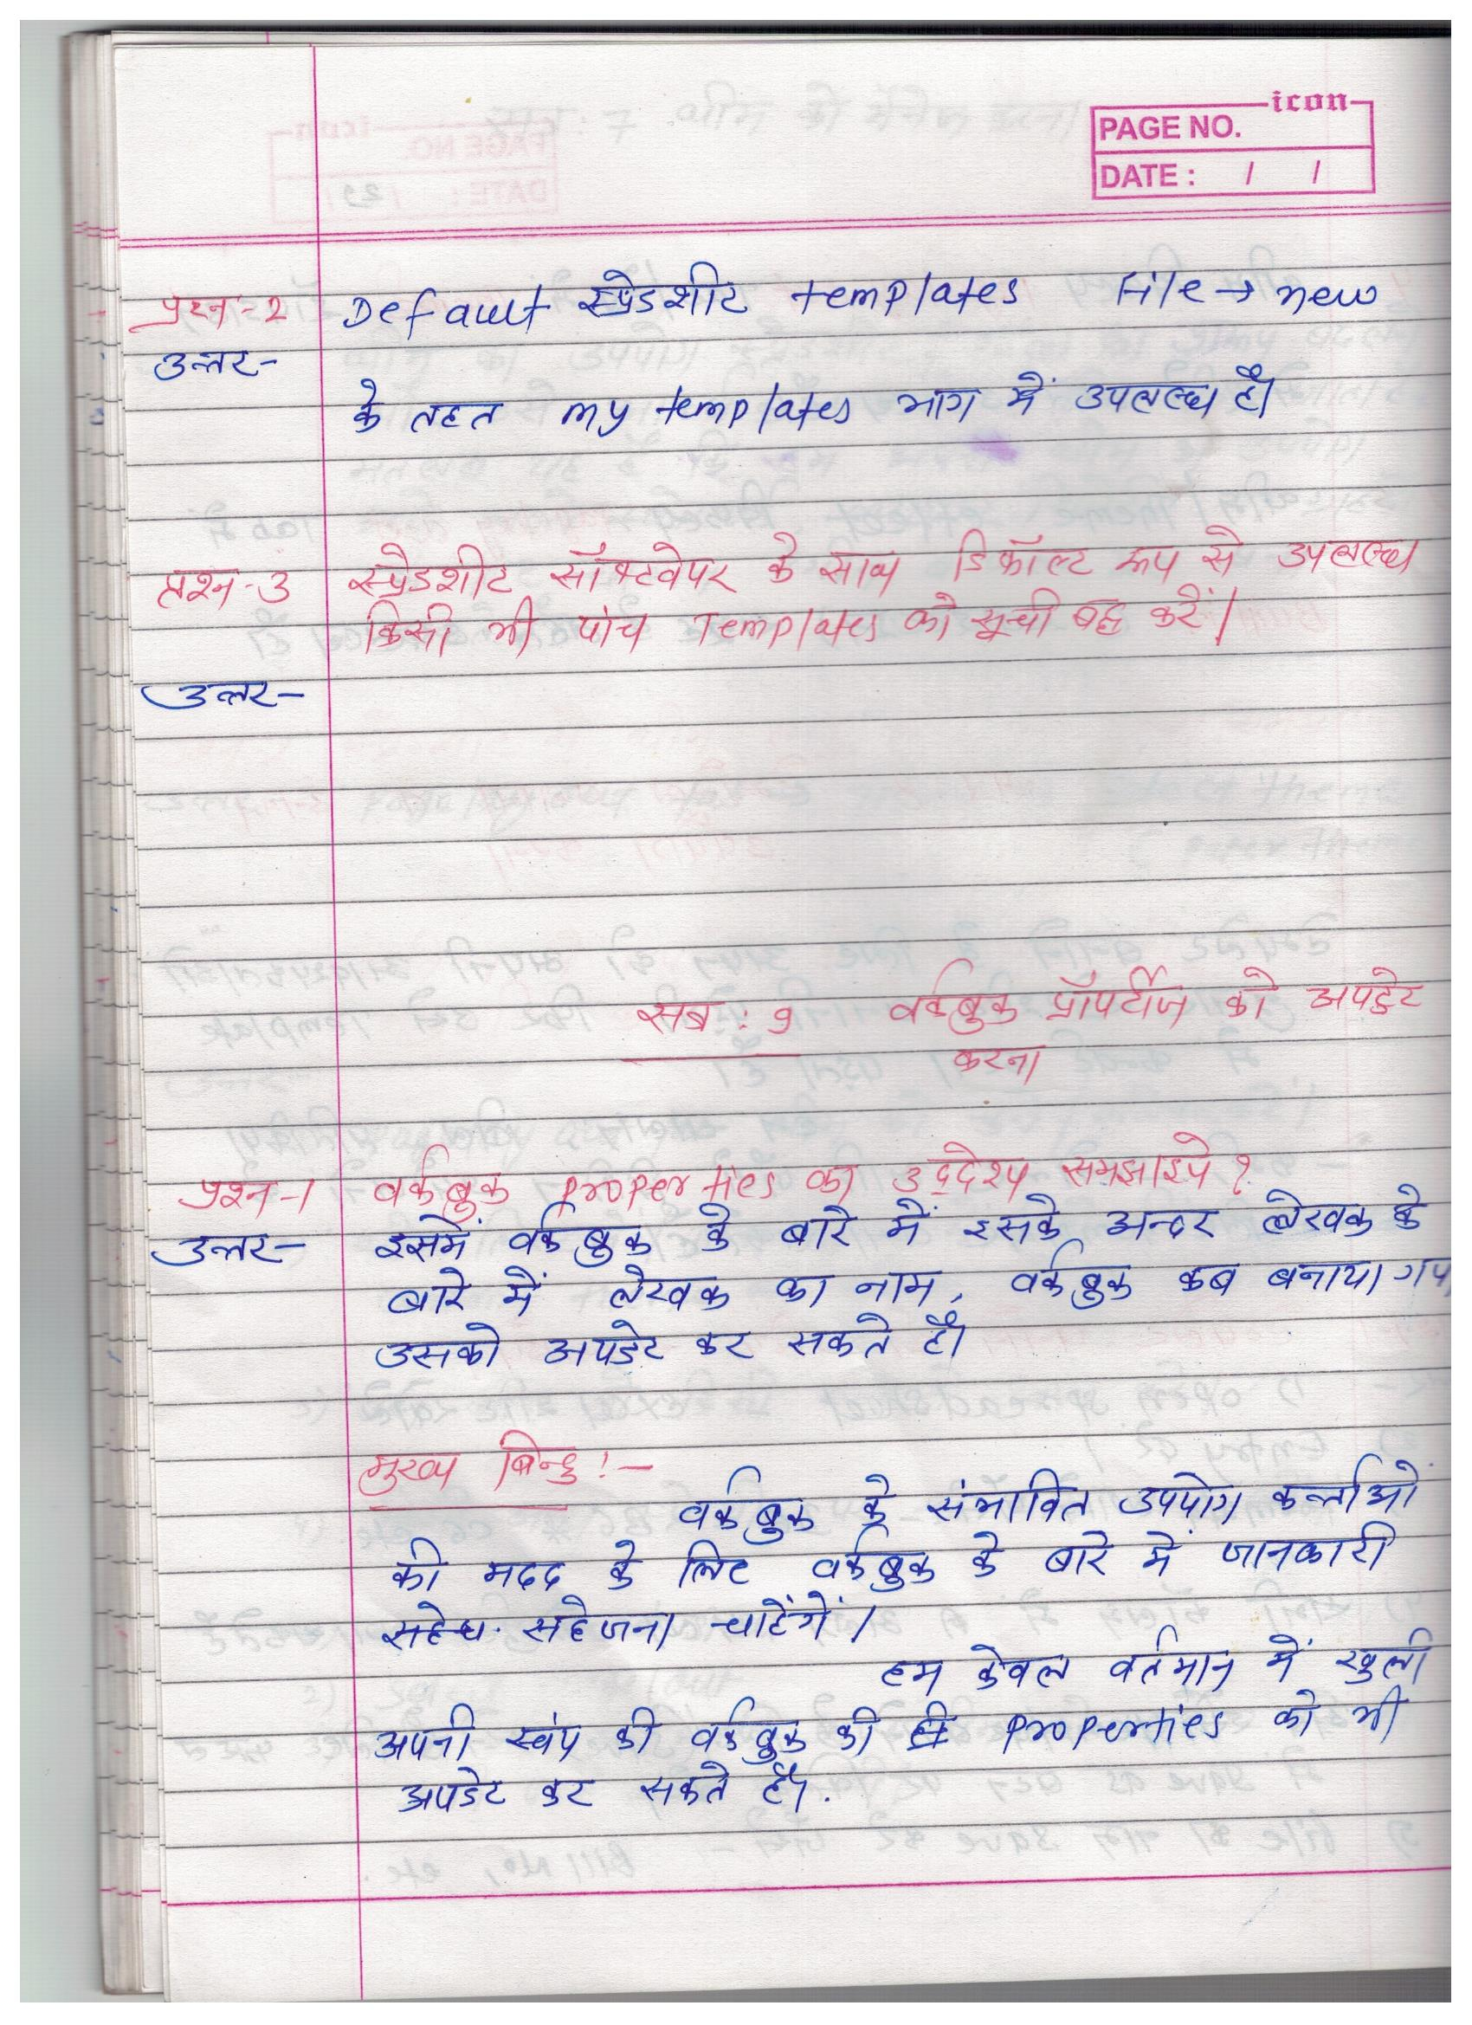

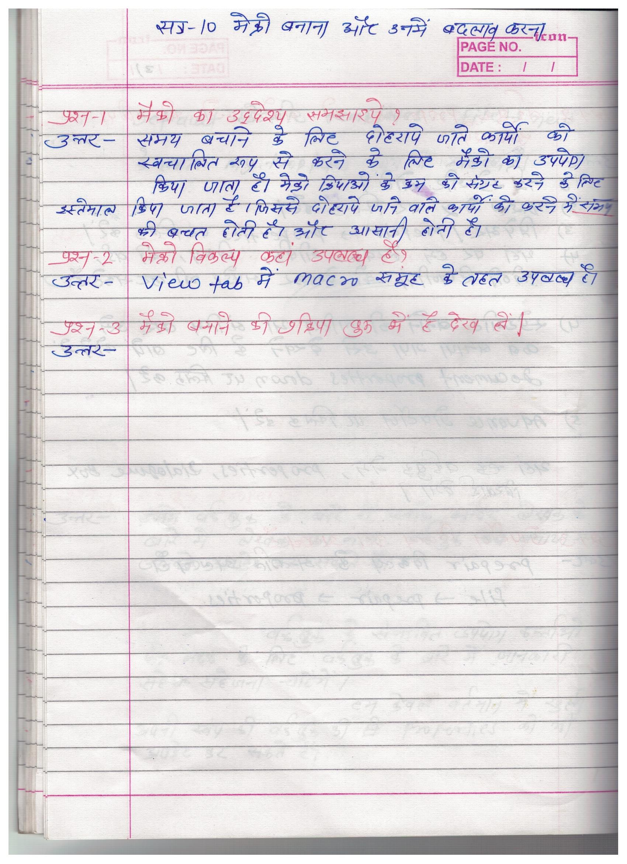
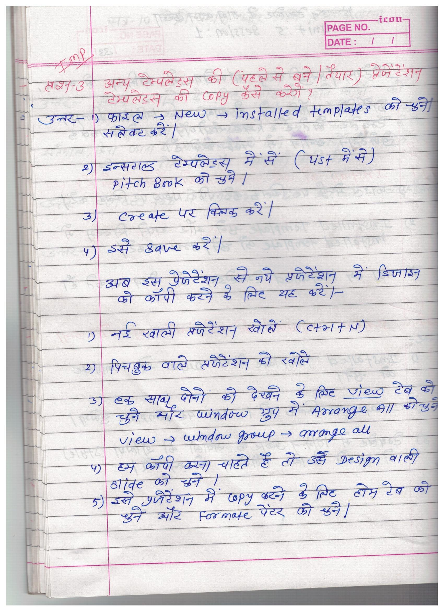
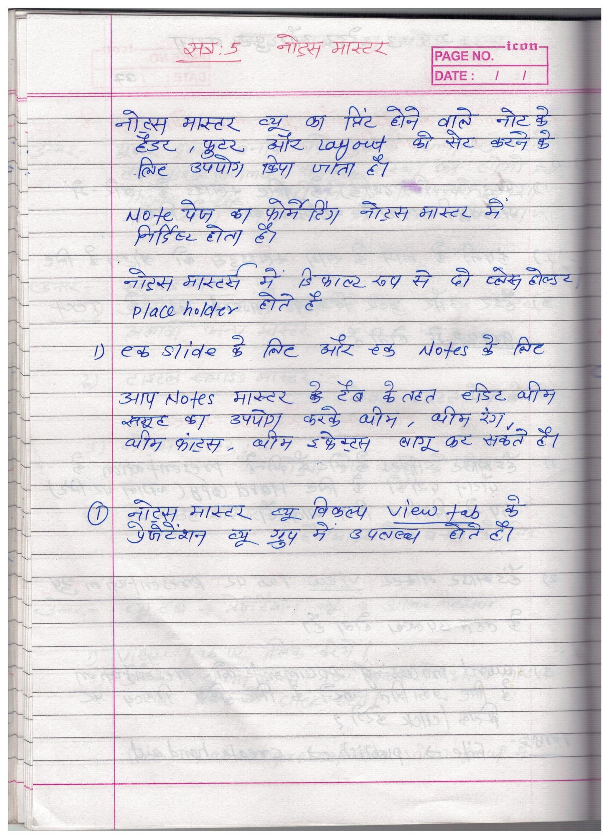
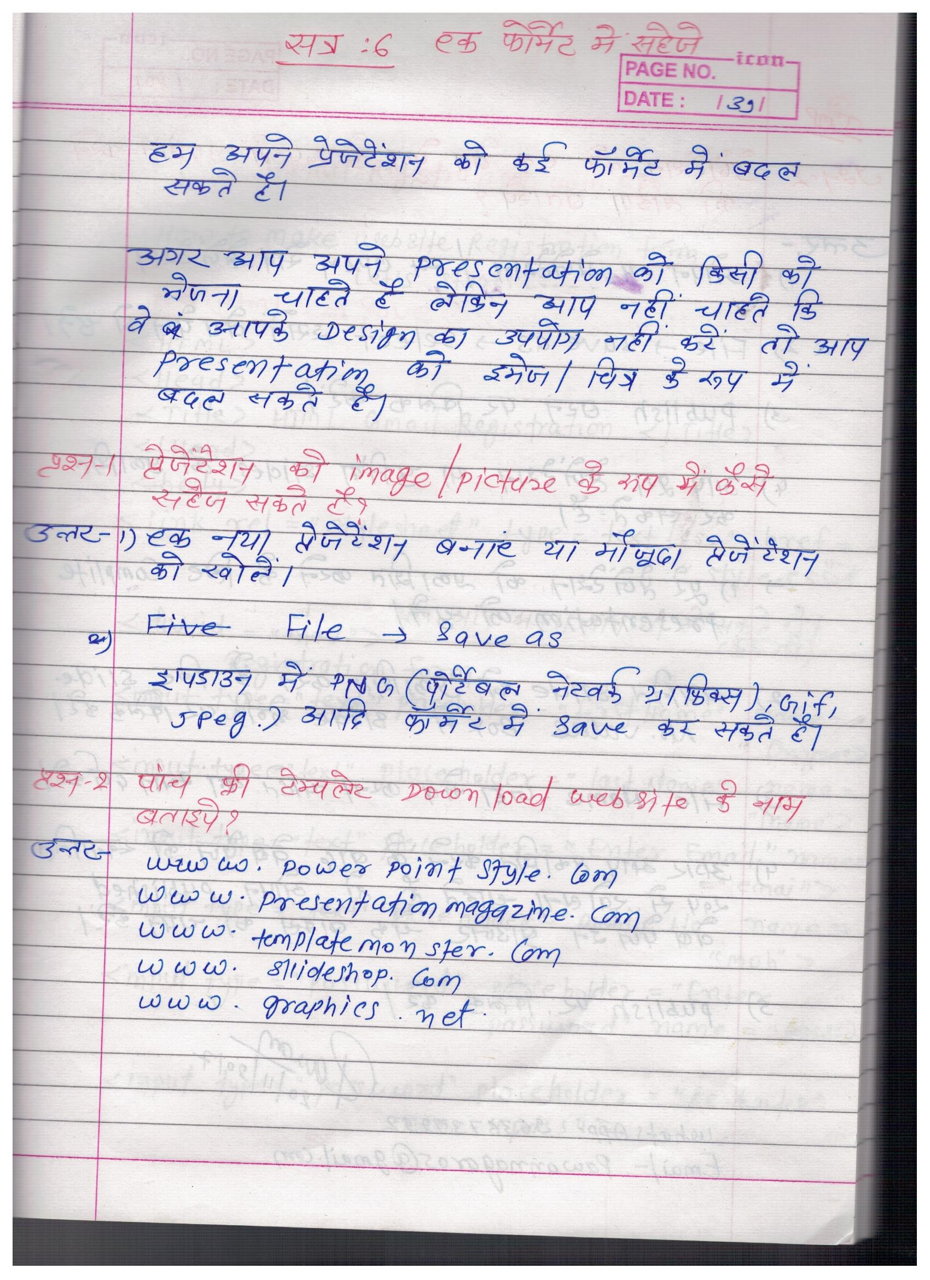
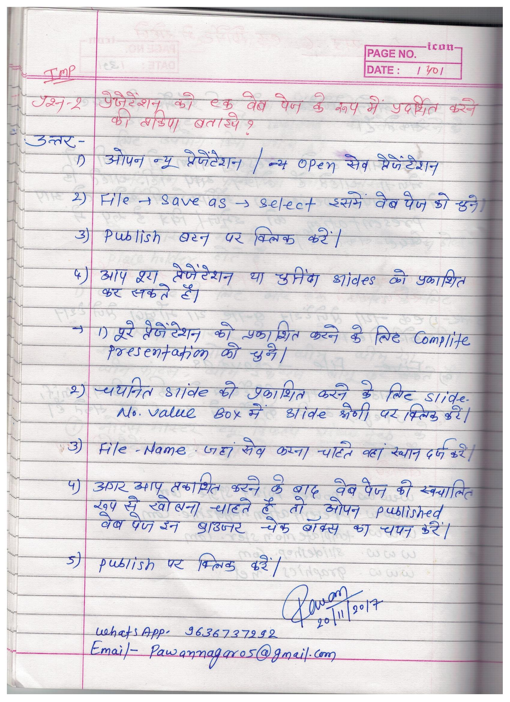

<html>
<head>
</head>
<body>
<form action="login.html" >
<table cellpadding="2" width="30%" height="80%" bgcolor="99FFFF" align="center" cellspacing="2" border="3">
<tr>
<td colspan=2>
<center><font size=4><b>Student Registration Form</b></font></center>
</td>
</tr>
<tr>
<td>Name</td>
<td><input type="text" placeholder="Name" size="30"></td>
</tr>
<tr>
<td>Father Name</td>
<td><input type="text" placeholder="father name" size="30"></td>
</tr>
<tr>
<td>Postal Address</td>
<td><input type="text" placeholder="Postal Address" size="30"></td>
</tr>
<tr>
<td>Personal Address</td>
<td><input type="text" placeholder="personal address" size="30"></td>
</tr>
<tr>
<td>File to upload:</td>
<td><input type=file ><br>
</td>
</tr>
<tr>
<td>Sex</td>
<td><input type="radio" name="sex" value="male" size="10">Male
<input type="radio" name="sex" value="Female" size="10">Female</td>
</tr>
<tr>
<td>City</td>
<td><select name="City">
<option>select..</option>
<option>K.PATAN</option>
<option >BUNDI</option>
<option >KOTA</option>
<option >JAIPUR</option>
<option >NEW DELHI</option>
<option >MUMBAI</option>
<option>GOA</option>
<option >PATNA</option>
</select></td>
</tr>
<tr>
<td>Course</td>
<td><select name="Course">
<option>select..</option>
<option >B.TECH</option>
<option>MCA</option>
<option >MBA</option>
<option>BCA</option>
</select></td>
</tr>
<tr>
<td>District</td>
<td><select name="District">
<option >select..</option>
<option>BUNDI</option>
<option>KOTA</option>
<option>AJMER</option>
<option>SIKAR</option>
</select></td>
</tr>
<tr>
<td>State</td>
<td><select Name="State">
<option>select..</option>
<option>RAJASTHAN</option>
<option >M.P</option>
<option>U.P.</option>
<option>BIHAR</option>
</select></td>
</tr>
<tr>
<td>PinCode</td>
<td><input type="text" placeholder="pincode" size="30"></td>
</tr>
<tr>
<td>Email Id</td>
<td><input type="text" placeholder="email id" size="30"></td>
</tr>
<tr>
<td>DOB</td>
<td><input type="DATE"></td>
</tr>
<tr>
<td>Mobile No</td>
<td><input type="text" placeholder="mobile" size="30"></td>
</tr>
<tr>
<td><input type="reset"></td>
<td colspan="2"><input type="submit" /></td>
</tr>
</table>
</form>
</body>
</html>

