

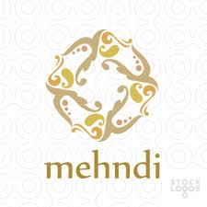
- ART & CRAFT , SPOKEN ENGLISH
Batch start from 19th May- FRIDAY
OPENING HOURS:-
- ZUMBA (FOR GIRLS $ LADIES):-7AM TO 8 AM
- DANCE:- 10 AM - 11:30 AM
- MEHNDI:- 9:AM – 1O:00AM
- ART & CRAFT: 8:00 AM – 9:00 AM
- SPOKEN ENGLISH : 8:00 AM- 9:00 AM Rs.400/-
ADDRESS:- MPS BUILDING, STEP BY STEP SCHOOL PURANI BHAKRI KA BASS, SOORSAGAR,JODHPUR(RAJ.)
CONTACT:-
SNEHA SOLANKI (9829660480)
For more queries: 9829663357, 0291-6532888
Log in at : www.stepbystepsch.com

