LETTER TO : APPLICATION FOR A JOB
Q.1 The following advertisement विज्ञापन is appeared दिखाई देना / प्रकट होना in the hindusthan Times
Haryana yidyut विधुत Board requires जरुरत , Electronical Engineers [5] at hisar ,rohtak, kurukshetra ,Gurgaon and faridabad . candidatea must have an experience of atleast कम से कम . 5-10 years.
- Age group – 35 to 40 years
- sailary – As per govt rules
- Reply with biodata within 15 days to
The Personel कार्मिक Manager प्रबंधक
Harayana viduyt Board
Urban Estate
Gurgaon
Write a Job application in (response/reference) सन्दर्भ to the above advertisement . you are pallavi sharma Answer : H.N. 134, Gandhi Nagar Rohtak Hriya Date : 05 August 2016 The Personel Manager Harayana viduyt Board Urban Estate Gurgaon
Subject : Appling for the post of electrical enginer at rohtak KJ Respected Sir, This letter is in the reference to the advertisement that appeared in the Hindustan Times dated on 31 june 2016 regarding the vaccency for the post of an electrical engineer at Rohtak . I would like to apply for the same. My Biodata reference and testimonials प्रसंसा पत्र are enclosed संलग्न for you kind perusal. I Would be highly obliged आभारी if given an opportunity अवसर दिया जाता है to serve सेवा the board . Thankyou Yours Sincerely Pallvi Sharm Enclosed: (1) Biodata (2) Reference (3) Testimonial प्रसंसा पत्र
BIODATA
- Name : Pallavi jain
- Date of birth :
- Permanent address : H.N. 134, Gandhi Nagar, Rohtak [Hariyana]
- [a] Father name : pappy Bai
[b] Mother Name : Sofiya Khan
5. Education Qualification : -
[1] XII from CBSE in 1994 with 92% marks .
[2] B.tech. in electrical Engineering from Punjab Engineering college Chandigarh in 2000 with 89.87 %
[3] M.tech in Electrical Engineering from ITI Mumbai in 2004 with 90.14 marks.
6. Experience : as electricalEngineridng with the Bihar Group of Industries for 7 years .
7. Health : Sound अच्छा Health . I suffer from no no majer प्रमुख aliment बिमारी
8. Present Employment वर्तमान रोजगार : I am a presently working as an electrical engineer with Bharat Industries ambla
9. Reference : Mr. P.K. Sinha Computer Lecturer At GAGSSS K.Patan.
10. Testimonial : The Principal
I.T.I. Pawai
Mumbai
11. Language : Hindi , English

LETTER TO : APPLICATION FOR A JOB
Q.2 You are Arpita Sharma B-120 Malviy Nagar chenni . Read to advertisement given below and write a letter to the advertisement applying for the job . also give your detailed reume which you would send along with your letter of application . C.B.S.E. 2009,12,14
SITUATION VACANT
Wanted Experience Trained post Graduate Teacher in Physics ,Biologyto teach class XI & XII in a reputed प्रतिष्ठित CBSE affiliated प्रमाणित residential आवासीय school , fullency धारा प्रवाह in English msut . Working knowledge of computer is preferable . commensurate बातचीत with experience and expertise दक्षता. Please apply to BOX NO- 9001 C/o The Hindu Chennai – 2
Answer : H.N. 120, malviy Nagar Channai
Date : 07 August 2016
BOX NO- 9001 C/o The Hindu Chennai – 2
Subject : Appling for P.G.T. in Physics,Biology Respected Sir, This letter is in reference to your advertisement in the Hindu Dated 05th march 2016 for the post of a post Graduate Lecture in Physics & Biology. I am an Applicant प्रार्थी for the same . I Have the requisite जरुरी qualifications and experience. I am Dynamic गतिशील young man with a pleasing खुशमिजाज personality व्यक्तित्व and good communication बोलने skills . If I select ,I Shall discharge प्रदान my duties to the entire पूर्ण satisfaction संतुष्ट of the concerned सम्बंधित authorities. अधिकारीयों . My Bio-data is enclosed संलग्न here with for your perusal and sympathetic सहानुभूति consideration विचार के लिए. Thankyou Yours Faithfully Arpita Sharma Enclosed: (1) Biodata (2) Reference (3) Experience Letter of teaching at school
BIODATA
- Full Name : Arpita Sharma
- Father name : Er. Raj kumar Sharma
- Mother Name : Dr. Anjali Sharma
- Age : 31 Years.
- Sex : Male
- Material Status : Married
- rmanent Address : B- 120 Malviy Nagar Chennai
- Correspondence Address : ……………………………….
- Date of birth : 05/07/1993
- Education Qualification : -
[1] XII from CBSE in 1994 with 92% marks ..
[2] B.Sc from Presidency College ,Chennai with 86 % marks.
[3] M.Sc from Presidency College ,Chennai with 74 % marks.
[4] B.ed from Govt. College of education ,Chennai with 73% marks .
[5] Computer Working Knowledge
11. Presently Working : 8 Year as TGT in St. Paul Public school ,Chennai.
12 Language Known : English and Hindi.
13 Ssailary Expected : PGT. – Grade With allowances भत्ते के साथ
14. Health : Sound Health . I suffer from no major aliment .
15 Testimonial : The Principal
Govt. College Of Education
Chennai
Poen No–2 “An Elementary(प्राथमिक)School classroom in slum(गन्दी बस्ति/झुग्गी झोंपड़ी)”
Summery of the poem : The Poet Presents a pathetic picture of a classroom in a slum school . The slum is far away from the sea-shore and the natural-surrounding. children are living slums are under fed , under-grown,and untouched by the civilized-world. The world map and picture of great person on th walls of the classroom are meaningless to these children. For them the narrow- lanes out side the class room windows, The dusty- sky and heaps of rubbish is their world. The poet urges the educated and civilized people of the society to break the barriers and lead them to green fields and pastures of knowledge, to make them part of the civilized word . people possessed with the warmth and power of the sun can make history.
Presents- प्रस्तुत | sea-shore समुद्र- तट | natural-surrounding -प्राक्रतिक-वातावरण |  | untouched-अछूते | dustysky-धूलभराआकाश
pathetic-दयनीय | under fed-आधे-भूखे | under-grown- शारीरिक-विकास |  | rubbish-गंदगी | barriers- रुकावटें/बाधाएं
power-ताकत | warmth-गर्माहट | educated and civilized-शिक्षित और सभ्यसमाज |  | urges-अपील | pastures-चारागाह
lead-नेतृत्व | possessed –अधिकार | meaningless निरर्थक/बिना काम के |  | break रोक- लगादे | barriers रुकावटें/बाधाएं
heaps-ढेर | civilized-world -सभ्य-समाज |  | make history-इतिहास का निर्माण | narrow lanes-तंगगलियां

मुख्य बिन्दु (MAIN POINTS) :- 1. The children of an elementary school classroom in slum गन्दी-बस्ति look pathetic दयनीय and miserable कष्टकारी. 2. They have pale face पीला/दुखी-चेहरा . They are like rootless जड़-विहीन wild plants जंगली पोधों. 3. they are distressed कष्ट में. The burdens बोझा of life जीवन का keep their head weight down निचे झुका हुआ. 4. their grouth वृद्धि is stunted रुकी हुई . They inherit जन्मजात twisted मुड़ीहुई bones हड्डियाँ are diseaseबिमारियों . 5. they do have dreams स्वप्न .The.y also dream of moving out in the बाहर निकलने का openखुलेमें . They want to see squirrel’s a game गिलहरी का खेल . 6. literature साहित्य and the works रचनाएँ of Shakespeare are useless बेकार हें for them. 7. this civilized-world सभ्य दुनियां is of importance महत्व only for powerful-persons शक्तिशाली लोंगों . 8. the powerful शक्तिशाली dictators shape तानाशाही लोग बनाते हें the map of the world at will अपनी इच्छा से . but their world is not the worlds of these unfortunate दुर्भाग्यशाली children. 9. the feature भविष्य of these children Is foggy धुंधली/कोहरे जेसी and uncertain अनिश्चित . 10. they live रहना in narrow- streets सकड़ी-गलियों में sealed बंद पड़ी in with a lady sky घने आसमान की तरह . 11. Rivers नदियों ,capes टापू and starry-places तारों वाली दुनियां exist अस्तित्व only in their dreams. 12. The slumगन्दी बस्ति in which they live are nothing less से कम then living जीवित hells नरकों से. Actuallyवास्तवमे they are a blot कलंक on their civilized-world सभ्य संसार पर. 13. the window to the world of joy खुशी and comforts आराम are shut बंद पड़ी हे of them इनके लिए. 14.governors व्यक्तियों सरकारी , teachers and powerful-people पेसे वाले लोग must bring लाना चाहिए them out of the their durty slums गन्दी बस्तियों से . 15.everything that bind बांधती हें them should be broken-open खुले रूप मे तोड़ दो . 16. their world must extend विस्तार करना’ . it must extend to the blue waves तरंगो,the gold send सुनहरी धरती and The green fields 17.they must अवश्य be freedom स्वतंत्रता to expressoion अभिव्यक्तियों को and learning सिखने की .
Letters to the Editors (Most)
Q.1 In its bad to educate शिक्षित people about the harmful हानिकारक effect of cigarette सिगरेट smoking धुम्रपान the Govt. of india has been taking serious steps to prevent रोकने केलिए it. Now it is considering विचार censorship प्रतिबन्ध of all cigarette smoking scenes in india cenima . write a letter to the editors of national daily giving your own-views स्वयं के विचार
answer :
19, Station Road New Delhi
10 august 2016
The Ediors, The Times of India NewDelhi
Sub: Harmful effect of smoking
Respect Sir,
Through the column of your respected daily news paper. I want to highlight the harmful effect of Cigarette smoking . A world wide movement विस्तृत सांसारिक आन्दोलन has been lunched /started againsted smoking. Medical experts have been published छाप elaborate बड़े पैमाने पर reports against smoking.Almost 90% of lung फेफड़ों का cancer is caused कैंसर का कारण by cigerette smoking सिगरेट के धुएं से.
Blood pressure ब्लड प्रेसर and heart diseases बीमारियाँ have a close connection जुडाव with smoking . the govt. must take serious steps to educate people against the harmful effect of smoking .only incuding लिखना a legal क़ानूनी warning चेतावनी on cigarette packs will not do good.
Luckly सोभाग्यसे in some state smoking has been banned at public palces .the government is conserding विचार censoring प्रतिबन्ध of all smoking scenes in films. It will be a good steps. Smoking in buses ,trains, and other public vehices should be banned by law.those who go against the law must get punishment.
Thanking you
Yours faithfully/truly Pawan kumar nagar (Nagar Nigam Chairman

Lession No. - # 05 INDIGO – Louis fisher (1896 – 1970)
Main Characters 1. Raj kumar Shukla 2. Mahatma Gandhi 3. Professer J.B. Kriplani 4. Sharecroppers of Champaran 5. Rajendra Prasad 6. Brij Kishor Babu,Maulana Mazharul Huq 7. Sir Edward Gait Governer 8. Mahadev Desai and Narha 9. Devdas & Kasturba Gandhi 10. Charles Freer Andrews
Summery of the Lession : This Chapter tell us how Gandhiji struggled संघर्ष किया against the British for the poor peasants किसानों of champaran.The India farmer had an agreement सहमत with the British landlords that they would Produce उत्पादित करें indigo on fifteen percent of the land and surrender आत्मसमर्पण it as rent to the landloards. The British planters came to know that Germany had developed synthetic कृत्रिम indigo. They did not need indigo crop any longer. They Demand compensation नुकसान भरपाई from the for setting them free from the agreement.Some of the farmer agreed to give compensation नुकसान भरपाई but other refused मना कर दिया to do so .At this time Gandhi came to champran and fought for the peasants for one year. He made them realise their power and the British their weakness.
Main Points :
1. A Poor Peasant किसान Raj Kumar Shukla met Gandhi at Lucknow session अधिवेशन / सभा of the Indian National Congress in 1916 December.
2. He wanted to inform सूचित Gandhi abour injustices अन्याय done जो हो रहा था the English landloards जमींदार in Champran .
3. Gandhi had other appointments नियुक्ति . But Shukla accompanied साथ दिया Gandhi everywhere , even to the ashram in Ahmedabad.
4. Gandhi was impressed प्रभावित by Shukla’s determinationदृढ़ निश्चय/(resoluate). He asked him to meet him in Culcutta).
5. From Calcutta , they boarded सवार होना a train to Patna. From Patna, Gandhi first went to Muzaffarpur .
6. he stayed there to know more about the condition शर्ते of the farmers in Champran.
7. The News of Gandhiji’s arrival आना spread फैलाना quickly बहुत जल्दी . Many Share-croppers बटाईदार साझेदारी में खेती करने वाला came on feet from Champaran to see their Champion.
8. Most of the arable कृषि योग्य land भूमि in Champran was owned मालिक by English Landloards.
9. The landloards made the sharecroppers to sign an agreement समझोता. According to the agreement 15% of their land was tobe planted लगाना Indigo.
10. Germany had developed विकसित करना synthetic indigo रसायनिक नील . So indigo plantation was no more profitable लाभदायक now.
11. Therefore इसलिय, the landloards forced बाह्य the sharecroppers बटाईदार to sign हस्ताक्षर a new contract समझोते पर. According to the new contarct , the sharecroppers were now free to grow उगाना indigo or not. But for this freedom they were to give some compensation मुआवजा to the landloards.
12. Gradually धीरे धीरे even illiterate अनपढ़ sharecroppers saw through the trick चालाकी of the landloards . Those who had already signed the agreement wanted their money back.
13. Gandhi met with the commissioner of Tirhut. He informed him about the injustics done to the peasants by the landloards.
14. The commissioner threatened धमकी देना Gandhi to leave the place . Gandhi didn’t leave the place . Instead के बजाये he proceeded/went चले गये to Motihari.
15. Gandhi was asked to appear in the court the next day.
16. Thousands of peasant held रखा a demonstration प्रदर्शन around the court house .
17. The authorities अधिकारी लोग were helpless असहाय .Gandhi helped a demonstration प्रदर्शन around the court house .
18. The government wanted to postpone स्थगित the trial मुकदमा but Gandhi opposed विरोध किया the dealy.
19. he respected the law but couldn’t ignore the voice of his conscrence. It compelled him to take up the cause of poor Peasants.
19. He respected the law but couldn’t ignore अवहेलना the voice of his consclence अंतरात्मा . IT compelled बाह्यकिया him to take up the cause मामले को of poor peasants.
20. All the Lawyers of Bihar, including शामिल करते हुए Dr. Rajendra Prasad decided to go jain with Gandhi
21. Gandhi exclaimed विस्मित होकर, “ The battle लड़ाई of Champaran Is Won “.
22. Several days later, the lieutenant Governor ordered the case to be dropped वापस लेने.
23. Civil Disobedience सविनय अवेज्ञा had triumphed/won जीत हो चुकी for the first time in India .
24. Gandhi met the lieutenant Governor प्रतिनिधित्व करने वाला four times to take up the causes of poor peasants of Champaran.
25. An Inquiry जाँच commission was set up स्थापित to look into जांचने के लिए the whole issue मुद्दे.
26. Gandhi wanted that 50% money paid to the land loards be returned to the sharecroppers.The landlords offerds to give only 25%. Gandhi agreed सहमत on 25% and the issue मुद्दे. was closed
27. Several socoal-workers सामाजिक कार्यकर्ता were undertaken उठाये गये by Gandhi and his followers अनुयाइयोin Champaran . Gandhi’s son and his wife joined him. Many other volunteers स्वंयसेवक also came from distant parts दूर दूर के भागो मेंof India.
28. Gandhi wanted Indians to carry जरी रखे on their struggle संघर्ष on their own स्वयं strength. Once some lawyers wanted C.F. Andrews to stay in Champran and help them.
29. But Gandhi opposed विरोध किया it . He did not want the help of an Englishmen in India’s struggle संघर्ष किया for freedom स्वतंत्रता.
30. Thus, Gandhi taught us a lession of self reliance आत्म निर्भरता.
Q.1. What was the attitude /outlook द्रष्टिकोण of the average ओषत indian in smaller localities बस्तियों towards कीओर advocates of वकालत कर करे थे “home rule”?
ans. The attidude of average indian in smaller localities towards advocates of home rule was negative . They were affired डरे हुए थे to show sympathy सहानुभूति for advocates वकालत of home rule those days. They were affired of being arrested जेल में जाने से.
Letters to the school Authorities only for ( X1 class )
कुछ करने की request या कुछ’ करने की pemission मांगी जाती हे |
- Sender address : भेजने वाले का पता लिखा जाता हे
- date
- receiver designation (नाम ऑफ़ थे स्कूल ) villege town city
- subject: प्रार्थनापत्र किस विषय में लिखा जाता हे
- saluation : संभोधन सर/मेडम
- कम्युनिकेशन
- courteous ending शिष्ट समाप्ति : thanking you
- copmplimentary phrase सम्मान सूचक वाक्यांश : yours obidentaly
Q.1imagine that u r the monitor of your class your studies suffers much un English and maths.as the teacher in the subject joined late .there was teachers strike also you need extra teaching in the two subjects.write an application to u r principal requesting him to arrange extr teaching for the subjects.
ans.
253 keshav nagar
k.patan
12 august 2016
The Principal
GAGSSSK.PATAN
BUNDI
Sub: to arrange extra teaching classes.
Mam/madam
Respectfully I b to say that our studies suffered in English and maths very week. The teacher is subject joined late . there was teacher stike also . our 12 board exam are near . our class need to have must extra – teaching class in two subject .
So please humbly request you mam to arrange extra teaching.
Thanking you.
Yours obediently
Monita
Class monitor
11 A
Q.2 write an application to your school principal with a request to issue your cc.:
The Principal
GAGSSSK.PATAN
DATE: 19TH AUGUST 2106
SUB: TO ISSUE MY CC(CHARACTER CERTIFICATE)
RESPECTED MAM,
Most kindly respectfully I beg to say that issue me a c.c. I must need it to submit verification of my police exam .i was a student of your school laast two years .i got first rank in school exam 10 and 11th . and I also participate in many debate compition in state level with caption role in cricket. I won several prizes.
So please issue me a c.c.
Thaning you
Yours obidently
Sona kuamrri

Q.2 write an application to your school principal with a request to issue your cc.:
The Principal
GAGSSSK.PATAN
DATE: 19TH AUGUST 2106
SUB: TO ISSUE MY CC(CHARACTER CERTIFICATE)
RESPECTED MAM,
MOST विनम्रतापूर्वक अनुरोध HUMBLY I am student of clss x1 a my father is a not and my mother is only earning member is my family . so I am going to apply for the post of cleark in pnb bank. Therefore I need to my cc.
My details are given below :
- I got 96 % marks in class xth.
- I am well behaved student oof your school
- I am also champion of your school cricket team.
- All the teacher are like me very much. Thus you are requested to issue my cc so that I am apply for the post of cleark on pnb bank. I will be greatfull to you.

Yours obidently.

Anjali nagar
Calss x1 old monitor

Q.2 write an application to your school principal to know lack of teacher faculty.:
The Principal
GAGSSSK.PATAN
DATE: 19TH AUGUST 2106
SUB: TO ISSUE MY CC(CHARACTER CERTIFICATE)
Respected sir,
Most humbly we are the studet of class x1 . want to draw your kind attentation about lack of science faculty in our school. So we have to say about it that .
- Physics lecturer is not punctual.
- His behaviour is also not good.
- There are not enough (pryapt)lecturer in our school.
- Physics period is not available daily .
- Accoding to this situation our syallbous will not be complete and our class feature will be in darkness.
Therefore you are requested to look into the matte at once and do the needful action against it.
We will greatful to you.
Yours faithfully.
All of the class student
X1
Fill handle

Presently, the landlords अब जागीरदारों को पता learned that Germany had developed synthetic indigo. They, thereupon,इस बात पर उन्होंने 15%की व्यवस्था सेobtained प्राप्तकरना agreements from the sharecroppers to pay them compensation क्षतिपूर्ति for being released from the 15 per cent arrangement.

The sharecropping arrangement समझोता was irksome मुसीबतभरा to the peasants, and many signed willingly अपनी इच्छा से. Those who resisted विरोध किया, engaged _{लगाना} lawyers; the landlords hired thugs. Meanwhile, the information about synthetic indigo reached the illiterate peasants who had signed, and they wanted their moneyback.

At this point Gandhi arrived in Champaran. He began by trying to get the facts. First he visited the secretary of the British landlord’s association. The secretary told him that they could give no information to an outsider.
Gandhi answered that he was no outsider.

Next, Gandhi called on the British official commissioner आयुक्त of the Tirhut division in which the Champaran district lay. ‘‘The commissioner,’’ Gandhi reports, ‘‘proceeded to bully me and advised me forthwith to leave Tirhut.’’

Gandhi did not leave. Instead he proceeded to Motihari, the capital of Champaran. Several lawyers accompanied him. At the railway station, a vast multitude greeted Gandhi. He went to a house and, using it as headquarters, continued his investigations. A report came in that a peasant had been maltreated in a nearby village. Gandhi decided to go and see;

the next morning he started out on the back of an elephant. He had not proceeded far when the police superintendent’s messenger overtook him and ordered him to return to town in his carriage. Gandhi compliedआज्ञा.

The messenger drove Gandhi home where he served him with an official noticeआधिकारिक to quit Champaran immediately. Gandhi signed a receipt for the notice and wrote on it that he would disobey the order.

In consequence परिणाम सवरूप, Gandhi received a summons कानूनी आदेश to appear in court the next day.All night Gandhi remained रहे awake. He telegraphed Rajendra Prasad to come from Bihar with influential प्रभावसाली friends. He sent instructions to the ashram. He wired a full report to the Viceroy.

Morning found the town of Motihari black with peasants. They did not know Gandhi’s record in South Africa. They had merely केवल heard that a Mahatma who wanted to help them was in trouble उलझगया with the authorities. Their spontaneousसरल demonstrationप्रदर्शन, in thousands, around the courthouse was the beginning of their liberationसवतंत्र from fear of the British कोर्ट के आसपास हजरों की तादात में उनका सहज प्रदर्शन अंग्रोजो के भय से उनकी मुक्ति की सुरुआत थी.

The officials felt powerless without Gandhi’s cooperation. He helped them regulate _{नियंत्रित करना}the crowd. He was polite and friendly. He was giving them concrete proof ठोसप्रमाणthat their might शक्ति, hitherto अबतक dreaded and unquestionedडरनेवाली और विरोधविहीन, could be challenged by Indians.
The government was baffled_{च} चकरागई. The prosecutor पक्षकार वकील requested the judge to postpone the trialसुनवाई. Apparently,स्पस्ट था की the authorities wished to consult their superiors.

Gandhi protested विरोध किया]against the delay. He read a statement pleading guiltyअपराध स्विकर्कारते हुए. He was involved, he told the court, in a “conflict of dutiesक्रत्व्य के विरोधाभास”— on the one hand, not to set a bad example as a lawbreaker; on the other hand, to renderदेना the “humanitarian and national service” for which he had come.
He disregardedउलंघन the order to leave, “not for want of respect for lawful authority, but वरन हमारे अस्तित्व के और भी और भी बड़े कानून का पालन करते हुए in obedience to the higher law of our being, the voice of conscience”. He asked the penalty due_{उचित दंड की मांग की}.

The magistrate announced that he would pronounce sentence _{निर्णय} after a two-hour recess and asked Gandhi to furnish bail जमानत देना for those 120 minutes. Gandhi refused. The judge released him without bail.
When the court reconvened, the judge said he would not deliver the judgment for several days. Meanwhile he allowed Gandhi to remainअनुमति at libertyस्वतंत्र.

Rajendra Prasad, Brij Kishor Babu, Maulana Mazharul Huq and several other prominentमुख्य lawyers had arrived from Bihar. They conferredविचार विमर्श with Gandhi. What would they do if he was sentenced to prison, Gandhi asked. Why, the senior lawyer replied, they had come to advise and help him; if
he went to jail there would be nobody to advise and they would go home.

What about the injustice to the sharecroppers, Gandhi demanded. The lawyers withdrewपीछे हट गये to consult. Rajendra Prasad has recorded the upshotपरिणाम of their consultations — “They thought, amongst themselvesआपस में, that Gandhi was totally a stranger बहरी, and yet he was prepared to go to prisonजेल for the
sake of _{के लिए} the peasants; if they, on the other hand, being not only residents of the adjoining आसपासdistricts but also those who claimed दावाकरनाto have served these peasants, should go home, it would be shameful desertionशर्मनाक _{धोका}.”

They accordingly went back to Gandhi and told him they were ready to follow him into jail. ‘‘The battle of Champaran is won,’’ he exclaimed. Then he took a piece of paper and divided the group into pairs and put down the order in which each pair was to court arrest.

Several days later, Gandhi received a written communication from the magistrate informing him that the Lieutenant-Governor of the province _{राज्य} had ordered the case to be dropped. Civil disobedience had triumphed, the first time in modern India.

Gandhi and the lawyers now proceeded to conduct करना a far-flung व्यापकस्तर inquiry जाँचinto the grievancesशिकायत of the farmers. Depositionsबयान by about ten thousand peasants were written down, and notes made on other evidence गवाही. Documents were collected. The whole area throbbed कम्पित होनाwith the activity of the investigators जाँच करने वाला and the vehement protests उग्रप्रतिवाद of the landlords.

In June, Gandhi was summoned to के पास बुलाया गया Sir Edward Gait, the Lieutenant-Governor. Before he went he met leading associates_{सहयोगी} and again laid detailed plans for civil disobedience if he should not return.

Gandhi had four protracted प्रमुख interviews with the Lieutenant- Governor who, as a result, appointed an official commission of inquiry into the indigo sharecroppers’ situation. The commission consisted of landlords, government officials, and Gandhi as the sole representative of the peasants.

Gandhi remained in Champaran for an initial uninterrupted period of seven months and then again for several shorter visits. The visit, undertaken casually on the entreaty of an unlettered peasant in the expectation that it would last a few days, occupied almost a year of Gandhi’s life.

“poster”
Q.1 you are secretary of health department govt of rajasthan . draft a poster to aware people for “save wild life”

SAVE WILD LIFE

SAVE
ENVIRNMENT
SAVE SA

SAVE
LIFE

SAVE WILD LIFE

- POLLUTION IS POSITION FOR CITIZION
- AWARE PEOPLE TO STOP POLLUTION
- DON’T USE POLYTHENE
ISSUED
BY
- PLANT MORE AND MORE TREES
NATIONAL ENVIRONMENT DEPARTMENT
GOVT. OF RAJASTHAN

Q.2 You are secretary a anti corruption departmetn . write a poster to aware people to “stop corruption”
ANSWER

STOP SORRUPTION

DO NOT TAKE AND GIVE
BRIBE
PEOPLE TO STOP CORRUPTION

CORRUPTION IS A BLACK SPOT IN COUNTRY

SAVE INDIA STOP

STOP CORRUPTION

SAVE COUNTRY

ANTI CORRUPTION DEPARTMEN T .
ISSUED BY
GOVT OF RAJASTHAN

Q.3 DRAFT A POSTER TO INSPIRE PEOPLE AGAINST THE WASTAGE OF WATER

SAVING WATER CAN SAVE THE WORLD
ANSWER :

WE HAVE A LOT ! AND SAVE A LOT !

SAVE LIFE

*keep in mind*
CONSERVE WATER

- TO TURN OFF THE TAPS
- TO PREVENTS USELESS WATER
- TO CHECK THE LEAKAGES
- WHEN WASH HANDS THEN CLOSE THE TAP

SAVE EVERY DROP OF WATER

ISSUED BY GOVT. OF RAJ.
SAVING WATER CAN SAVE THE WORLD
WE HAVE A LOT
CONSERVE WATER AND SAVE A LOT OF

Q.4 draft a poster to blood donation camp in your school sarde chatravas k.patan

BLOOD DONATION CAMP

BLOOD DONATION CAMP

TIMING 11:04 PM
FROM AUGUST 10TH TO 12TH

VANUE : TT HOSPITAL

VOLUNTERS WILL GET
- A CERTIFICATE
- A WRIST WATCH
- FUTURE IMERGENCY RETURN BLOOD

Issued by : SARDE BALIKA SOCACITY IN K.PATAN

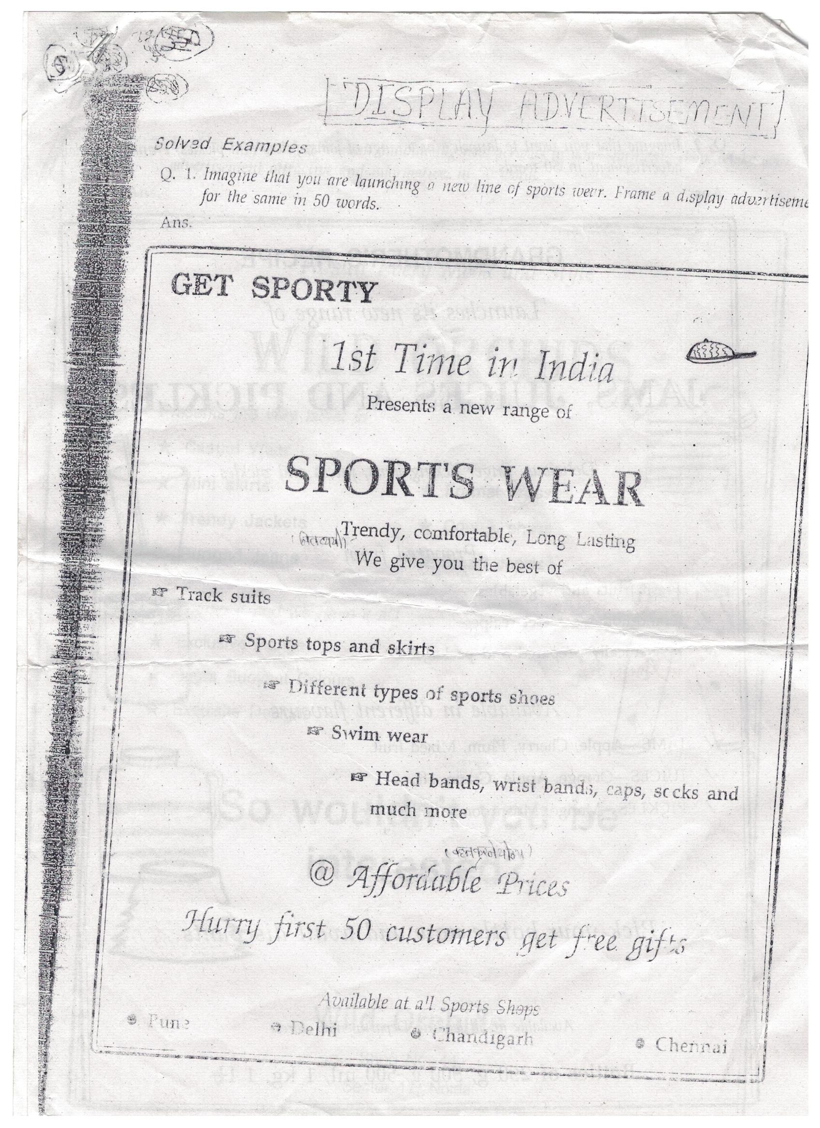
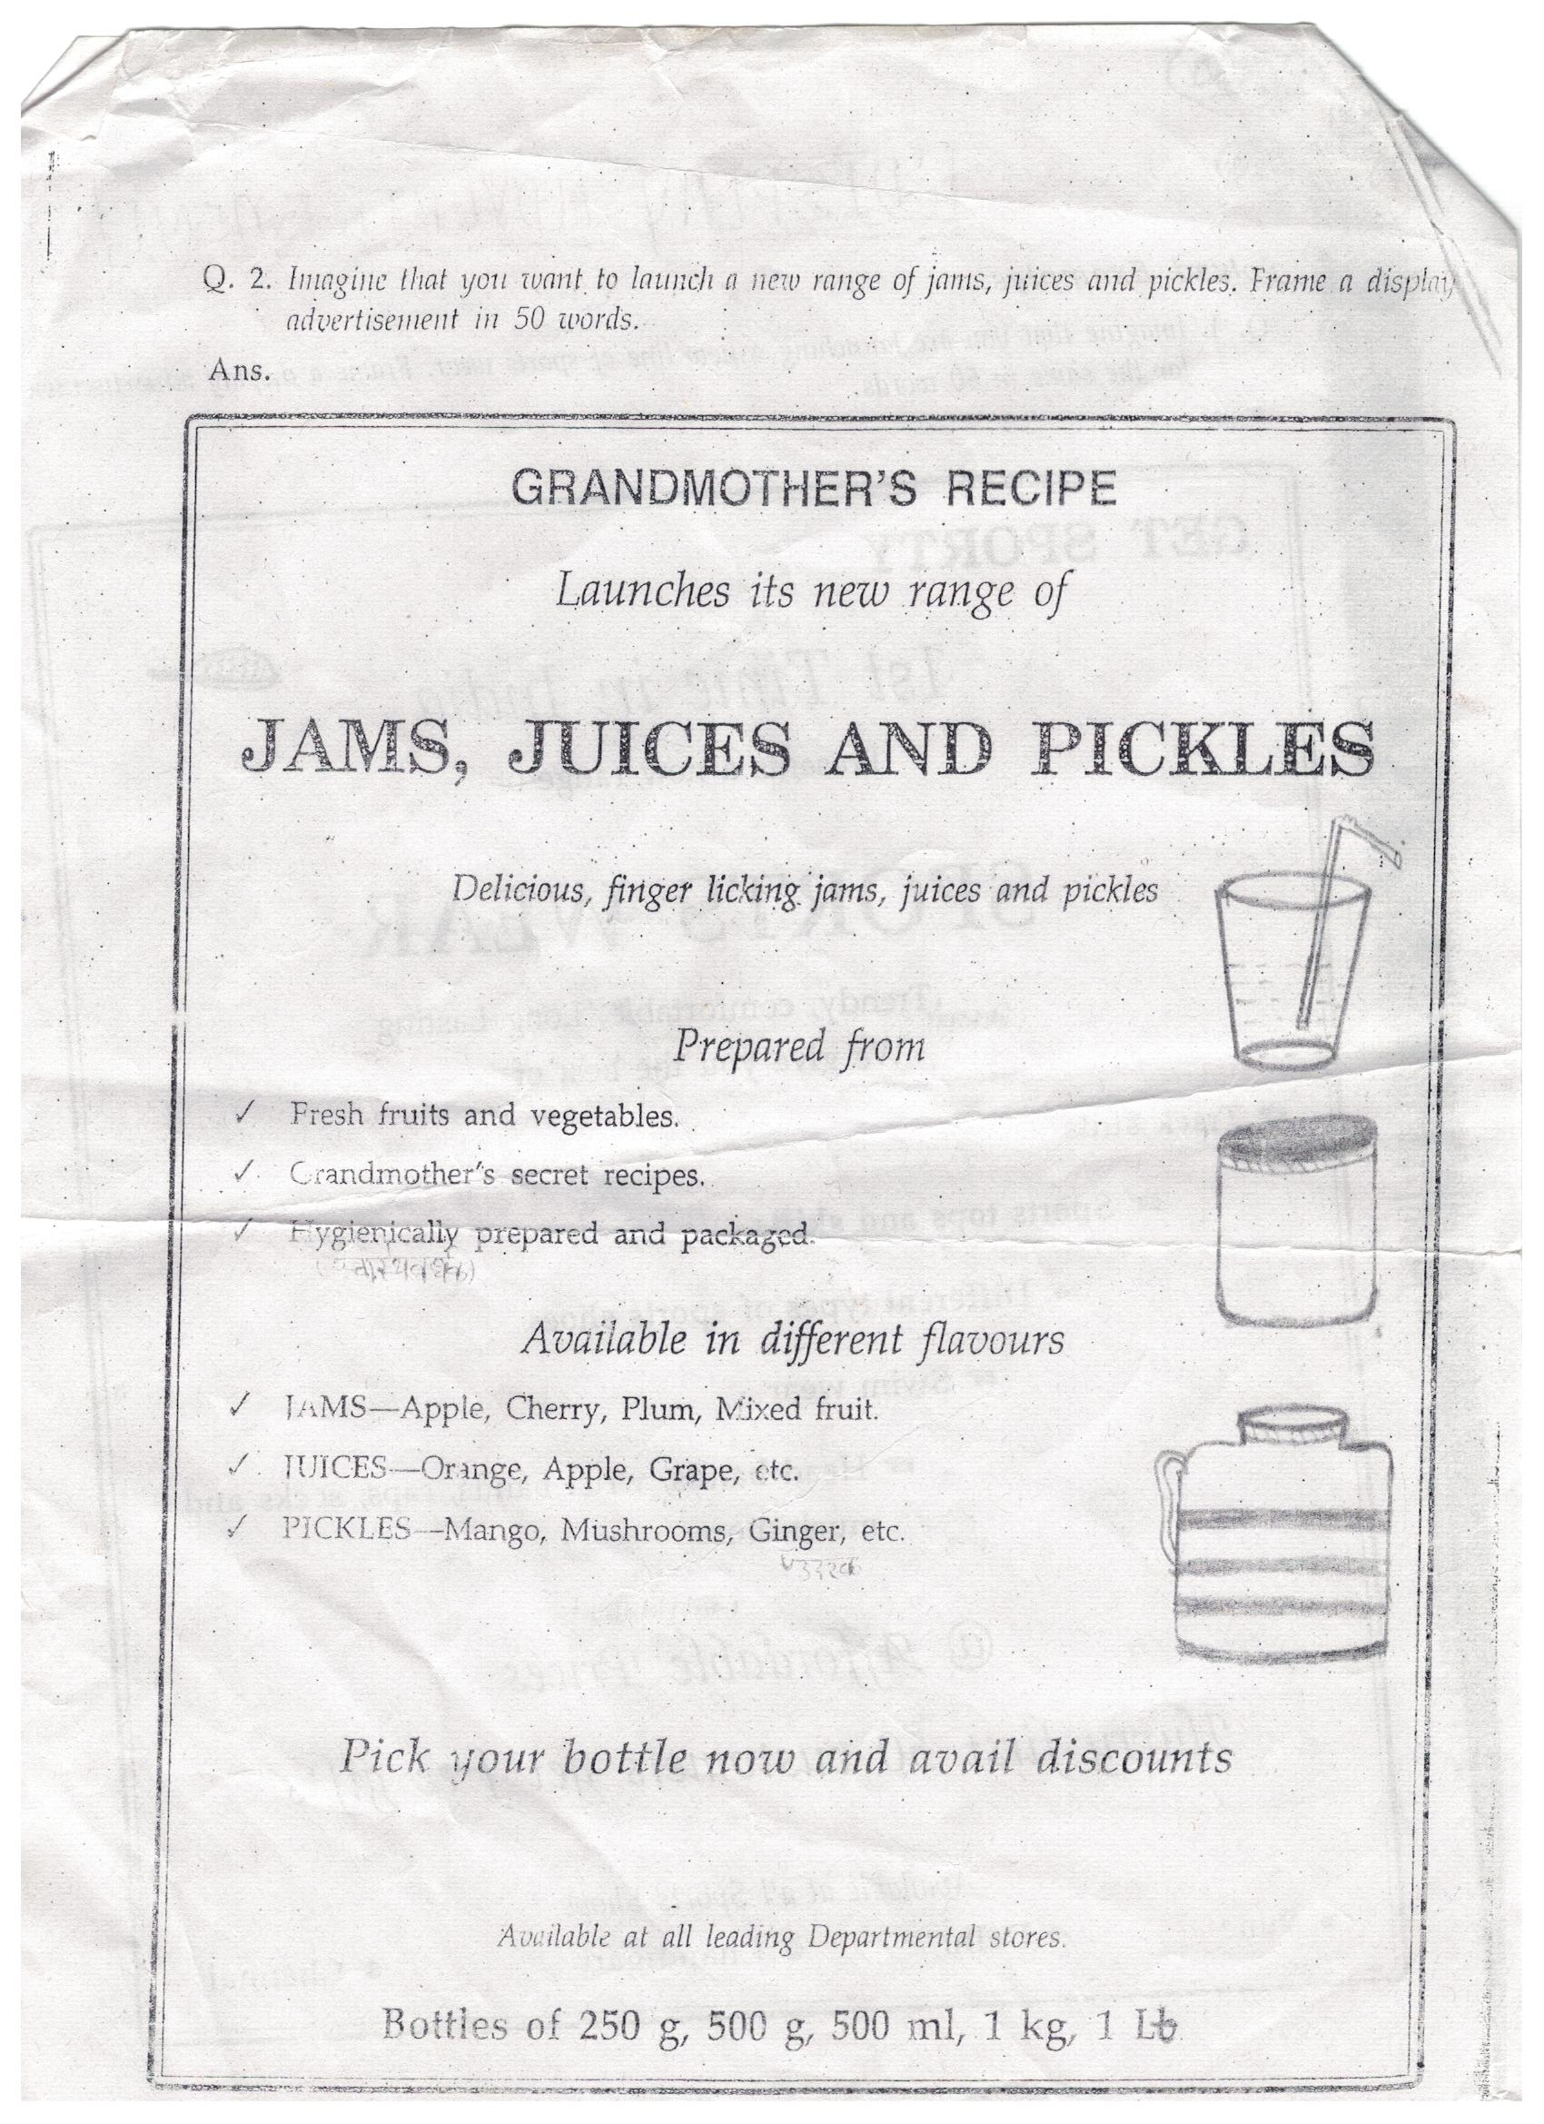
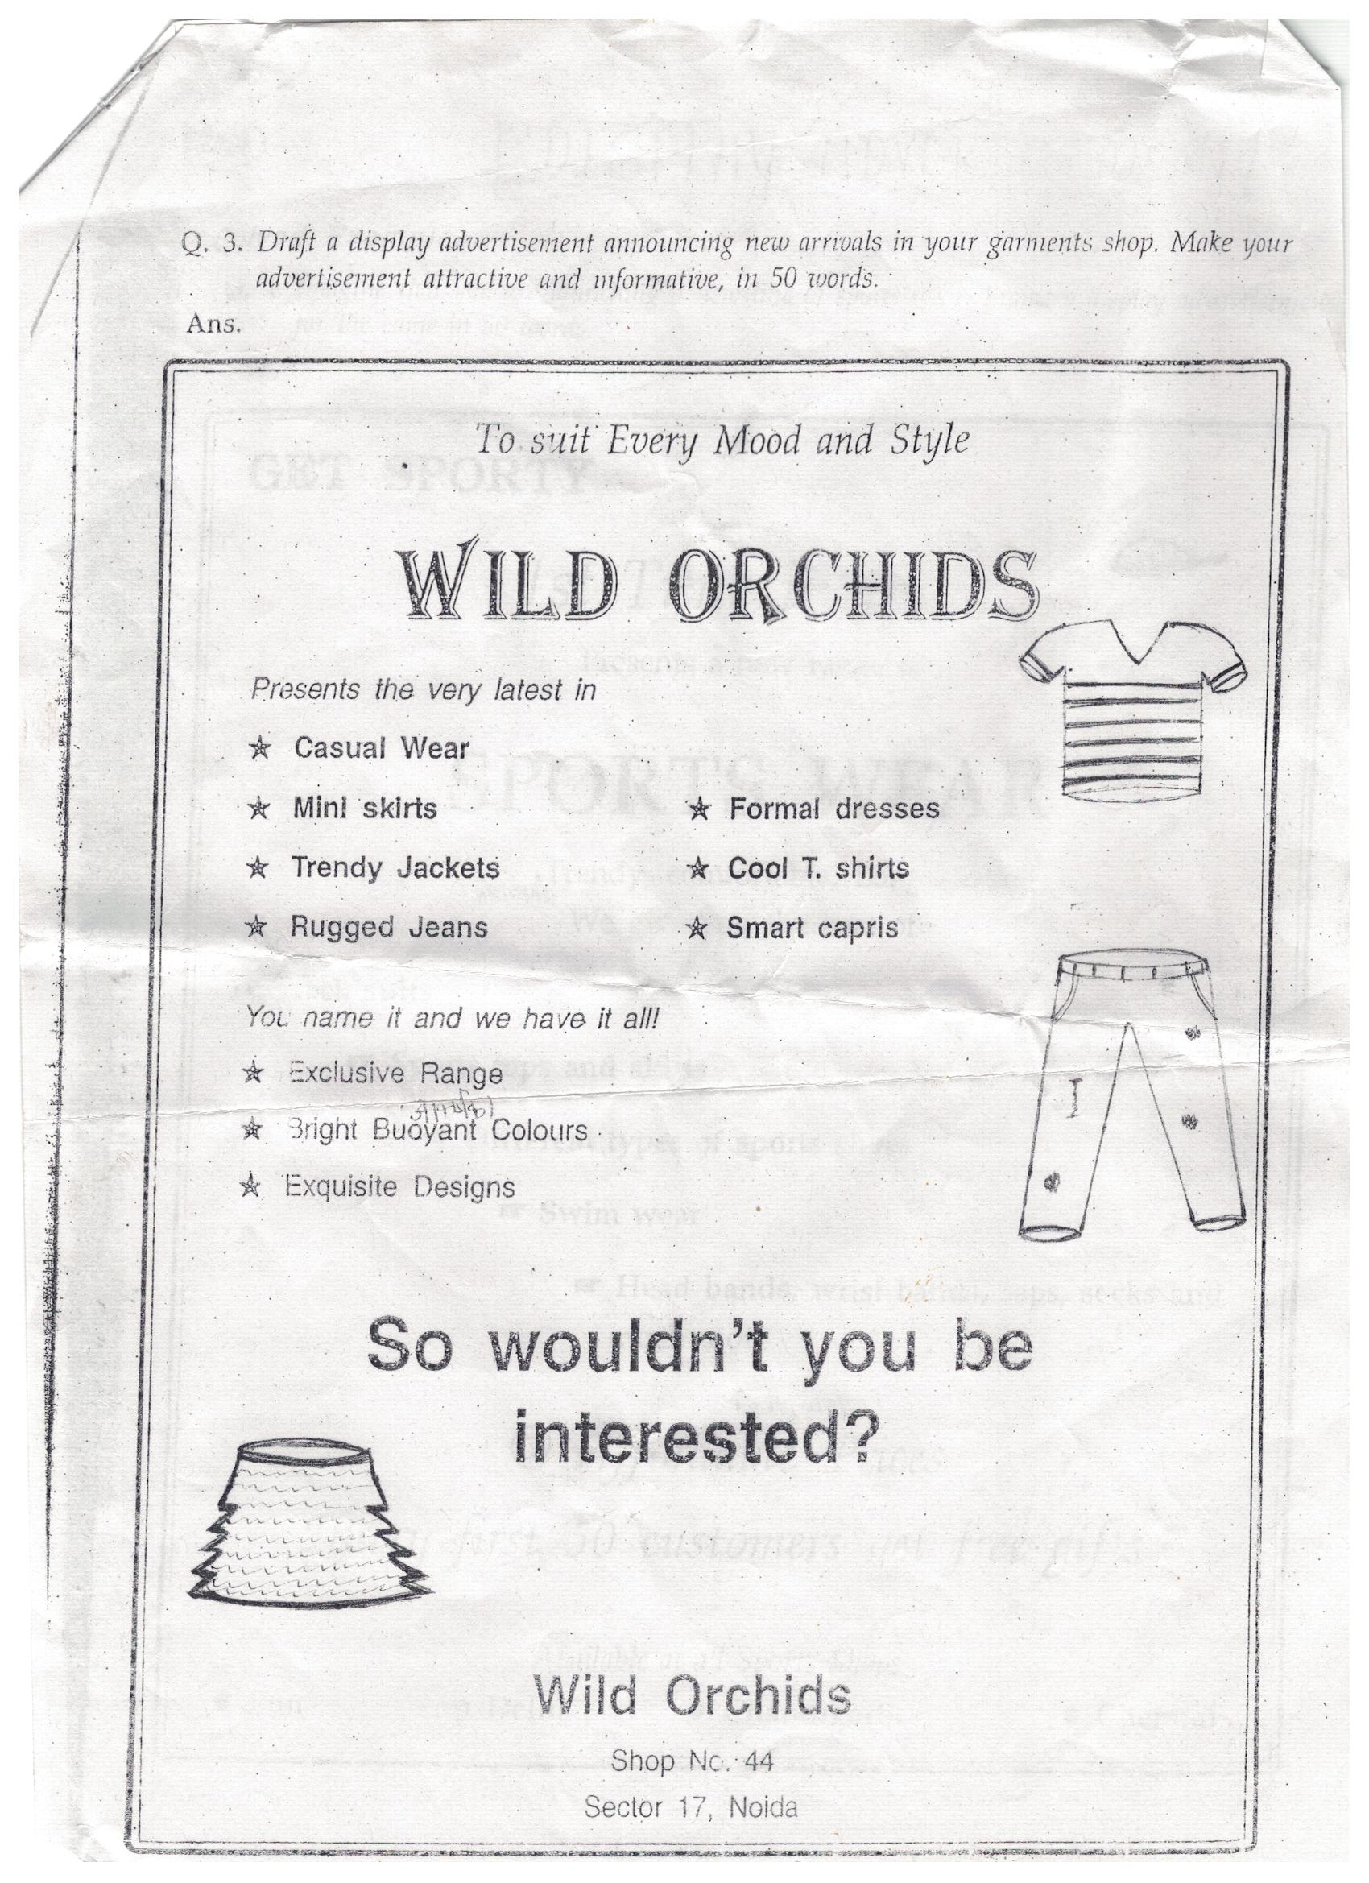

Q.5 prepare a poster to encourage people to keep their city clean and green
Ans:
KEEP YOUR
CITY GREEN
AND CLEAN
GREEN AND
DOS. DON’TS
- USE DUSTBINS AT PUBLIC PLACE LITTER HERE AND THERE
- SAVE PLANTS & TREES CUT TREES
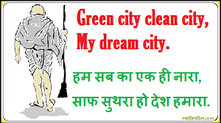
- GROW MORE & MORE PLANTS
- ENCOURAGE OTHER TO KEEP YOUR
- CITY CLEAN AND GREAN
CLEAN & GREEN CITY

IT IS ESSENTIAL TO KEEP YOURSELF HEALTHY AND ENJOY BEAUTIFUL ENVIRNMENT

Issued by : - NAGAR pALIKA
K.PATAN, BUNDI

Q.5 prepare a poster to create awareness about Ganga River to awareness.
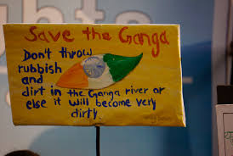
Ans:
SAVE
THE
GANGA

SAVE GANGA SAVE LIFE
CLEAN THE GANGA RIVER TO SAVE THE LIFE

ISSUED BY : AGRA NAGAR NIGAM

