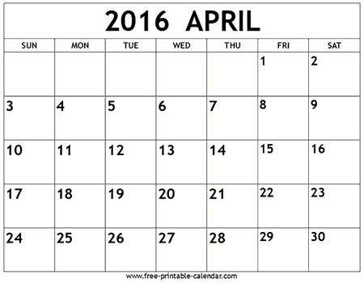

Chetichand
Ambedkar Ramnavmi
Jayanti Mahaveer
Jayanti

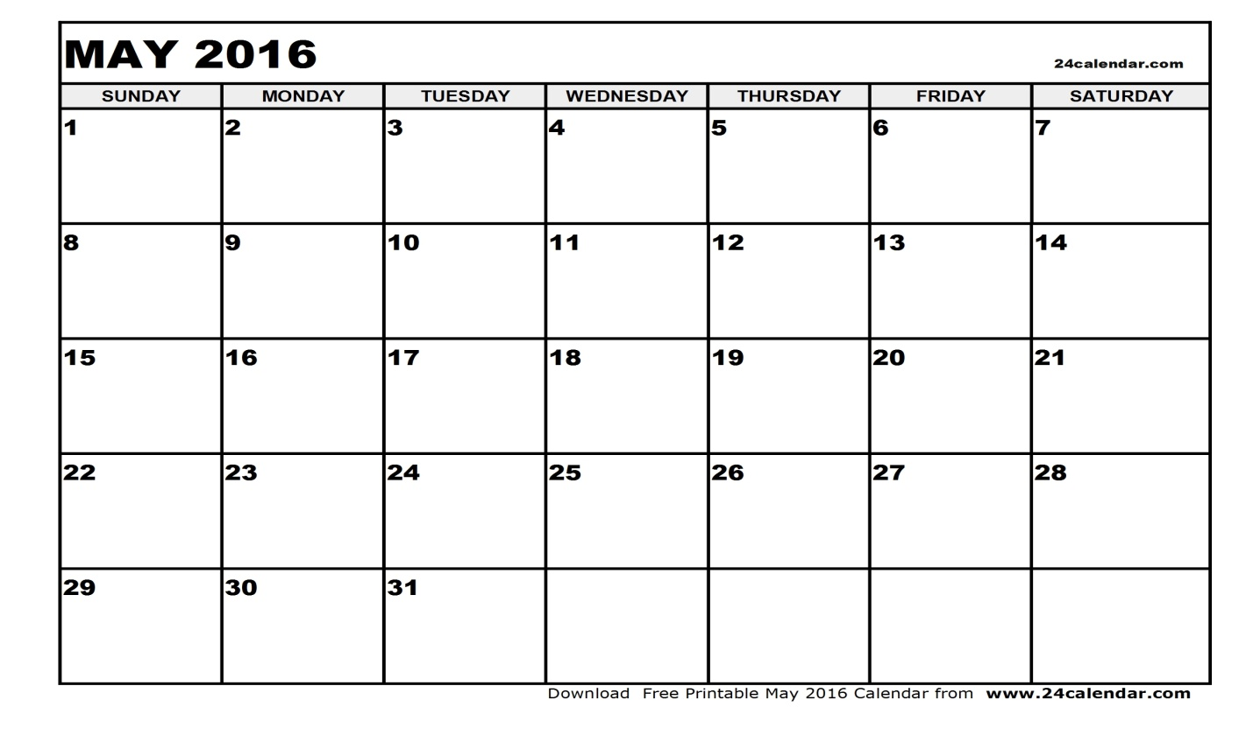

PTM
SUMMER BREAKS
SUMMER BREAKS

SUMMER BREAKS

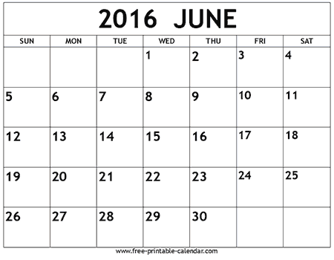
SUMMER BREAKS
SUMMER BREAKS
SUMMER BREAKS
SUMMER BREAKS
SUMMER BREAKS
SUMMER BREAKS
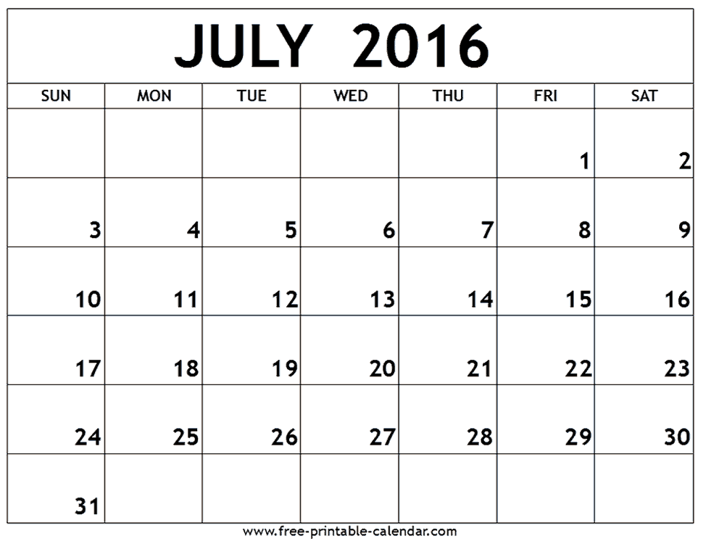

SCHOOL
REOPEN
ID UL FITR

F.A.2

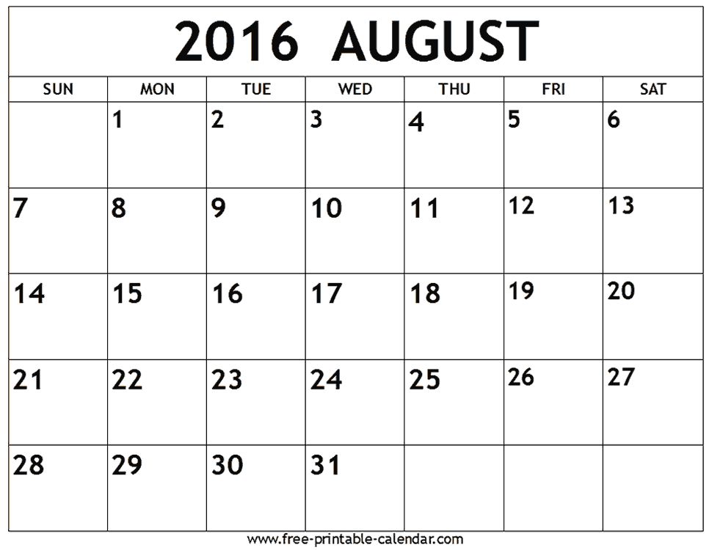

INDEPENDENCE Raksha-
Day bandhan

Janmashtami

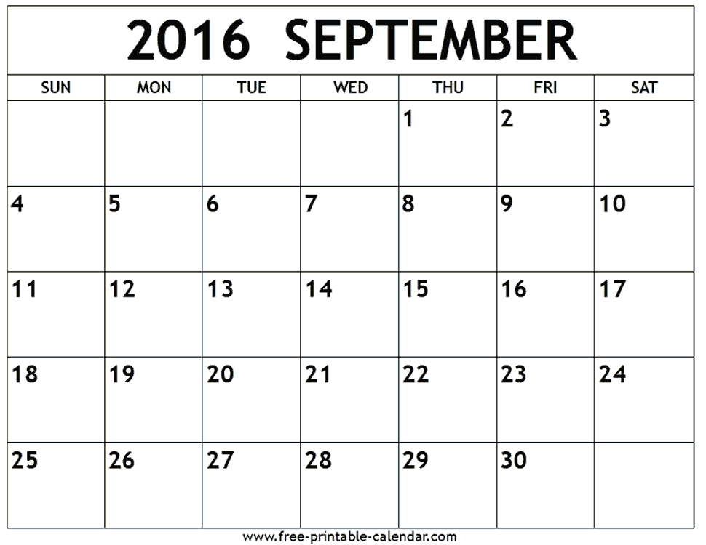

GANESH
CHATURTHI
BAKRID
S.A.1
S.A.1
S.A.1

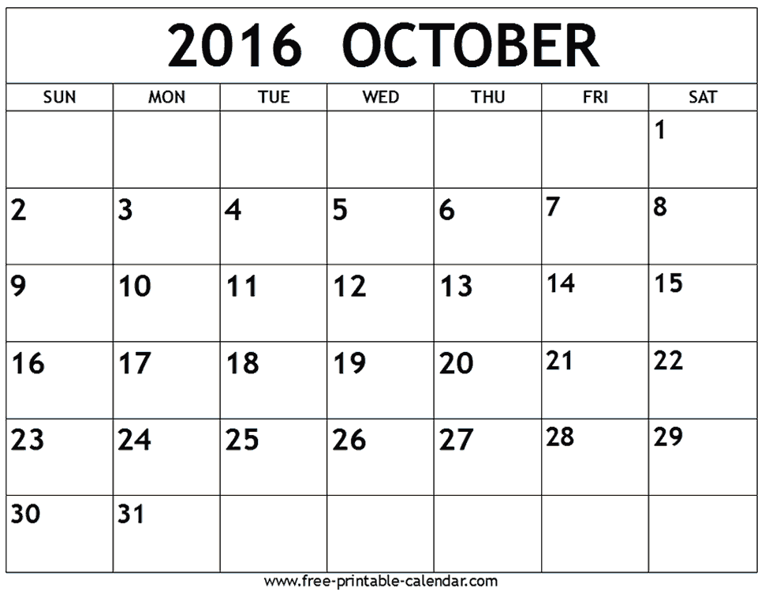

NAVRATRA STHAPANA
GANDHI
JAYANTI PTM
VIJAY-
DASHAMI MUHARRAM

DIWALI BREAKS
DIWALI BREAKS

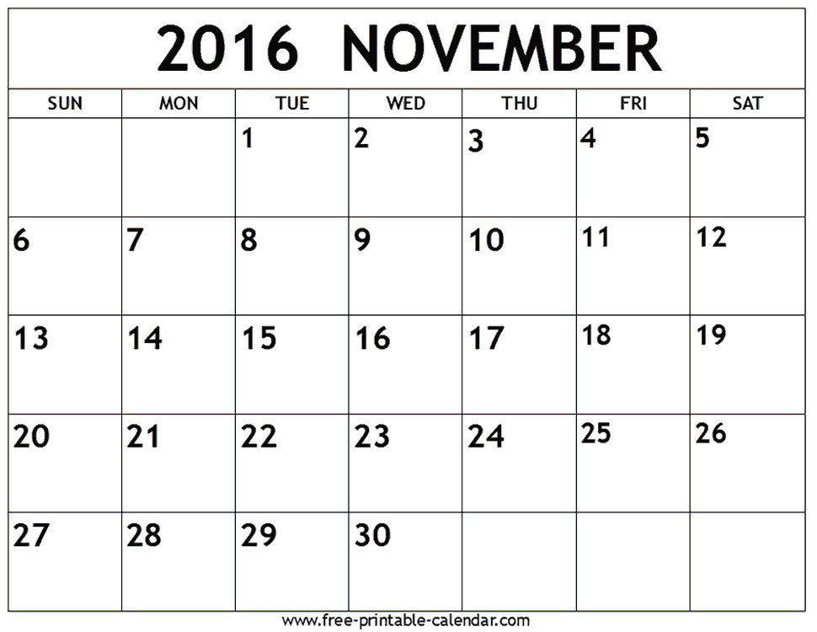

DIWALI BREAKS

CHILDREN’S DAY GURU NANAK JAYANTI
F.A.3
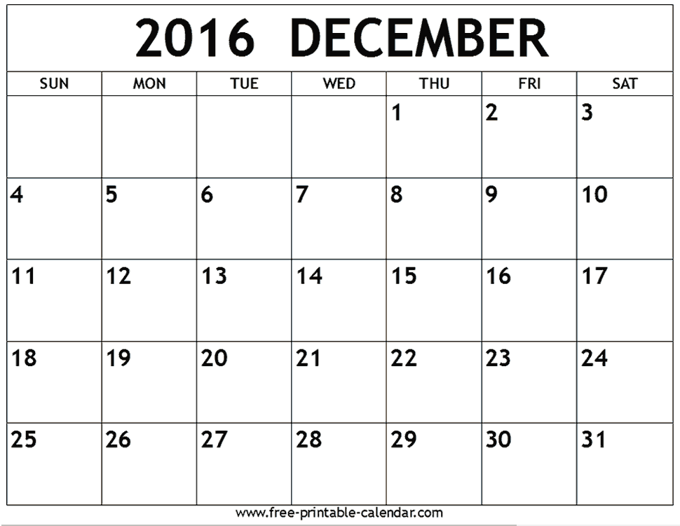

PTM

ID –E-MILAD
WINTER
BREAK
CHRISTMAS



MAKAR SAKRANTI
WINTER BREAKS
WINTER BREAKS

REPUBLIC DAY

F.A.4
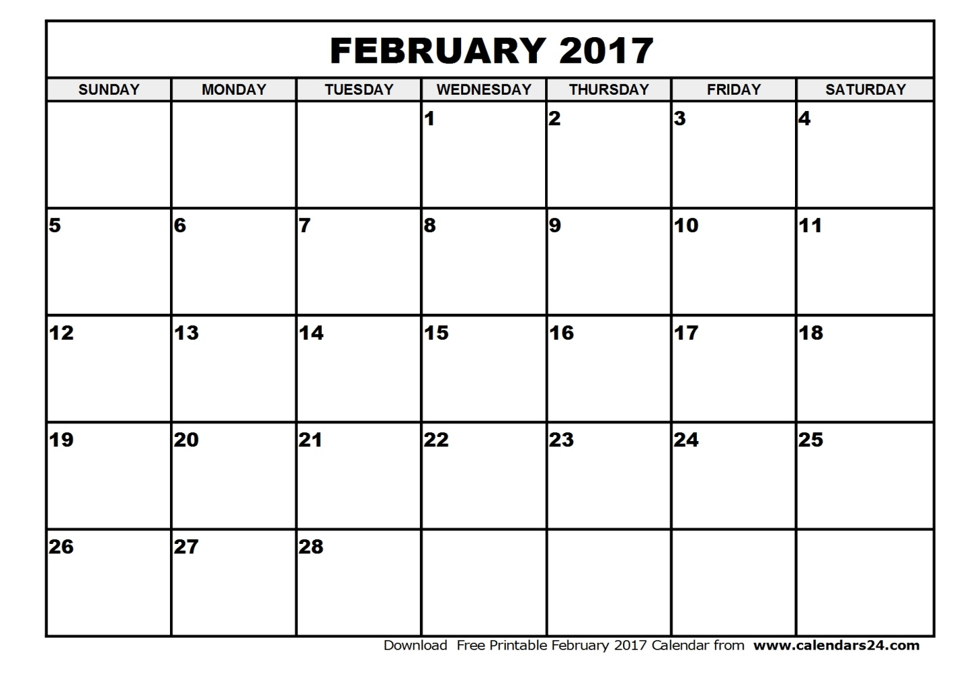

BASANT
PANCHAMI PTM MAHA
SHIVRATRI
ANNUAL
FUNCTION

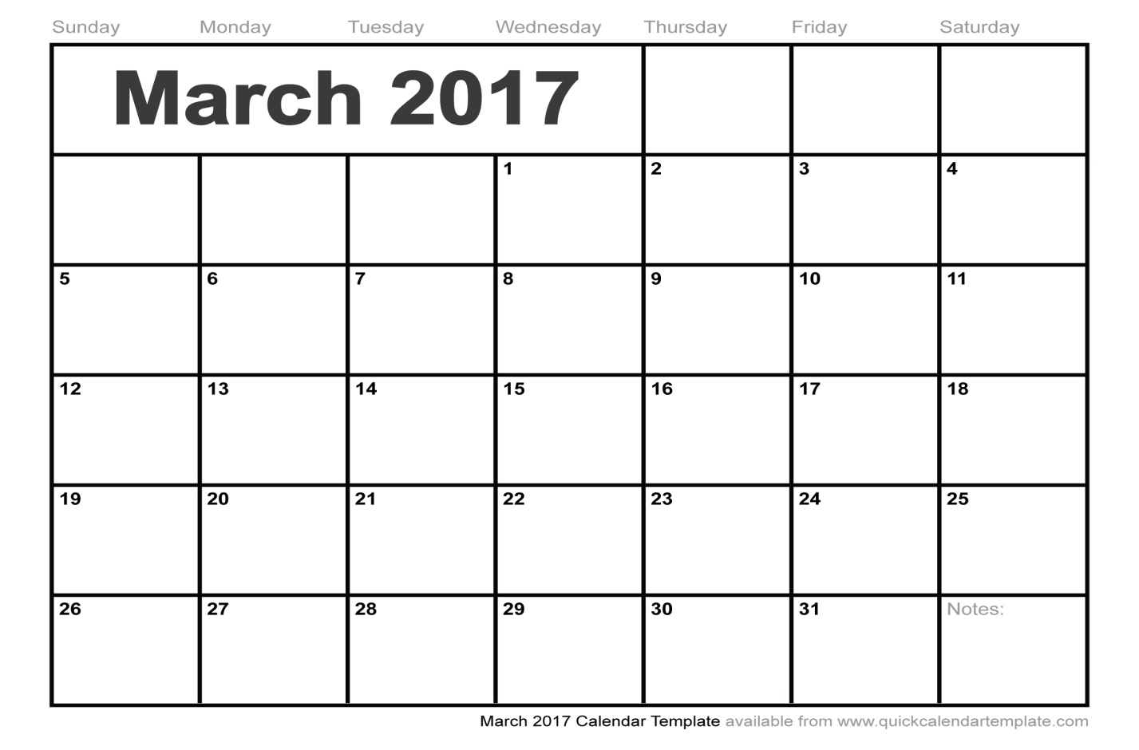
S.A.2
S.A.2

HOLI DHULANDI PTM
S.A.2

