**Information Technology**

**NVEQ Level 2 – Class X**

**IT206-NQ2012-Email Messaging (Intermediate)**

**Student’s Handbook**













**© PSS Central Institute of Vocational Education, 2012**

Copyright protects this publication. Except for purposes permitted by the Copyright Act, reproduction, adaptation, electronic storage and communication to the public are prohibited without prior written permission.

Student Details

**Student Name:______________________________**

**Student Roll Number:_________________________**

**Batch Start Date:____________________________**

Table of Contents

Acknowledgements 5

Preface………………………………………………………………………………………………………………6

**About Your Book………………………………………………………………………………………………..8**

SESSION 1: Working With Calendar 9

SESSION 2: Schedule an Appointment 13

SESSION 3: Categorize an Appointment 17

SESSION 4: Share a Calendar 19

SESSION 5: Print a Calendar 25

SESSION 6: Creating a Meeting Request 27

SESSION 7: Respond To a Meeting Request 29

SESSION 8: Create and Edit a Task 31

SESSION 9: Create and Edit a Note 33

SESSION 10: Create and Edit a Journal Entry 35

**Acknowledgements**

The following partners were instrumental in providing the content:

1. Central Board of Secondary Education (CBSE) in conjunction with Pandit Sunderlal Sharma Central Institute of Vocational Education (PSSCIVE) for providing text and exercises in Computer and IT Basics. The team involved included Dr. Om Vikas (Convener), Dr. Vinay Swarup Mehrotra (Co-Convener), Ms Gurpreet Kaur, Mr. Mukesh Kumar, Ms Nancy Sehgal and Mr. Yogesh Kumar and Mr. Rituraj Tamrakar.
2. Accenture India’s Corporate Citizenship Program (Skills 4 Life). Accenture has provided the content material they have commissioned and developed as well as access to their implementing partners (Dr. Reddy’s Foundation and QUEST Alliance) for this material.
3. Microsoft Free Digital Literacy Program eLearning package has been used to supplement CBSE/ PSSCIVE’s content.
4. The Wadhwani Foundation team involved in designing and building this curriculum and content include Ms. Darshika Sanghani, Ms. Sonia Kakkar, Mr. Karthik Chandru, Ms. Toral Veecumsee, Ms. Rekha Menon, Mr. Ajay Goel and Mr. Austin Thomas.
5. In addition, various public domain sources have been leveraged to create materials and illustrations across module. The contributions of all these sources is gratefully acknowledged and recognized.

**Preface**

The National Curriculum Framework, 2005, recommends that children’s life at school must be linked to their life outside the school. This principle makes a departure from the legacy of bookish learning which continues to shape our system and causes a gap between the school, home, community and the workplace.

The student workbook on “**Email Messaging (Intermediate)**” is a part of the qualification package developed for the implementation of National Vocational Education Qualification Framework (NVEQF), an initiative of Ministry of Human Resource Development (MHRD), Government of India to set common principles and guidelines for a nationally recognized qualification system covering Schools, Vocational Education and Training Institutions, Technical Education Institutions, Colleges and Universities. It is envisaged that the NVEQF will promote transparency of qualifications, cross-sectoral learning, student-centred learning and facilitate learner’s mobility between different qualifications, thus encouraging lifelong learning.

This student workbook, which forms a part of vocational qualification package for student’s who have passed Class IX or equivalent examination, was created by a group of experts. The IT-ITeS Skill Development Council approved by the National Skill Development Corporation (NSDC) for the IT/ITeS Industry developed the National Occupation Standards (NOS). The National Occupation Standards are a set of competency standards and guidelines endorsed by the representatives of IT Industry for recognizing and assessing skills and knowledge needed to perform effectively in the workplace.

The Pandit Sunderlal Sharma Central Institute of Vocational Education (PSSCIVE), a constituent of National Council of Educational Research and Training (NCERT) in association with Wadhwani Foundation has developed modular curricula and learning materials (Units) for the vocational qualification package in IT/ITes sector for NVEQ levels 1 to 4; level 1 is equivalent to Class IX. Based on NOS, occupation related core competencies (knowledge, skills, and abilities) were identified for development of curricula and learning modules (Units).

This student workbook attempts to discourage rote learning and to bring about necessary flexibility in offering of courses, necessary for breaking the sharp boundaries between different subject areas. The workbook attempts to enhance these endeavours by giving higher priority and space to opportunities for contemplation and wondering, discussion in small groups and activities requiring hands-on-experience. We hope these measures will take us significantly further in the direction of a child-centred system of education outlined in the National Policy of Education (1986). The success of this effort depends on the steps that school Principals and Teachers will take to encourage children to reflect their own learning and to pursue imaginative and on-the-job activities and questions. Participation of learners in skill development exercises and inculcation of values and creativity is possible if we involve children as participants in learning, and not as receiver of information. These aims imply considerable change in school routines and mode of functioning. Flexibility in the daily time-table would be a necessity to maintain the rigour in implementing the activities and the required number of teaching days will have to be increased for teaching and training.

**About Your Workbook**

This workbook is to assist you with completing the Unit of Competency **IT206-NQ2012: Email Messaging (Intermediate).** You should work through the workbook in the classroom, at the workplace or in your own time under the guidance and supervision of your teacher or trainer.

This workbook contains sessions which will help you to acquire relevant knowledge and skills (soft and hard) on various aspects of the unit of competency. Each session is small enough to be easily tackled and digested by you before you move on to the next session. Animated pictures and photographs have been included to bring about visual appeal and to make the text lively and interactive for you. You can also try to create your own illustrations using your imagination or taking the help of your teacher. Let us now see what the sections in the sessions have for you.

**Section1: Introduction**

This section introduces you to the topic of the Unit. It also tells you what you will learn through the various sessions covered in the Unit.

**Section 2: Relevant Knowledge**

This section provides you with the relevant information on the topic (s) covered in the session. The knowledge developed through this section will enable you to perform certain activities. You should read through the information to develop an understanding on the various aspects of the topic before you complete the exercise (s).

**Section 3: Exercise**

Each session has exercises, which you should complete on time. You will perform the activities in the classroom, at home or at the workplace. The activities included in this section will help you to develop necessary knowledge, skills and attitude that you need for becoming competent in performing the tasks at workplace. The activities should be done under the supervision of your teacher or trainer who will guide you in completing the tasks and also provide feedback to you for improving your performance. To achieve this, prepare a timetable in consultation with your teacher or trainer and strictly adhere to the stipulated norms or standards. Do not hesitate to ask your teacher or trainer to explain anything that you do not understand.

**Section 4: Assessment**

The review questions included in this section will help you to check your progress. You must be able to answer all the questions before you proceed to the next session.

## **session 1: Working With Calendar**

**RELEVANT KNOWLEDGE**

Time Management is the act of planning to stay organized that will result in increased efficiency and productivity. Time management can be performed using simple techniques such as a paper and pen; you can also use calendar software to plan your time.

Calendaring software provides the user an electronic version of a calendar. It is a time management tool, a system of organizing days for social, religious, commercial, or administrative purposes. Most email applications include support for working with Calendar; you can also use online calendar such as Google Calendar however this requires internet connectivity.

In this exercise, you will learn to work with a calendar application. In these exercises, you will be practicing on Outlook Calendar. At the end of the sessions, you can easily navigate on any other calendar software as the features are almost the same. To learn about Google calendar you can explore the site <http://services.google.com/apps/resources/overviews_breeze/Calendar/index.html>.

Start the email program by:

Click ***Start*** > ***Programs*** > ***Microsoft Office*** > ***Microsoft Outlook*.**

Click ***Calendar*** located at the bottom left corner (figure below).

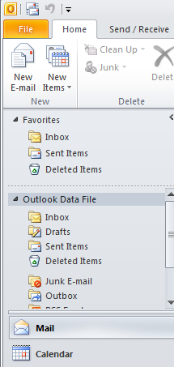

A window similar to the one below appears.

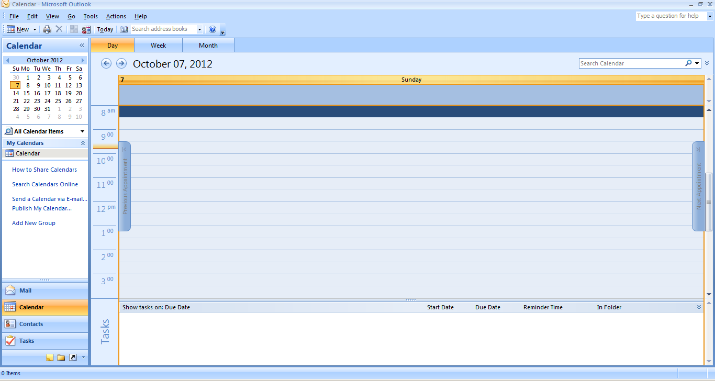

You can create appointments and schedule day-to-day activities using calendar. The application provides three views:

* Day
* Week
* Month

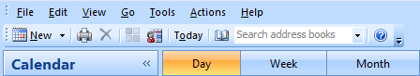

For example, to schedule an activity for a particular time in the day, choose Day view. The default view is by “Day”.

You can select either the ***Show work week*** (Monday to Friday) or ***Show full week*** (Sunday to Saturday) to view the appropriate days in the week by selecting one of the given options.



Selecting the ***Month*** view shows calendar for a month. You can plan your monthly schedule here. Any appointments/meetings/commitments previously set in the day/week view will also be reflected here.

You can switch over to a specific date in the calendar by selecting the date in the data navigator.

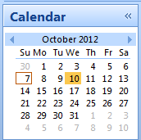

You can set the options for the calendar by selecting ***Tools*** > ***Options***. A dialog box appears as shown below.

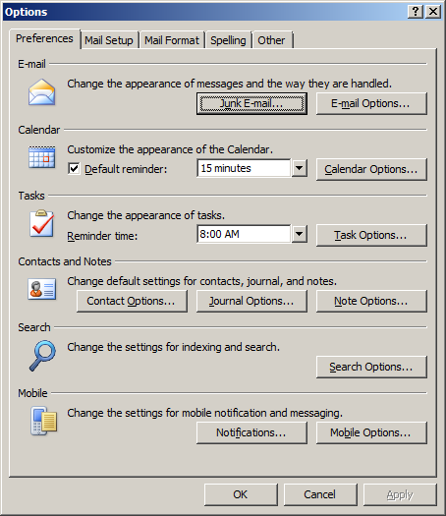

Click on ***Calendar Options…*** and a dialog box appears as shown below.

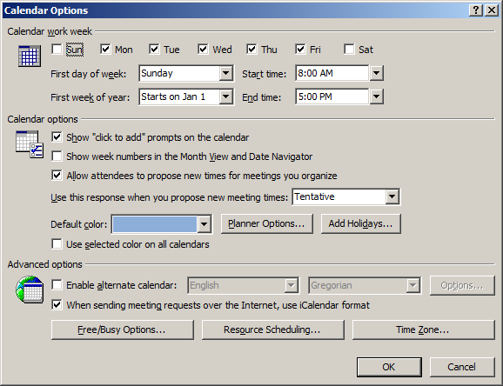

You can make changes to the calendar by using appropriate options in the dialog box.

**EXERCISE**

Perform the following activities till you are confident:

|  |  |
| --- | --- |
| **S.No.** | **Activities** |
| 1. | Try each of the options in the Calendar Options dialog box and observe the changes. Make a note of all changes in your notebook. |

**ASSESSMENT**

**Fill in the blanks:**

1. _________________ is the act of planning to stay organized that will result in increased efficiency and productivity.
2. A _____________ software provides the user an electronic version of a calendar.
3. The three view supported by a calendaring software are ________ , _______ & ______.

## **session 2: Schedule an Appointment**

**RELEVANT KNOWLEDGE**

You can create appointments using the calendar. For example, you can create an appointment for visiting a dentist.

In this exercise, you will learn to schedule an appointment.

You can schedule an appointment in two ways:

1. Using menu bar.
2. Using calendar view.

Go to ***File*** > ***New*** > ***Appointment***, a window similar to the one below will be displayed.

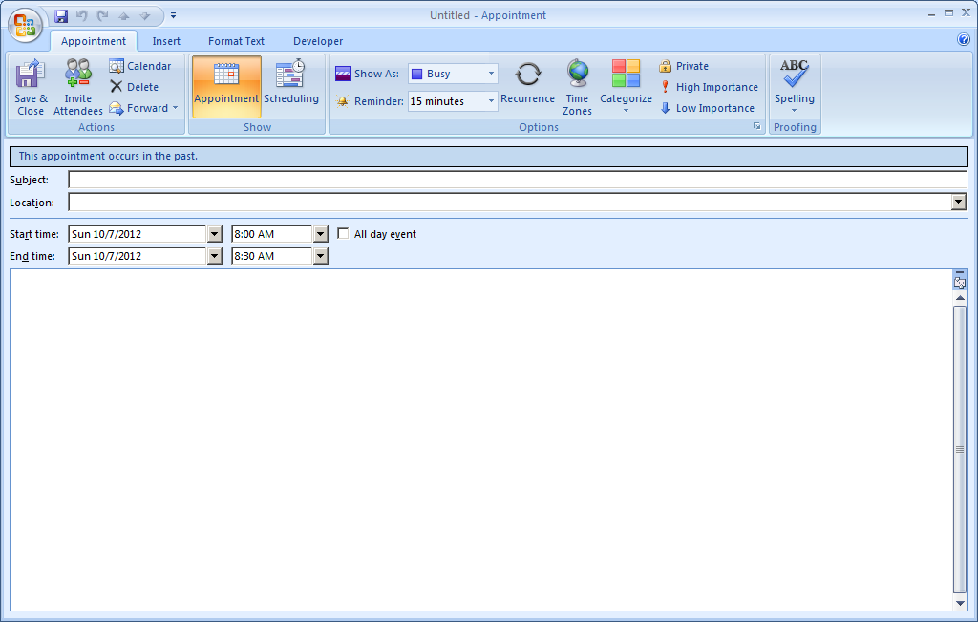

Subject of the appointment

Location of the appointment

Once you have created an appointment, click the ***Save & Close*** option for the calendar to store this information. The details will be reflected in the calendar.

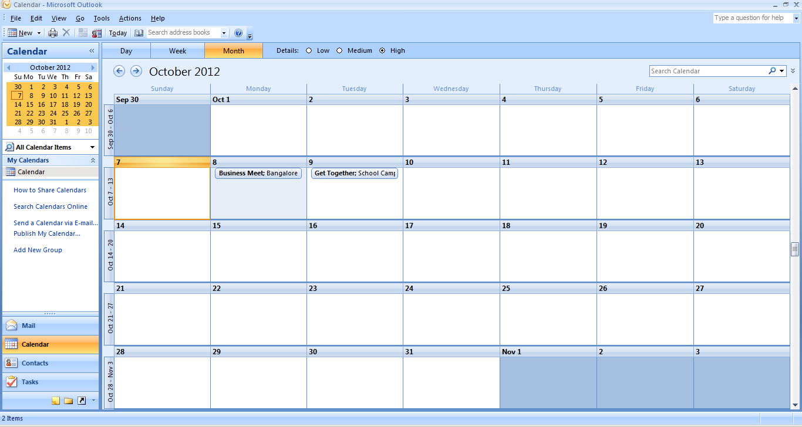

Calendar software prompts you with an alert based on entries scheduled in the calendar.

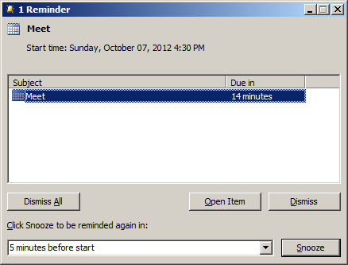

You can create appointments on a daily, weekly, monthly or yearly basis. You can create recurring appointments, for example, you create your breakfast schedule everyday between 7:30 to 8:00 AM. To do so, right-click on the calendar and click ***New Recurring Appointment***.

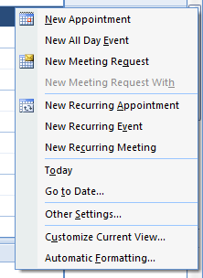

An ***Appointment Recurrence*** window appears. You can specify the appointment time, recurrence pattern and the range of recurrence here.

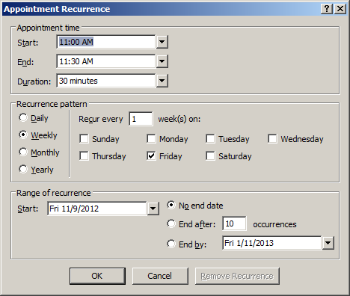

Enter a recurring event, select multiple days and click **OK**.

Recurring appointments appear on the calendar as a daily activity as displayed below.



**EXERCISE**

Perform the following activities till you are confident:

|  |  |
| --- | --- |
| **S.No.** | **Activities** |
| 1. | Schedule a onetime and a recurring appointment |
| 2. | Create appointments for the following items:   1. Daily class schedule. 2. Exam schedule. 3. Exam preparation schedule. 4. Visit to Circus (One time activity). 5. Parent / Teacher Meeting (Monthly activity). 6. Visit to a book store (One time activity). 7. Vaccine Schedule (Yearly activity).   Save the appointments, you will use them in the next exercise. |

**ASSESSMENT**

**Fill in the blanks:**

1. The two ways to schedule an appointment are: ____________________________ & _____________.
2. Calendar software prompts with an __________ based on entries scheduled in the calendar.
3. _______________ appointments can be used for scheduling repetitive tasks.

## **session 3: Categorize an Appointment**

**RELEVANT KNOWLEDGE**

You can categorize the appointments in time management software by giving the specific colors to the appointments. For example, you can use green color for all school related activities and blue for all personal activities. Using Calendar you can name colors (and change the names when you want to). You use colors to make specific entries stand out at a glance and catch your eye. In this exercise, you will learn to categorize appointments.

You can either categorize the appointments at the time of creation of the appointment or categorize after creating the appointment.

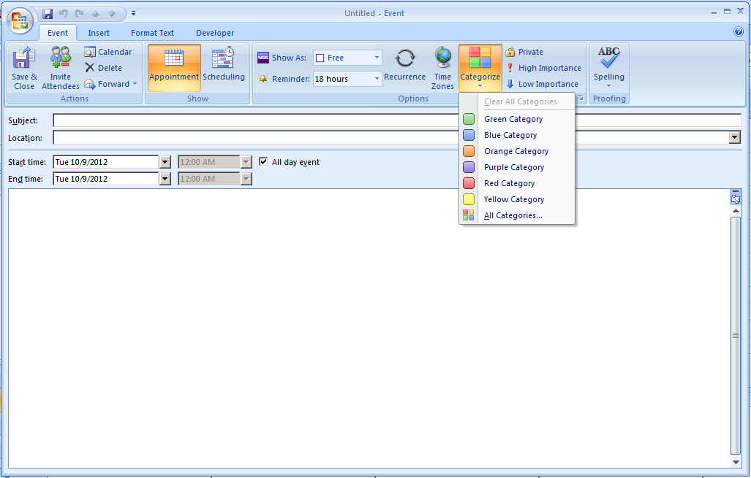

To use a category while creating an appointment, select a color from the **Categorize** dropdown list (figure above). To apply category for an existing appointment, double-click on the appointment and select a color from the **Categorize** dropdown list.

You can name all the categories. A sample has been shown below:

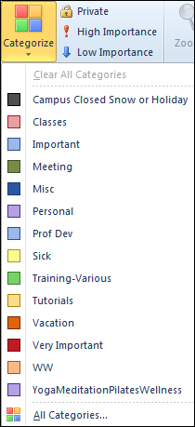

**EXERCISE**

Perform the following activity till you are confident:

|  |  |
| --- | --- |
| **S.No.** | **Activity** |
| 1. | Create appointments with different categories and apply categories to existing appointments created in the previous exercise. Also, try to rename a named category and to remove a category you have created. |

**ASSESSMENT**

**Fill in the blanks:**

1. You can categorize appointments in time management software by giving specific __________ to appointments.
2. Some of the categories in the time management software are:
3. ____________________________
4. ____________________________
5. ____________________________
6. ____________________________
7. ____________________________
8. ____________________________

## **session 4: Share a Calendar**

**RELEVANT KNOWLEDGE**

You can also share your calendar with someone else by sending the calendar to the concerned person’s email id. The question that comes to the mind is why should I? Sharing your calendar helps to share various segments of your time-centric life with your spouse, family, and others. You are able to receive time-centric news and updates from trusted providers. Calendar sharing is the last frontier for true collaboration and social networking. Moreover, you can create calendar folders and choose specific folders to share. For example, you can create a calendar folder for a particular project and share it with your co-workers. You can also grant them permission to modify the events and appointments in the calendar.

In this exercise, you will learn to share a copy of your calendar in an email message using email server. The calendar will be uploaded to the mail server and can be accessed by others using their email id.

Click on ***Publish My Calendar…*** option available in the Navigation Pane of the Calendar as shown below.

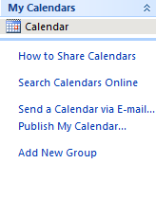

Note: In order to upload your calendar to the mail server, you must have an email account in Microsoft Mailing service. Click ***Sign in***, to login with your account, if you having one; otherwise create an email account by selecting ***click here to sign up for a free account*** available in the window***.*** Enter your email ID and password and click ***Sign in***. The following window appears:

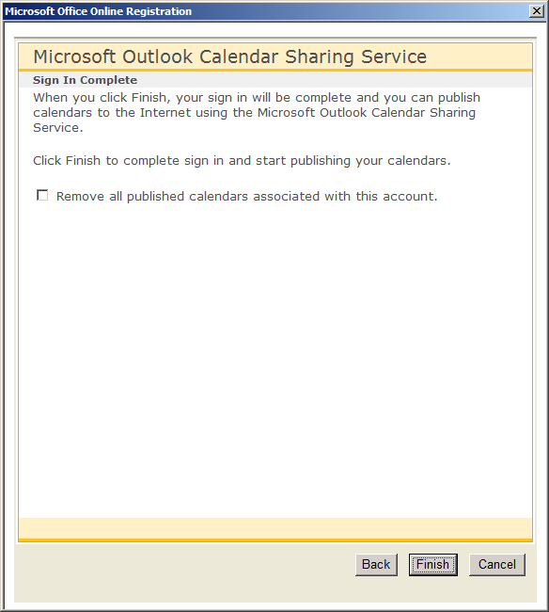

Click ***Finish*** to publish the calendar on the mail server. The following dialog box appears:

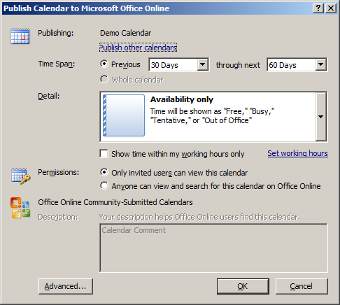

Select the time span in the calendar to be shared by selecting the drop down values. You can configure what details are to be shared with others using the ***Detail*** list and ***Permissions*** options. After specifying necessary details, click ***OK.*** The following dialog box appears as shown below.

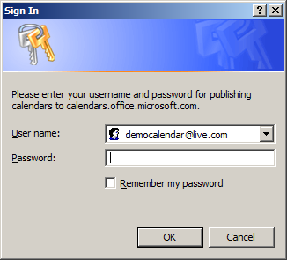

You are asked to enter your email account details to publish the calendar.

Once you enter all the details, click ***OK.*** Once you click ***OK*** the following message box appears.

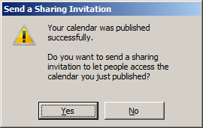

To send the invitation, click **Yes**. The ***Calendar - Share*** window appears.

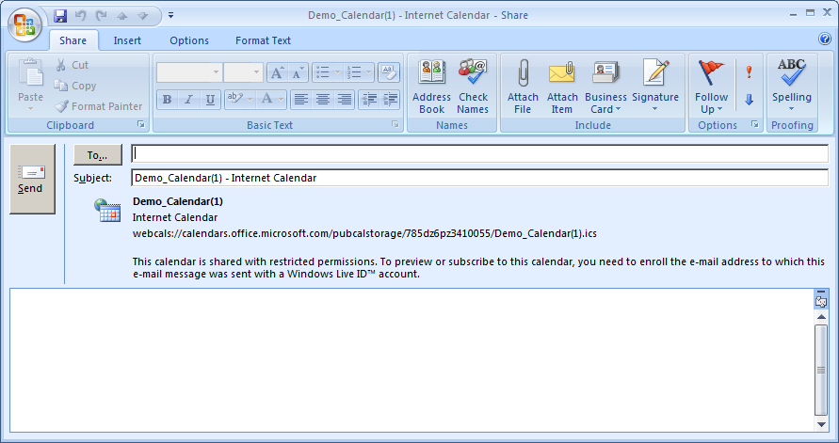

Enter the email accounts to whom you would like to share the calendar with and click **Send** and the invitation will be sent to their email accounts.

When others sign in into their mail accounts, the following message will be displayed to the recipients.

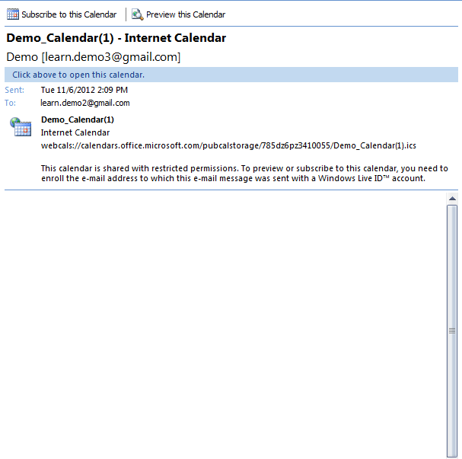

To view the shared calendar, the recipients have to click on ***Subscribe to this Calendar*** option available at the top of the message. The following dialog box appears:

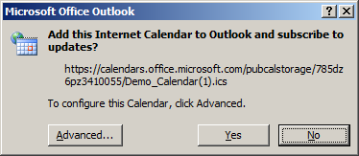

Click ***Yes*** to subscribe to the shared calendar. Once you click ***Yes,*** the recipients will be displayed with a window similar to the one below to enter their account details.

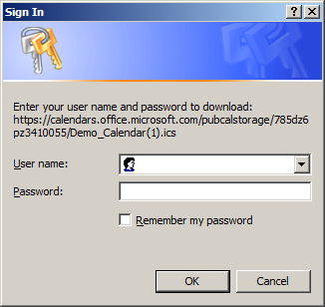

Once the authentication is complete, the calendar will be downloaded and made available on their calendar program.

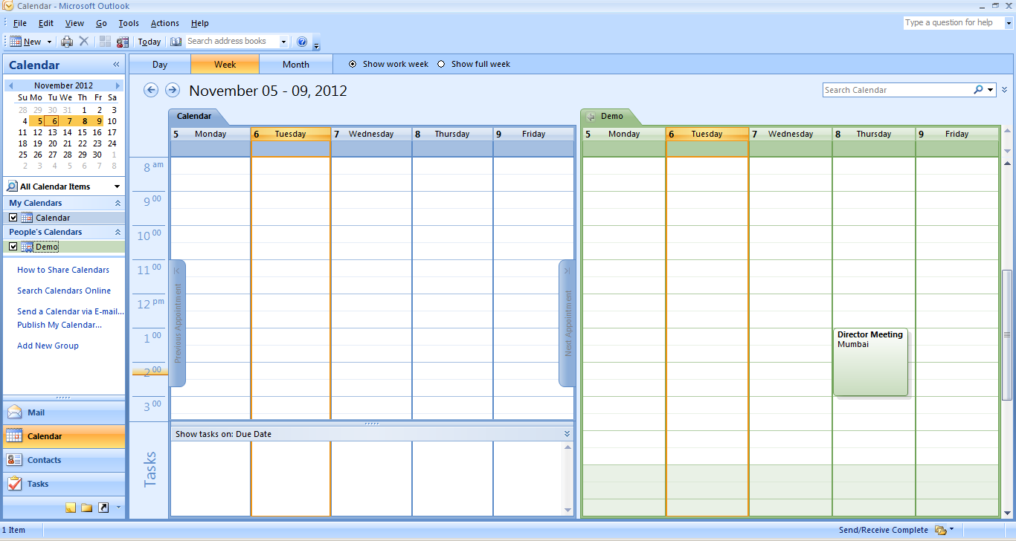

Now other users can view your calendar.

You can also send a copy of your calendar to other users as a standard email message. The calendar will be displayed as an attachment to the recipients in the email. To do so, click on ***Send a Calendar via E-mail*** option available in the Navigation Pane of the Calendar as shown below.

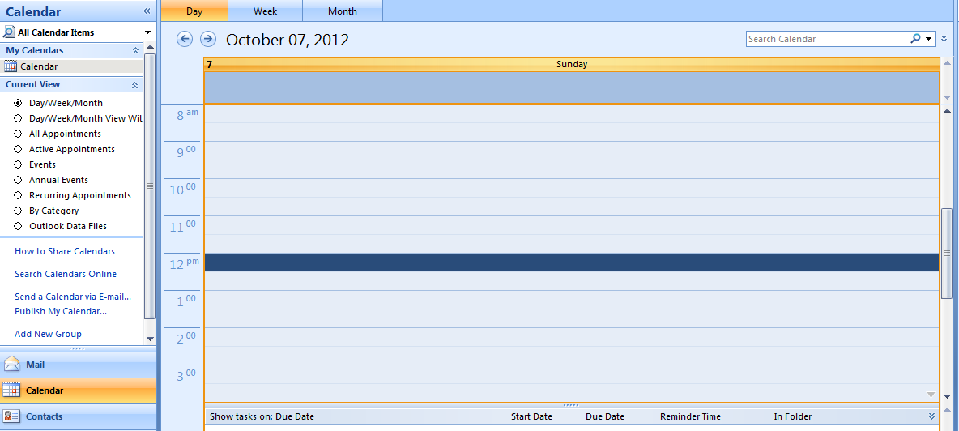

The ***Send a Calendar via E-mail*** dialog box appears.

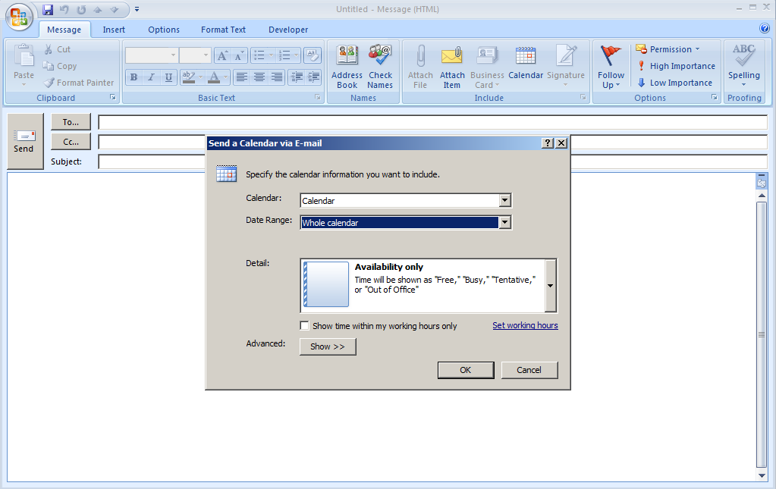

You can send either the entire calendar or particular week or day in the calendar by selecting the appropriate option and click **OK**.

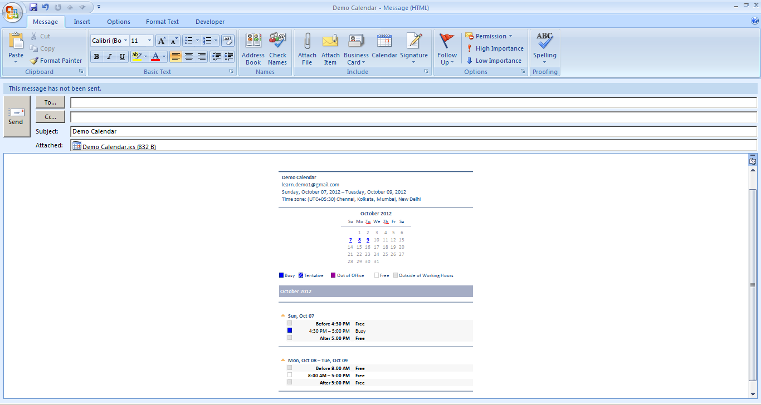

You can specify the address of the user to whom you want to share the calendar and click ***Send*** to send the calendar to the person.

**EXERCISE**

Perform the following activities till you are confident:

|  |  |
| --- | --- |
| **S.No.** | **Activities** |
| 1. | Share the calendar you have created in the previous sessions with your classmates using both the methods you have learnt in this exercise. |

**ASSESSMENT**

**Fill in the blanks:**

1. _____________ your calendar helps to share various segments of your time-centric life with your spouse, family, and others.
2. _____________ is the last frontier for true collaboration and social networking.
3. To share a calendar you have to select __________________ option available in the Navigation Pane.

## **session 5: Print a Calendar**

**RELEVANT KNOWLEDGE**

You can print the calendar and keep it for reference. This might be useful in situations when you don’t have access to a computer. In this exercise, you will learn to print a calendar.

Go to ***File*** > ***Print***, the ***Print*** dialog box appears.

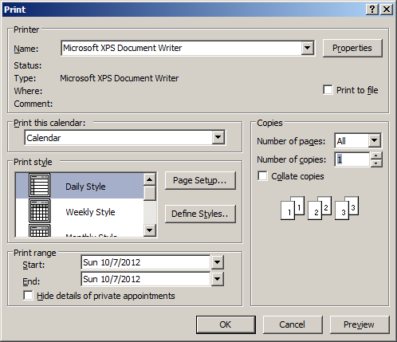

Select the range of the calendar by specifying the dates that you need to be printed and click ***OK****.*

Now try printing using different styles (Daily, Weekly, and Monthly) available in the ***Print style*** box (figure above).

To print the details of private appointments, uncheck the ***Hide details of private appointments*** check box.

To print non-adjacent days, change to Week or Month [view](javascript:AppendPopup(this,'156463030_2')) and then select the days you want to print, and then click ***File*** > ***Print***.

**EXERCISE**

Perform the following activities till you are confident:

|  |  |
| --- | --- |
| **S.No.** | **Activities** |
| 1. | Print a calendar using options in the print dialogue box. You may opt for either the daily, monthly or weekly style as per your choice. |

**ASSESSMENT**

**Fill in the blanks:**

1. Print option is available under ___________ menu.
2. To print the details of private appointments you have to uncheck ______________________ checkbox.

## **session 6: Creating a Meeting Request**

**RELEVANT KNOWLEDGE**

A meeting is an appointment to which you invite people or reserve resources for (meeting hall, equipment etc.). You can create and send meeting requests and reserve resources for face-to-face meetings or for online meetings. To create a meeting, you identify the people to be invited, the resources to be reserved and pick a meeting time. Responses to your meeting request appear in your Inbox. You can also add people to an existing meeting or reschedule a meeting if the schedule is not convenient. In this exercise, you will learn to create a meeting request. You can schedule a meeting request using email application software.

Go to ***File*** > ***New*** > ***Meeting Request***, the following window will be displayed:

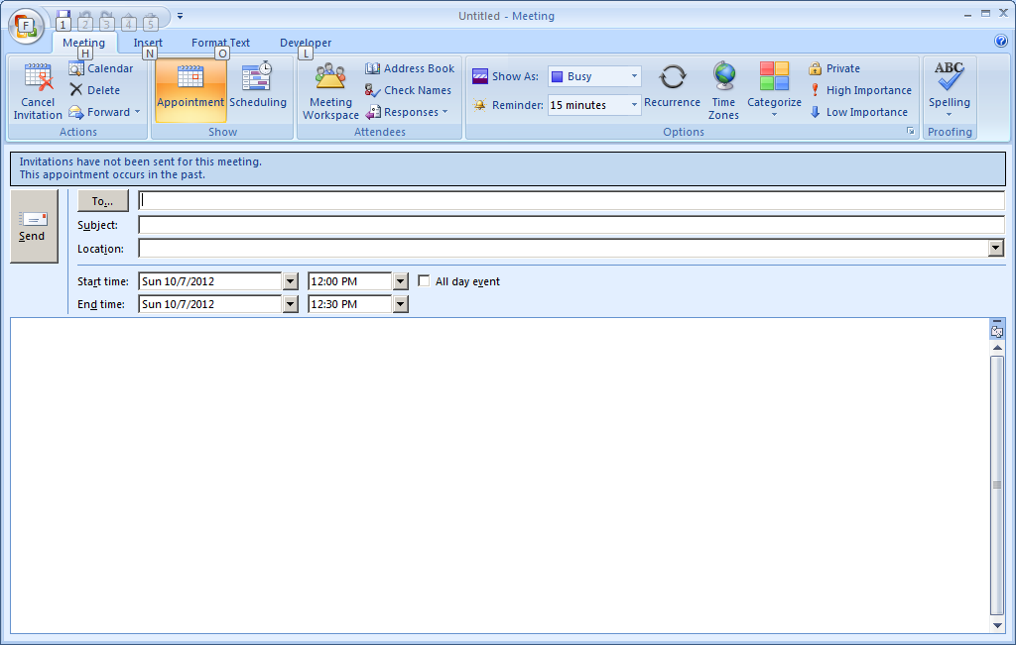

You can send the meeting details to another user by setting the Subject, Location and Timings of the meeting in the window shown above.

Click ***Send***.

**EXERCISE**

Perform the following activities till you are confident:

|  |  |
| --- | --- |
| **S.No.** | **Activities** |
| 1. | Create meeting request for the following items:   1. School Annual Day function discussion. 2. Blood donation camp discussion |

**ASSESSMENT**

**Fill in the blanks:**

1. A __________ is an appointment to which you invite people or reserve resources.
2. You can specify ________, _________ & ______ while sending a meeting request.

## **session 7: Respond To a Meeting Request**

**RELEVANT KNOWLEDGE**

Calendar software allows the user to respond to other users meeting requests. In this exercise, you will learn to respond to a meeting request.

Open the email application to view the request. To respond, select ***Accept***, ***Tentative***, ***Decline*** or ***Propose New Time*** options (figure below)

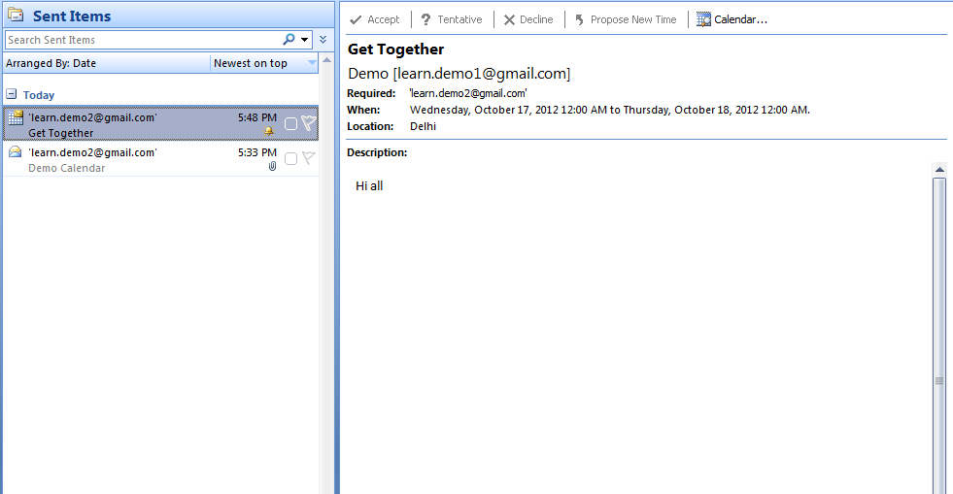



As a meeting attendee, *you can propose an alternative meeting time*. However, the meeting organizer must accept the new time. Meeting organizers can send meeting requests that restrict the ability to propose alternate meeting times. If the meeting organizer has restricted meeting proposals, the ***Propose New Time*** command is not available. By default, when you propose a new time, you tentatively accept the meeting. However, if you click the text ***Propose New Time***, you have the additional options to click ***Tentative and Propose New Time*** or ***Decline and Propose New Time***.

**EXERCISE**

Perform the following activities till you are confident:

|  |  |
| --- | --- |
| **S.No.** | **Activities** |
| 1. | Respond to the meeting requests sent by one of your classmates using mentioned procedure you have learnt today. |
| 2. | Respond to requests from other classmates using options such as *Accept*, *Tentative*, etc. and observe the results sent to your mail. |

**ASSESSMENT**

**Fill in the blanks:**

1. Calendar software allows the user to _________ to other users meeting requests.
2. Responses to your meeting request appear in your ____________.
3. Some of the response options for meeting request are __________,____________,___________ & ________________ .
4. You have received a meeting request for which the schedule is not convenient to you; however you would like to reschedule this meeting. Which option should be used when responding to this meeting request? ________________

## **session 8: Create and Edit a Task**

**RELEVANT KNOWLEDGE**

Tasks refers to actions that can be performed by an user; tasks may include action items such as booking a conference room, booking tickets, reminder for a task completion itself, etc. In this exercise, you will learn to create and edit a task.

You can create tasks in email calendar application software.

Go to ***File*** > ***New*** > ***Task***, a ***Task*** window will be displayed as shown below.

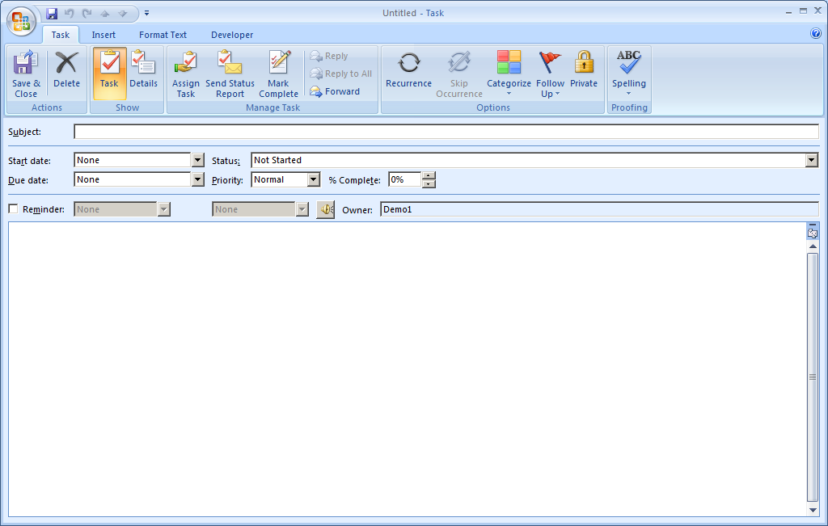

Here you can define a subject name for the task; the start date and end date of the task; the status of the task and the priority of the task. Once you have given the entire details click ***Save & Close*** at the top of the page. A window is displayed as shown below.

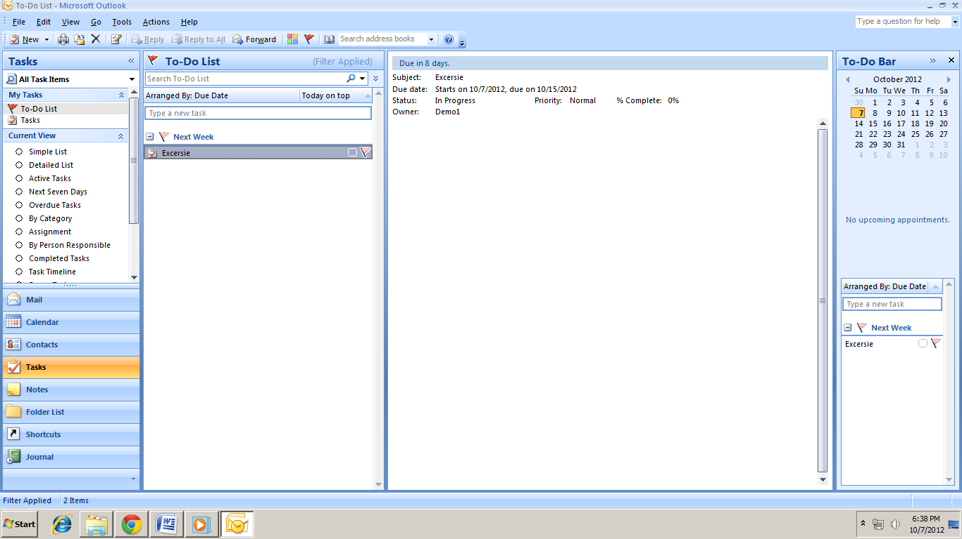

You can also the edit the task by double clicking the task name available in the email application software.

**EXERCISE**

Perform the following activities till you are confident:

|  |  |
| --- | --- |
| **S.No.** | **Activities** |
| 1. | Create a new task |
| 2. | Edit an existing task |

**ASSESSMENT**

**Fill in the blanks:**

1. _______ refers to actions that can be performed by a user.
2. While creating a task you can define_______________ , ____________, ______________, _______________ & _________________ of a task.

## **session 9: Create and Edit a Note**

**RELEVANT KNOWLEDGE**

Notes are short text messages that can be used for taking quick notes. You can create notes in the calendar software. In this exercise, you will learn to create and edit a note.

Go to ***File*** > ***New*** > ***Note***, a window will be displayed as shown below.

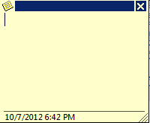

You can type the content of the note and click the  icon. Once you click the  icon, a dropdown list appears as shown below.

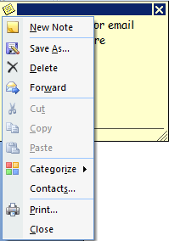

To view the notes that you have created, click ***Notes*** in the calendar application. If you would like to edit the note, double-click on it and edit as required.

**EXERCISE**

Perform the following activities till you are confident:

|  |  |
| --- | --- |
| **S.No.** | **Activities** |
| 1. | Create a note |
| 2. | Edit a note |
| 3. | Create note for the following items:   1. Grocery list. 2. Books to buy list. |

**ASSESSMENT**

**Fill in the blanks:**

1. __________ are short text messages that can be used for taking quick notes.
2. To view the list of notes you select the ___________ option in the Calendar application.

## **session 10: Create and Edit a Journal Entry**

**RELEVANT KNOWLEDGE**

Journal entry creates a timeline of transactions that can be linked to a contact. A transaction might be an email, task, appointment etc. The following activities can be automatically recorded:

* Emails Sent & Received
* Telephone calls
* Meeting requests & responses
* Office documents you manage

By automatically recording all documents you work on, email sent to specific contacts, and phone calls made, the journal logs all your activity. This is very useful when you needs to know how long you worked on a document or spent on a phone call because the journal tracks the elapsed time along with the event; or when a manager might want to know the number of calls made or email sent by the team members or track the number of documents created per hour.

In this exercise, you will learn to work with journal entries.

If you would like to track the usage of an application such as Microsoft Word, go to **Tools** > **Options**, a dialog box will be displayed as shown below.

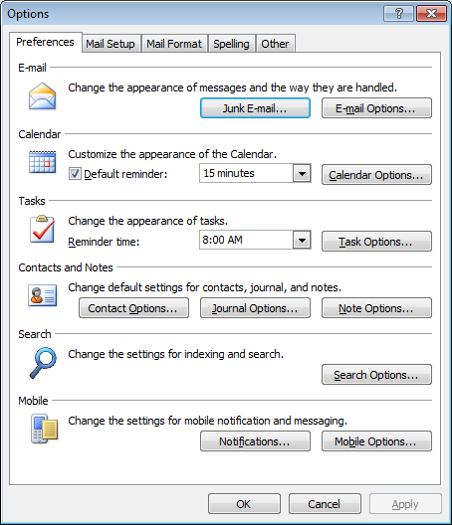

Click on **Journal Options** button.

Once you click the button, a dialog box will be displayed as shown below.



Check ***Microsoft Word*** under ***Also record files from*** Section and Click **Ok**. Close the time management software.

Now open the word processing software, create a document and save it. Close the Word Processing software. Open the time management software.

Select ***Go*** > ***Journals***.

Following window will be displayed:



Notice the document that you created earlier is listed. You can edit the journal entry by double-clicking the entry or by right-clicking the entry and selecting **Open Journal Entry**.

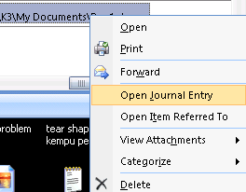

A window similar to the one below will be displayed:

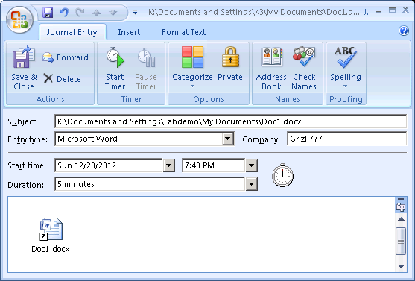

Notice the following items that are displayed:

* Document file name and path
* Created time and date
* Duration (Amount of time spent on that document)
* Shortcut to the document itself! (Double-clicking the shortcut will open the document)

Similarly if you would like to track emails send to your contacts, Go to ***Tools*** > ***Options***. Click on **Journal Options** button.

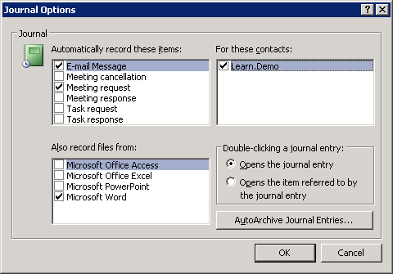

Under **For these contacts:** section, select the contacts that you wish to track by placing a check against each contact. Click **OK**.

Note: The contacts added in the calendar application will be visible here.

Now send mail to the contacts (selected in the previous step). Once you have completed sending the mails, Click **Go** > **Journals**. A window similar to the one will be displayed.

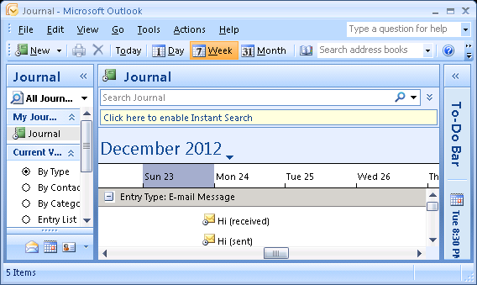

Notice the mail entries (sent & received) displayed. Right-click on the entry and select **Open Journal Entry**.

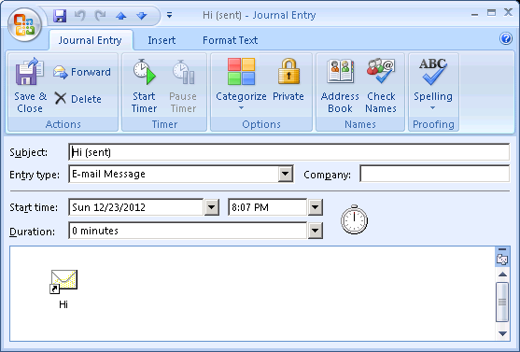

Notice the following items that are displayed:

* Mail Subject
* Timestamp (time and date)
* Shortcut to the mail itself! (Double-clicking the shortcut will open the mail)

Now that you have learnt to work with Journal, work with different other options such as task requests, meeting requests, etc. and observe the tracking in the time management software.

**EXERCISE**

Perform the following activities till you are confident:

|  |  |
| --- | --- |
| **S.No.** | **Activities** |
| 1. | Create a new journal entry |
| 2. | Edit an existing journal entry |

**ASSESSMENT**

**Fill in the blanks:**

1. _______________ creates a timeline of transactions that can be linked to a contact.
2. __________________, __________________, ________________, ______________ are some of the items that can be automatically recorded by the Calendar Software.